VIETNAM - KOREA UNIVERSITY OF INFORMATION AND COMMUNICATION TECHNOLOGY

**FACULTY OF COMPUTER SCIENCE**



**GRADUATION PROJECT**

**TOPIC NAME: BUILD AN E-COMMERCE APPLICATION THAT INTEGRATES AI**

**Student name:**  Phan Van Lai 20IT1028

**Industry:**  Information Technology

**Major:**  Software Engineering

**Student name:**  Nguyen Quoc Thanh 20IT965

**Industry:**  Information Technology

**Major:**  Software Engineering

**Instructor:**  Msc. Do Cong Duc

**Da Nang, July 2025**

VIETNAM - KOREA UNIVERSITY OF INFORMATION AND COMMUNICATION TECHNOLOGY

**FACULTY OF COMPUTER SCIENCE**



**GRADUATION PROJECT**

**TOPIC NAME: BUILD AN E-COMMERCE APPLICATION THAT INTEGRATES AI**

**Student name:**  Phan Van Lai 20IT1028

**Industry:**  Information Technology

**Major:**  Software Engineering

**Student name:**  Nguyen Quoc Thanh 20IT965

**Industry:**  Information Technology

**Major:**  Software Engineering

**Instructor:**  Msc. Do Cong Duc

**Da Nang, July 2025**

INSTRUCTOR COMMENTS

**(By the instructor)**

**Danang, July 2025**

**Instructor**

EXAMINER COMMENTS

**(By the examiner)**

**Danang, July 2025**

**Examiner**

ACKNOWLEDGEMENTS

We would like to express our sincere gratitude to all those who supported and accompanied us during our studies and the implementation of this graduation project.

First of all, we sincerely thank **MSc. Do Cong Duc**, our project supervisor, for his dedicated guidance, valuable feedback, and continuous support throughout the development of our project titled “Build an e-commerce application that integrates AI” His mentorship played a crucial role in helping us complete this project successfully.

We also extend our thanks to all lecturers at the Vietnam – Korea University of Information and Communication Technology, The University of Danang (VKU) for providing us with the foundational knowledge and professional skills that enabled us to carry out this project confidently.

We are grateful to our classmates and team members for their cooperation and support throughout the working process.

Lastly, we would like to thank our families for always being a strong source of motivation and encouragement during our studies and project work.

Although we have made great efforts, due to limited experience and time, this report may still contain shortcomings. We sincerely welcome any feedback from our instructors to help us improve in the future.

We are truly grateful.

STATEMENT OF AUTHORSHIP

We hereby declare that this graduation project report, titled “Build an e-commerce application that integrates AI”, is the result of our own work. It has not been copied or plagiarized from other sources. All references and sources of information used in the project have been properly cited and acknowledged.

We confirm that this report has not been submitted, in whole or in part, for any other degree or qualification at this or any other institution.

We take full responsibility for the content of this report.

***Danang, July 5th, 2025***

**NGUYEN QUOC THANH**

**PHAN VAN LAI**

TABLE OF CONTENTS

INSTRUCTOR COMMENTS i

EXAMINER COMMENTS ii

ACKNOWLEDGEMENTS iii

STATEMENT OF AUTHORSHIP iv

TABLE OF CONTENTS v

ABBREVIATIONS x

LIST OF FIGURES xi

LIST OF TABLES xv

INTRODUCTION 1

1. Problem statement 1

2. Aims and Objectives 1

3. Structure of the thesis 1

CHAPTER 1. OVERVIEW OF E-COMMERCE 3

1.1 Overview Of E-Commerce 3

1.1.1 Definition and Characteristics of E-commerce 3

1.1.2 Popular E-commerce Platforms 3

1.2 Programming language 4

1.2.1 Dart 4

1.2.2 Python 5

1.3 Framework 7

1.3.1 Flutter 7

1.3.2 FastAPI 10

1.4 Platform 10

CHAPTER 2. SYSTEM DESIGN ANALYSIS 15

2.1 System survey 15

2.1.1 Field survey 15

2.1.2 User survey 15

2.1.3 Business diagram 16

2.2 Software requirements specification 16

2.2.1 Identify the factors 16

2.2.2 Functional requirements 16

2.2.3 Non - functional requirements 17

2.3 Use Case Diagram 18

2.3.1 Overall 18

2.3.2 Managing product in the shopping cart 18

2.3.3 Search 20

2.3.4 User 21

2.3.5 Address 22

2.3.6 Product 23

2.3.7 Banner 24

2.3.8 Brand 25

2.3.9 Category 26

2.3.10 Media 27

2.3.11 Order 28

2.3.12 Profile 29

2.3.13 Setting 30

2.4 Workflow Diagram 31

2.5 Operational diagram 32

2.5.1 Register and login 32

2.5.2 User 32

2.5.3 Banner 33

2.5.4 Brand 33

2.5.5 Category 34

2.5.6 Product 34

2.5.7 Order 35

2.6 Sequential sketch 36

2.6.1 Register 36

2.6.2 Login 36

2.6.3 Product 37

2.6.4 Banner 38

2.6.5 Brand 39

2.6.6 Category 40

2.6.7 Order 41

2.6.8 Media 41

2.6.9 Shopping cart Management 42

2.6.10 User Management 42

2.7 Class diagram 43

2.8 Database Table Design 43

2.8.1 User 43

2.8.2 Address 44

2.8.3 CartItem 44

2.8.4 Order 45

2.8.5 Banner 45

2.8.6 Product 46

2.8.7 Category 46

2.8.8 Brand 47

2.8.9 Image 47

2.8.10 ProductCategory 48

2.8.11 BrandCategory 48

2.9 Interface design 49

2.9.1 User 49

2.9.1.1 Onboarding 49

2.9.1.2 Login 50

2.9.1.3 Register 51

2.9.1.4 Forget Password 53

2.9.1.5 Home 54

2.9.1.6 Shopping cart 56

2.9.1.7 Checkout 57

2.9.1.8 Search 59

2.9.1.9 Category 61

2.9.1.10 Product 62

2.9.1.11 All Product 64

2.9.1.12 Brand 65

2.9.1.13 All Brand 66

2.9.1.14 Store 67

2.9.1.15 Wishlist 69

2.9.1.16 Review & Ratings 70

2.9.1.17 Setting 71

2.9.1.18 Profile 73

2.9.1.19 Address 74

2.9.1.20 Order detail 76

2.9.2 Admin 78

2.9.2.1 Login 78

2.9.2.2 Dashboard 79

2.9.2.3 Media 80

2.9.2.4 Category 81

2.9.2.5 Brand 84

2.9.2.6 Banner 86

2.9.2.7 Product 89

2.9.2.8 Customer 92

2.9.2.9 Order 94

2.9.2.10 Profile 95

2.9.2.11 Setting 97

CHAPTER 3. AI-POWERED PRODUCT IMAGE GENERATION AND SMART FEATURES 99

3.1 Product Image Generation System Using AI 99

3.1.1 ComfyUI 99

3.1.2 Image Generation Workflow Design 99

3.1.2.1 Model Loading and Initialization 100

3.1.2.2 Image Input & Preprocessing 100

3.1.2.3 Prompt Handling & Translation 100

3.1.2.4 Primary and Secondary Sampling Pipelines 100

3.1.2.5 Output & Visualization 100

3.1.2.6 Advanced Features 100

3.2 AI Screen Design 104

CONCLUSIONS AND SUGGESTIONS 105

1. Conclusions 105

2. Suggestions 105

REFERENCES xvii

ABBREVIATIONS

|  |  |
| --- | --- |
| **ABBREVIATIONS** | **MEANING** |
| AI | Artificial Intelligence |
| API | Application Programming Interface |
| AOT | Ahead-Of-Time (Compilation) |
| B2B | Business to Business |
| CDN | Content Delivery Network |
| CRD | Create, Read, Delete |
| CRU | Create, Read, Update |
| CRUD | Create, Read, Update, Delete |
| GPS | Global Positioning System |
| JIT | Just-In-Time (Compilation) |
| N/A | Not Applicable |
| RU | Read, Update |
| SDK | Software Development Kit |
| SMEs | Small and Medium-sized Enterprises |
| SSL | Secure Sockets Layer |
| UI | User Interface |
| UX | User Experience |

LIST OF FIGURES

Figure 1.1 Dart 5

Figure 1.2 Python 6

Figure 1.3 Flutter 7

Figure 1.4 FastAPI 10

Figure 1.5 Firebase 11

Figure 1.6 Postman 13

Figure 2.1 Business diagram 16

Figure 2.2 Overall use case 18

Figure 2.3 Managing product in the shopping cart 18

Figure 2.4 Use case search 20

Figure 2.5 Use case User management 21

Figure 2.6 Use case address 22

Figure 2.7 Use case product management 23

Figure 2.8 Use case product management 24

Figure 2.9 Use case brand management 25

Figure 2.10 Use case category management 26

Figure 2.11 Use case media management 27

Figure 2.12 Use case order management 28

Figure 2.13 Use case profile management 29

Figure 2.14 Use case setting management 30

Figure 2.15 Workflow diagram 31

Figure 2.16 Sequential Sketch Register 36

Figure 2.17 Sequential Sketch Login 36

Figure 2.18 Sequential sketch Product 37

Figure 2.19 Sequential sketch Banner 38

Figure 2.20 Sequential sketch Brand 39

Figure 2.21 Sequential Sketch Category 40

Figure 2.22 Sequential sketch Order 41

Figure 2.23 Sequential sketch Media 41

Figure 2.24 Sequential Sketch Shopping Cart 42

Figure 2.25 Sequential Sketch User 42

Figure 2.26 Class Diagram 43

Figure 2.27 “Onboarding 1” interface 49

Figure 2.28 “Onboarding 2” interface 49

Figure 2.29 “Onboarding 3” interface 49

Figure 2.30 “Sign in” interface 50

Figure 2.31 “Register 1” interface 51

Figure 2.32 “Register 2” interface 51

Figure 2.33 “Forget Password” interface 53

Figure 2.34 “Home 1” interface 54

Figure 2.35 “Home 2” interface 54

Figure 2.36 “Register” interface 56

Figure 2.37 “Checkout 1” interface 57

Figure 2.38 “Checkout 2” interface 57

Figure 2.39 “Checkout 3” interface 58

Figure 2.40 “Checkout 4” interface 58

Figure 2.41 “Search 1” interface 59

Figure 2.42 “Search 2” interface 59

Figure 2.43 “Category” interface 61

Figure 2.44 “Product 1” interface 62

Figure 2.45 “Product 2” interface 62

Figure 2.46 “All Product 1” interface 64

Figure 2.47 “All Product 2” interface 64

Figure 2.48 “Brandt 1” interface 65

Figure 2.49 “Brand 2” interface 65

Figure 2.50 “All Brand” interface 66

Figure 2.51 “Store 1” interface 67

Figure 2.52 “Store 2” interface 67

Figure 2.53 “Wishlist” interface 69

Figure 2.54 “Review & Ratings 1” interface 70

Figure 2.55 “Review & Ratings 2” interface 70

Figure 2.56 “Setting 1” interface 71

Figure 2.57 “Setting 2” interface 71

Figure 2.58 “Profile 1” interface 73

Figure 2.59 “Profile 2” interface 73

Figure 2.60 “Address 1” interface 74

Figure 2.61 “Address 2” interface 74

Figure 2.62 “Order detail 1” interface 76

Figure 2.63 “Order detail 2” interface 76

Figure 2.64 “Login” interface 78

Figure 2.65 “Dashboard 1” interface 79

Figure 2.66 “Media” interface 80

Figure 2.67 “Category” interface 81

Figure 2.68 “Create category” interface 82

Figure 2.69 “Update category” interface 82

Figure 2.70 “Brand” interface 84

Figure 2.71 “Create brand” interface 84

Figure 2.72 “Update brand interface” interface 85

Figure 2.73 “Banner” interface 86

Figure 2.74 “Create banner” interface 87

Figure 2.75 “Update banner” interface 87

Figure 2.76 “Product” interface 89

Figure 2.77 “Create product 1” interface 89

Figure 2.78 “Create product 2” interface 90

Figure 2.79“Update product 1” interface 90

Figure 2.80 “Update product 2” interface 91

Figure 2.81 “Customer” interface 92

Figure 2.82 “Customer detail” interface 93

Figure 2.83 “Order” interface 94

Figure 2.84 “Orders” interface 94

Figure 2.85 “Profile” interface 95

Figure 2.86 “Setting” interface 97

Figure 3.1 Workflow design overall 101

Figure 3.2 Workflow design 1 101

Figure 3.3 Workflow design 2 102

Figure 3.4 Workflow design 3 102

Figure 3.5 Workflow design 4 103

Figure 3.6 Workflow design 5 103

Figure 3.7 AI Image Processing 104

LIST OF TABLES

Table 1.1 Strengths and Limitations of Shopee, Lazada, and Tiki 4

Table 1.2 Comparison of Flutter, React Native, and Native Development 9

Table 2.1 Scenario Use-case “Managing product in the shopping cart” 19

Table 2.2 Scenario Use-case “Search” 20

Table 2.3 Scenario Use-case “User” 21

Table 2.4 Scenario Use-case “Address” 22

Table 2.5 Scenario Use-case “Product” 23

Table 2.6 Scenario Use-case “Banner” 24

Table 2.7 Scenario Use-case “Brand” 25

Table 2.8 Scenario Use-case “Category” 26

Table 2.9 Scenario Use-case “Media” 27

Table 2.10 Scenario Use-case “Order” 28

Table 2.11 Scenario Use-case “Profile” 29

Table 2.12 Scenario Use-case “Setting” 30

Table 2.13 “User” database 43

Table 2.14 “Address” database 44

Table 2.15 “CartItem” database 44

Table 2.16 “Order” database 45

Table 2.17 “Banner” database 45

Table 2.18 “Product” database 46

Table 2.19 “Category” database 46

Table 2.20 “Brand” database 47

Table 2.21 “Image” database 47

Table 2.22 “ProductCategory” database 48

Table 2.23 “BrandCategory” database 48

Table 2.24 “Sign in” interface 50

Table 2.25 “Sign up” interface 52

Table 2.26 “Forget” interface 53

Table 2.27 “Home” interface 54

Table 2.28 “Shopping cart” interface 56

Table 2.29 “Checkout” interface 58

Table 2.30 “Search” interface 60

Table 2.31 “Category” interface 61

Table 2.32 “Product” interface 62

Table 2.33 “All Product” interface 64

Table 2.34 “Brand” interface 65

Table 2.35 “All Product” interface 67

Table 2.36 “Store” interface 68

Table 2.37 “Wishlist” interface 69

Table 2.38 “Reviews & Rating” interface 70

Table 2.39 “Setting” interface 72

Table 2.40 “Profile” interface 73

Table 2.41 “Address and Add new address” interface 75

Table 2.42 “Order Details screen” interface 77

Table 2.43 “Admin Login” interface 78

Table 2.44 “Dashboard” interface 80

Table 2.45 “Media” interface 81

Table 2.46 “Category” interface 83

Table 2.47 “Brands” interface 85

Table 2.48 “Banner” interface 88

Table 2.49 “Products” interface 91

Table 2.50 “Customers” interface 93

Table 2.51 “Orders” interface 95

Table 2.52 “Profile” interface 96

Table 2.53 “Setting” interface 97

INTRODUCTION

## Problem statement

In recent years, e-commerce has witnessed remarkable growth both globally and in Vietnam. However, many small and medium-sized enterprises (SMEs) still face challenges in adopting cost-effective and user-friendly digital commerce solutions. There is a growing demand for flexible, scalable, and accessible platforms that can help businesses expand their online presence efficiently.

In this context, building a cross-platform e-commerce application becomes highly relevant. Such an application can support businesses in managing their online stores, handling customer interactions, and streamlining product and order management in a convenient and scalable manner.

## Aims and Objectives

The overall aim of this project is to develop a cross-platform e-commerce application to improve user experience and support business operations.

The specific objectives of this thesis are to:

* Develop a multi-platform mobile application using Flutter.
* Integrate Firebase as a robust backend for data management and user authentication.
* Build essential e-commerce functionalities, including product listing, shopping cart, user authentication, order tracking, and payment processing.
* Design a user-friendly interface to ensure smooth user interaction and usability.

## Structure of the thesis

After the *Introduction*, the thesis is structured in three chapters:

*Chapter 1:* *Overview of E-commerce.* This chapter presents the fundamental concepts of e-commerce, analyzes popular e-commerce platforms in the Vietnamese market such as Shopee, Lazada, and Tiki, and identifies opportunities and limitations for new solutions.

*Chapter 2: System Analysis and Design*. This chapter includes requirement analysis, system architecture, database modeling using Firebase, and the design of user interfaces based on Material Design principles.

*Chapter 3:* AI Integration and Smart Features. This chapter proposes the implementation of AI-driven modules including product image generation using Stable Diffusion, smart product recommendation systems, chatbot integration, and optimization strategies.

Finally, there are *Conclusions*, *Suggestions,* *References* and *Appendices* related to the topic.

# OVERVIEW OF E-COMMERCE

## Overview Of E-Commerce

### Definition and Characteristics of E-commerce

E-commerce, or electronic commerce, refers to the buying and selling of goods and services through electronic networks, primarily the Internet. Its key characteristics include digital transactions, automation of processes, global accessibility, and 24/7 availability.

There are several common types of e-commerce models:

* Business to Consumer (B2C): Businesses sell directly to individual customers (e.g., Shopee, Tiki).
* Business to Business (B2B): Transactions between companies, often involving wholesale or bulk orders.
* Consumer to Consumer (C2C): Individuals sell to each other through platforms like Facebook Marketplace or Cho Tot.

E-commerce has experienced significant global growth in recent years. In Vietnam, the market is expanding rapidly due to increasing internet penetration, mobile device usage, and improved logistics. The government's digital economy strategy further supports the development of online commerce.

### Popular E-commerce Platforms

In recent years, various e-commerce platforms have rapidly evolved to dominate the digital marketplace in Southeast Asia, particularly in Vietnam. Among the most notable are Shopee, Lazada, and Tiki—each playing a crucial role in shaping the way consumers shop online and how sellers conduct business in the digital age.

Analysis of Leading Platforms

* Shopee

Shopee is one of the leading e-commerce platforms in Southeast Asia, known for its mobile-first approach, aggressive marketing strategies, and wide range of product categories. It features a user-friendly interface, frequent promotional campaigns (like Flash Sales and Free Shipping), and strong logistics support via Shopee Xpress. It also emphasizes social shopping by incorporating features like live streaming and in-app games.

* Lazada

Lazada, owned by Alibaba Group, leverages advanced logistics and backend technologies. Lazada stands out for its seller center tools, payment gateways, and integrations with global supply chains. The platform is designed to scale and accommodate both SMEs and large brands.

* Tiki

Tiki started as a book-selling platform and has expanded to become one of Vietnam’s trusted e-commerce sites. It differentiates itself by focusing on genuine products, fast delivery (TikiNOW), and a more curated catalog. Tiki has a strong domestic user base and is known for customer service and reliable product quality.

**Advantages and Limitations of Existing Platforms**

Table 1.1 Strengths and Limitations of Shopee, Lazada, and Tiki

|  |  |  |
| --- | --- | --- |
| **Platform** | **Strengths** | **Limitations** |
| Shopee | Wide user base, attractive promotions, social features | Fake products, intense competition, seller quality inconsistency |
| Lazada | Advanced logistics, strong seller tools, Alibaba backing | Complicated seller onboarding, less user engagement |
| Tiki | High product quality, local trust, fast delivery | Smaller product range, limited international expansion |

## Programming language

### Dart

Dart is an object-oriented programming language developed by Google, optimized for building efficient and smooth user interfaces across multiple platforms. It is especially prominent when used with Flutter – a popular cross-platform UI toolkit. With its clear and concise syntax, Dart enables developers to quickly build and deploy applications on mobile, web, desktop, and even backend systems.

Advantages of Dart:

* High performance: Dart compiles directly to native machine code, allowing apps to run quickly and smoothly on both Android and iOS.
* Hot reload: Enables real-time updates to the UI and application logic without restarting the app, significantly speeding up development and testing.
* Easy to learn and write: Dart's syntax is friendly and similar to Java or JavaScript, making it accessible for both beginners and experienced developers.
* Rich library ecosystem: Dart offers a wide range of built-in and third-party libraries, making it easy to implement common features like HTTP requests, JSON parsing, animations, and more.
* UI-focused design: Dart is designed with user interface development in mind, making it highly suitable for Flutter’s reactive programming model and flexible UI architecture.



Figure 1.1 Dart

### Python

Python is a high-level programming language known for its readable and easy-to-learn syntax, widely used in many fields such as web development, artificial intelligence (AI), machine learning, and data science. Python was developed in the late 1980s by Guido van Rossum, and first released in 1991. The goal of Python is to be an easy-to-understand, accessible language for programmers. Over the years, Python has become one of the most popular languages, with strong community support and integrated libraries for a variety of applications.



Figure 1.2 Python

Advantages and benefits:

- Simple, easy-to-read syntax: One of the reasons Python is loved is that its syntax is close to natural language, making it easy for programmers to write and understand source code. This reduces development time and makes code easier to maintain later.

- Versatile and flexible: Python can be used in a wide variety of domains. From web development with frameworks like Django and Flask, to data science, automation, machine learning, and artificial intelligence (AI) with libraries like TensorFlow, scikit-learn, pandas.

- Large community and documentation: Python has a huge community of programmers. This means there are a lot of learning materials, libraries, and libraries, and online tutorials, help programmers easily solve problems encountered.

- Libraries and Frameworks: Python has a huge library ecosystem, especially in areas like data science, AI, and web development. Libraries like NumPy, pandas, and Matplotlib help with fast data processing and analysis, while frameworks like Django and Flask make web development a breeze.

- Suitable for small and large projects: Python can be used for everything from small, one-off projects to large, complex applications. Thanks to its clear syntax and good extensibility, Python is often chosen for both research, academic projects and large commercial products.

- Cross -platform: Python runs on almost every operating system, including Windows, macOS, and Linux, making it easy for developers to deploy applications across multiple platforms.

## Framework

### Flutter

Flutter is an open-source UI toolkit developed by Google, first introduced in 2017. It enables developers to build high-performance, cross-platform applications for mobile (Android and iOS), web, and desktop using a single codebase. With Flutter, developers write code in Dart—a modern, object-oriented programming language optimized for building user interfaces efficiently and expressively. One of Flutter's standout features is its "hot reload" capability, which allows developers to see changes in real time without restarting the app, significantly accelerating the development and testing process. Unlike other frameworks that rely on native UI components, Flutter uses its own high-performance rendering engine (Skia) to draw widgets directly to the screen. This gives developers full control over the UI and ensures consistent design and performance across all platforms. Flutter also offers a rich set of customizable widgets and tools, making it easy to create visually attractive, responsive, and smooth user experiences. Thanks to its flexibility, performance, and strong community support, Flutter has quickly become one of the most popular choices for cross-platform app development.

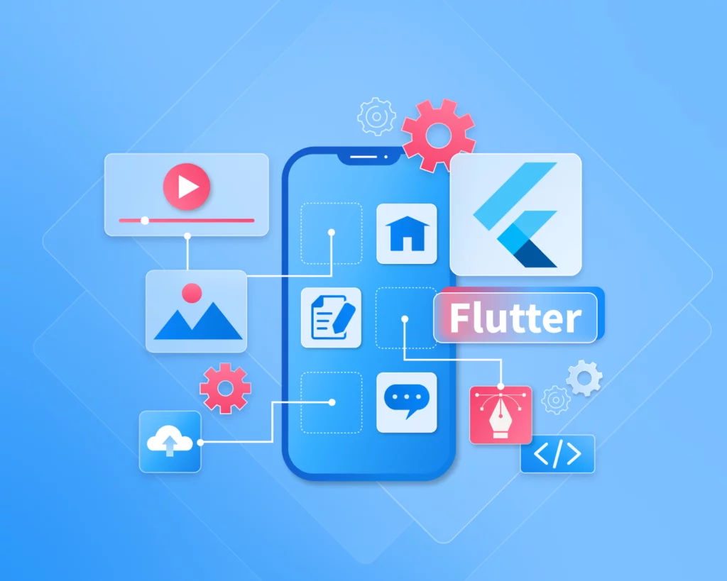

Figure 1.3 Flutter

Advantages and benefits:

* Cross-platform development: Flutter allows developers to write a single codebase and deploy it across multiple platforms, including Android, iOS, web, Windows, macOS, and Linux. This significantly reduces development time and maintenance costs, especially for startups or teams with limited resources.
* High performance: Unlike many other cross-platform frameworks that rely on a bridge to communicate with native components, Flutter uses its own rendering engine (Skia) to draw everything directly to the screen. This results in smooth animations, fast load times, and a native-like performance on all platforms.
* Hot reload: This feature enables developers to instantly see the effects of code changes without restarting the entire application. It boosts productivity, allows for quick experimentation, easier debugging, and faster UI design iterations during development.
* Rich widget library: Flutter provides a comprehensive set of pre-designed and customizable widgets that follow both Material Design (Google) and Cupertino (Apple) guidelines. This makes it easy to build beautiful, responsive, and platform-adaptive user interfaces.
* Consistent UI and behavior: Since Flutter renders the UI itself and does not depend on native platform components, the look and feel of the app remain consistent across different operating systems. Developers don’t have to worry about UI differences caused by OS version variations.
* Strong community and Google support: Flutter has robust backing from Google and a rapidly growing global community. This means frequent updates, strong documentation, and a large ecosystem of plugins, packages, and learning resources that help accelerate development.

**Comparison with React Native and Native Development**

Table 1.2 Comparison of Flutter, React Native, and Native Development

|  |  |  |  |
| --- | --- | --- | --- |
| **Criteria** | **Flutter** | **React Native** | **Native Development** |
| **Language** | Dart | JavaScript | Java/Kotlin (Android), Swift/Obj-C (iOS) |
| **Rendering** | Skia (custom UI engine) | Native components via JS bridge | Native system APIs |
| **Performance** | Near-native (compiled to ARM code) | Moderate (bridge causes some overhead) | Best (direct access to hardware) |
| **UI Consistency** | High (custom-rendered) | Medium (depends on native components) | High (native by default) |
| **Development Speed** | Fast (hot reload, single codebase) | Fast (but some bridging limitations) | Slower (separate codebases for each platform) |
| **Learning Curve** | Medium (Dart-specific) | Low (JavaScript is widely known) | High (platform-specific languages/tools) |
| **Ecosystem Maturity** | Growing rapidly | Mature, widely adopted | Mature, platform-bound |
| **Tooling** | Official support via Android Studio, VS Code | Strong community tools | Robust, platform-specific IDEs (Xcode, Android Studio) |

### FastAPI

FastAPI is a modern and fast web framework developed in Python, focused on building RESTful APIs. It was first released in 2018 by Sebastián Ramírez. FastAPI is notable for its ease of use, high performance, and strong support for Python type hints, which help reduce errors and improve development efficiency.

Some advantages and benefits of FastAPI framework:

- High Performance: FastAPI is built on Starlette and Pydantic, which makes it comparable in performance to frameworks like Node.js and Go.

- Integrated Type Hints: Use Python's type hints to reduce errors, automatically generate API documentation, and powerfully validate data.

- Automatic API documentation: FastAPI automatically generates OpenAPI and Swagger compatible API documentation, making API testing and development easier

- Easy to learn and easy to use: Clean syntax, easy to learn even for beginners, yet powerful enough for complex projects.

- Asynchronous support: FastAPI fully supports asynchronous features (async/await), helping to optimize performance for applications that require processing multiple tasks at the same time.



Figure 1.4 FastAPI

## Platform

* + 1. **Firebase**

Firebase is a comprehensive application development platform that provides developers and teams with a rich set of tools and services to build, improve, and scale web and mobile applications efficiently. Originally launched in 2011 by James Tamplin and Andrew Lee, Firebase began as a real-time backend solution designed to synchronize data between users and applications in real-time. Since its acquisition by Google in 2014, Firebase has grown into a robust development suite integrated with the Google Cloud Platform



Figure 1.5 Firebase

Firebase Services: Authentication, Firestore, Storage, FunctionsFirebase offers a collection of core services that support backend development, enhance user engagement, and facilitate performance monitoring. The most widely used services include:

* Firebase Authentication: Simplifies user identity management by offering multiple login methods such as email/password, phone numbers, and federated identity providers like Google, Facebook, and Apple. It ensures secure authentication while providing ease of integration.
* Cloud Firestore: A flexible, scalable NoSQL cloud database that stores data in documents and collections. It supports powerful querying and real-time data synchronization across devices. Firestore is designed for offline support, enabling users to access content even without an internet connection.
* Firebase Cloud Storage: Ideal for storing user-generated content such as images, audio, and video. It is built on Google Cloud Storage and provides robust upload/download capabilities, secure access controls, and smooth integration with other Firebase services.
* Firebase Cloud Functions: A serverless backend solution that lets developers run backend code in response to events triggered by Firebase features or HTTPS requests. Cloud Functions automatically scale and eliminate the need for server management.

These services are modular and highly integrated, allowing developers to combine them to create scalable, full-featured applications.

Advantages of Firebase in Application Development:

Firebase provides several key benefits for building and maintaining modern applications:

* Real-time Updates: Firestore and Realtime Database allow instant data syncing, critical for apps like chat, collaborative editing, or e-commerce inventory.
* Cross-platform SDKs: Firebase supports Android, iOS, Flutter, and web, making it an excellent choice for cross-platform development.
* Security and Authentication: With Firebase Authentication and customizable security rules, developers can manage access and data protection easily.
* Scalability and Performance: Powered by Google Cloud, Firebase automatically handles traffic spikes and scales globally with minimal developer effort.
* Faster Development Cycles: Hot reload in Flutter, built-in services, and integration reduce development and testing time.
* Serverless Architecture: Cloud Functions allow code execution in response to database changes, authentication events, and API calls without provisioning servers.
* Built-in Analytics and Monitoring: Firebase integrates with Google Analytics, Crashlytics, and Performance Monitoring to provide deep insights into user behavior and app health.
  + 1. **Postman**

Postman is a powerful and widely-used API development platform that supports developers in designing, testing, documenting, and managing APIs efficiently. With its intuitive graphical interface, Postman allows users to easily send HTTP requests (such as GET, POST, PUT, DELETE), observe server responses, and validate API functionality without writing manual code. It has become an essential tool in modern software development workflows, especially in projects that use microservices architecture or RESTful APIs.



Figure 1.6 Postman

Postman offers a wide range of key advantages, including:

- User-friendly and intuitive interface, making it accessible even to those with limited technical knowledge.

- Support for various HTTP methods and data formats, allowing accurate simulation of real-world API interactions.

- Collection management, enabling users to group requests logically by module or function, and easily share them with others.

- Environment variables, which allow seamless switching between different environments like development, staging, and production.

- Built-in automated testing, with JavaScript-based scripts that validate API responses and ensure stability over time.

- CI/CD integration via Newman, enabling automated API testing as part of the software deployment pipeline.

- Team collaboration, with Postman Workspaces allowing multiple team members to work together in real time.

- API monitoring, which periodically checks API health and helps detect issues proactively.

- Automatic API documentation, saving time and simplifying communication with frontend developers, testers, and third-party partners.

Thanks to these advantages, Postman is more than just an API testing tool—it is a vital part of a professional and scalable API lifecycle management system.

# SYSTEM DESIGN ANALYSIS

## System survey

### Field survey

For the e-commerce application development project, the current state survey reveals that Vietnam's market is experiencing rapid growth with major platforms like Shopee, Tiki, and Lazada dominating the market. However, significant gaps remain in niche segments, B2B e-commerce, or specialized industry sectors. Vietnam's technological infrastructure is well-prepared with a developed electronic payment system, increasingly sophisticated logistics services, and high smartphone penetration rates. Traditional business models of many enterprises have not yet fully undergoing digital transformation, creating substantial opportunities for new e-commerce solutions.

### User survey

Through surveying 500 potential customers, we identified that Vietnamese users prioritize fast and convenient shopping experiences with simple and user-friendly interfaces. They desire flexible payment methods, particularly cash-on-delivery and digital wallets. Personal information security and product reviews from other users are considered top priorities. For suppliers, they need simple management tools, bulk product upload support, and detailed revenue reporting. Administrators require comprehensive dashboards, real-time transaction monitoring capabilities, and powerful data analysis tools.

### Business diagram

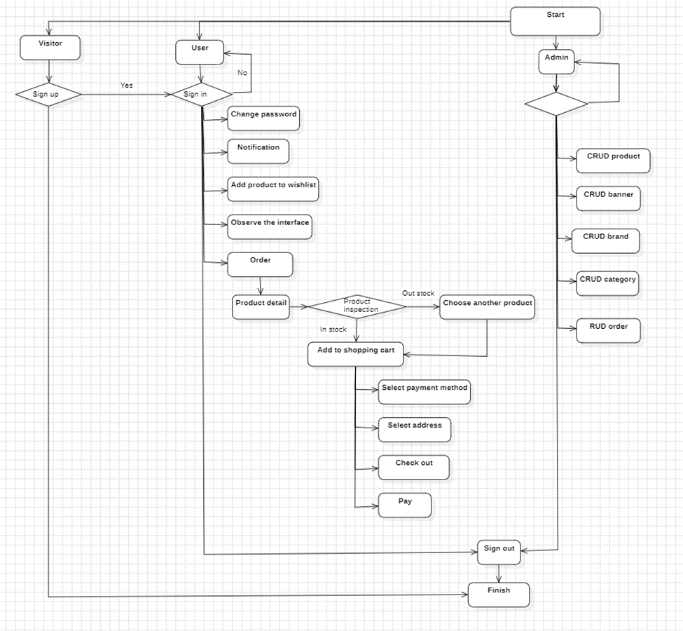

Figure 2.1 Business diagram

## Software requirements specification

### Identify the factors

The topic consists of three main factors

* User
* Admin

### Functional requirements

**\*.User**

* Log in, log out, change password.
* Manage profile
* Manage address
* Manage product
* Manage wishlist product
* Managing product in the shopping cart
* Search
* View all product and brand
* View review and rating of product
* View order history and details
* Create, edit photos with AI

**\*.Admin**

* User management
* Manage media : CRD media
* Manage products : CRUD products
* Manage categories : CRUD categories
* Manage brands :`CRUD brands
* Manage banners : CRUD banners
* Manage order : RUD order
* Manage setting : CRU setting
* Manage profile : RU profile
* Data statistics
* Log in, log out, change password.

### Non - functional requirements

* Interface, beautiful, simple, easy to use.
* Ensure security and safety.
* Fast processing speed.

## Use Case Diagram

### Overall

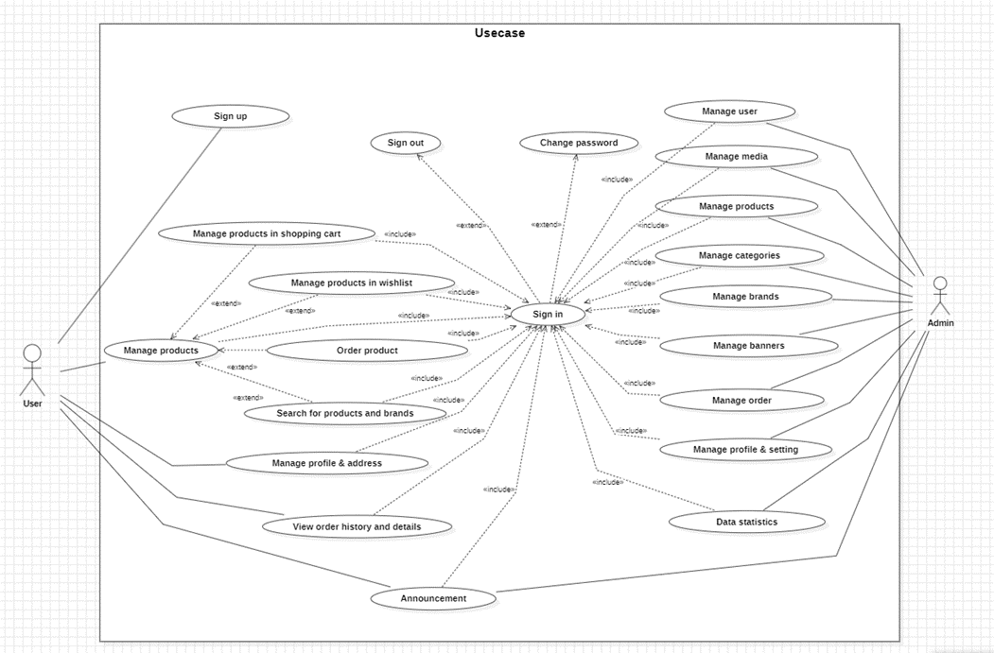

Figure 2.2 Overall use case

### Managing product in the shopping cart

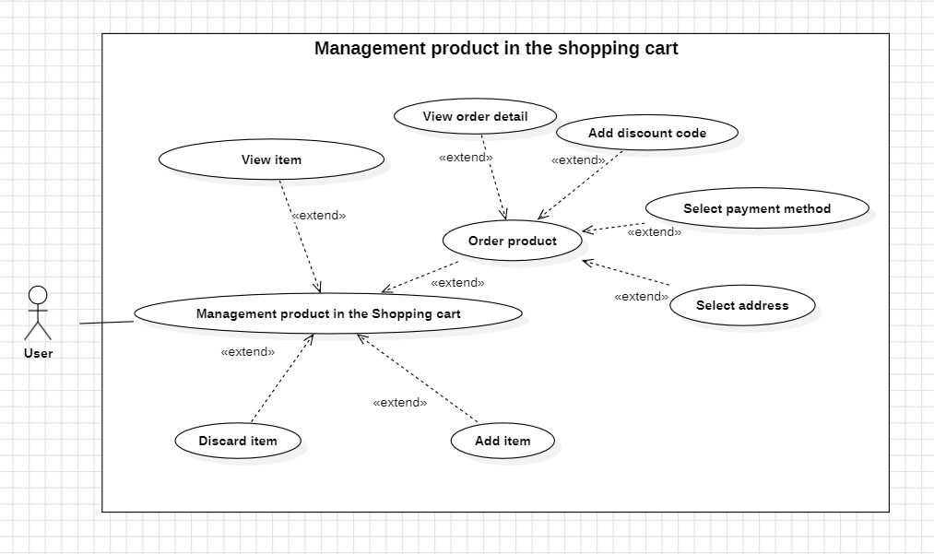

Figure 2.3 Managing product in the shopping cart

Table 2.1 Scenario Use-case “Managing product in the shopping cart”

|  |  |
| --- | --- |
| **Use case name** | **Managing product in the shopping cart** |
| **Description** | Used to manage item-related activities such as collecting, viewing, using, crafting, upgrading, and disposing of items in the World. |
| **Actors** | User |
| **Input** | User has successfully logged in and enter shopping cart |
| **Output** | Successfully perform item management operations (View, add or delete items). |
| **Basic flow** | 1. The Actor clicks “Shopping cart” icon -> The Use-case begins.  2. The Actor can choose one of the following actions:  - View Item: Actor selects the “Inventory” icon. -> Select an item to view details (stats, description).  - Add items: Actor can add items => Items are added to inventory.  - Discard item: Actor selects item from inventory and discards => Item is removed from inventory.  3. The Actor enter “Checkout” to order product:  - Select payment method: PayPal, Master card, Visa, Google Pay, …  - Select Address.  - Check order detail and enter Checkout to pay.  4. The system saves the inventory updates -> End of use case |
| **Alternative flow** |  |
| **Exception flow** | If the Actor attempts to pay but does not have enough funds: The system will warn that this order cannot be executed. |

### Search

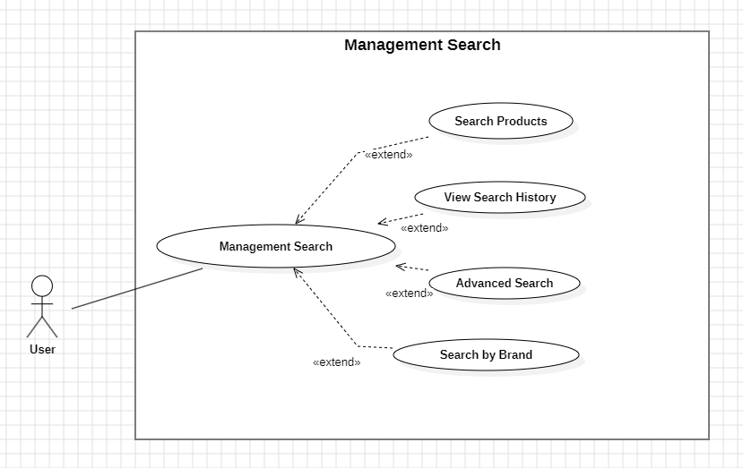

Figure 2.4 Use case search

Table 2.2 Scenario Use-case “Search”

|  |  |
| --- | --- |
| **Use case name** | **Search** |
| **Description** | Used to manage search. |
| **Actors** | User |
| **Input** | Actor successfully logged in |
| **Output** | Show list of product, brand |
| **Basic flow** | 1. Actor clicks on the “Search box” ➔Start Use case  2. Actor performs the necessary operations (view search history, search by product or brand) for the user.  3. The system records and updates user edits if any. ➔End of use case |
| **Alternative flow** |  |
| **Exception flow** |  |

### User

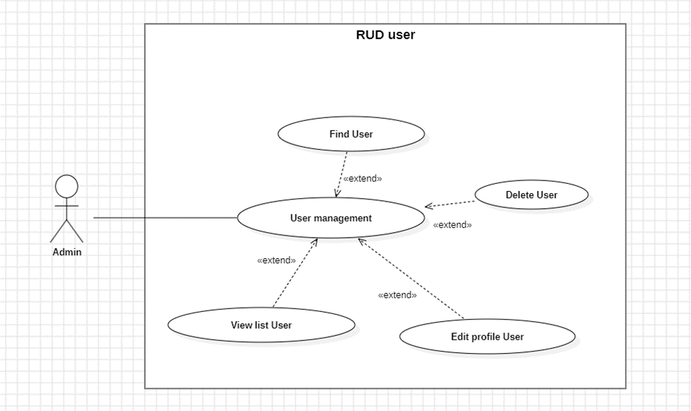

Figure 2.5 Use case User management

Table 2.3 Scenario Use-case “User”

|  |  |
| --- | --- |
| **Use case name** | **User Management** |
| **Description** | Used to manage users. |
| **Actors** | Admin |
| **Input** | Actor successfully logged in with admin rights |
| **Output** | Show list of users |
| **Basic flow** | 4. Actor clicks on the “Customer” menu in the side-bar -> Start Use case  5. Actor performs the necessary operations (view details, edit, delete, search) for the user.  6. The system records and updates user edits if any. -> End of use case |
| **Alternative flow** |  |
| **Exception flow** |  |

### Address

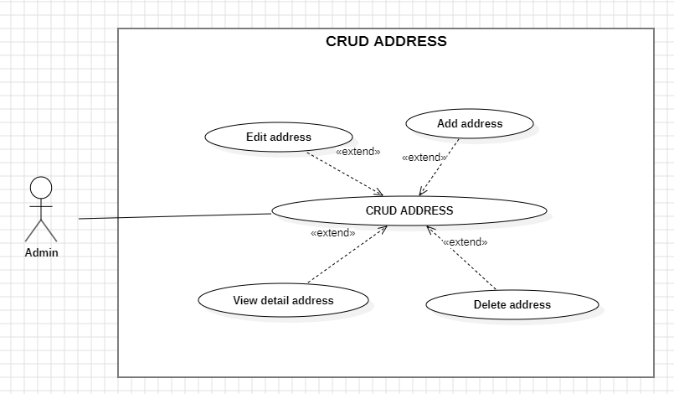

Figure 2.6 Use case address

Table 2.4 Scenario Use-case “Address”

|  |  |
| --- | --- |
| **Use case name** | Address Management |
| **Description** | Used to manage address. |
| **Actors** | User |
| **Input** | Actor successfully logged in |
| **Output** | Show list of address |
| **Basic flow** | 1. Actor clicks on the “My address” menu in the profile -> Start Use case  2. Actor performs the necessary operations (view details, edit, delete) for the user.  3. The system records and updates user edits if any. -> End of use case |
| **Alternative flow** |  |
| **Exception flow** |  |

### Product

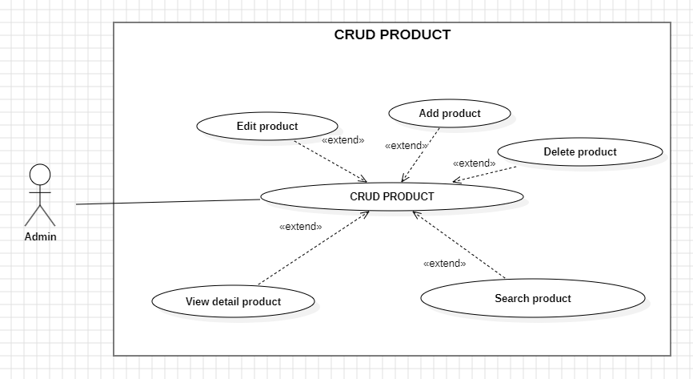

Figure 2.7 Use case product management

Table 2.5 Scenario Use-case “Product”

|  |  |
| --- | --- |
| **Use case name** | **Product** |
| **Description** | Used to manage product |
| **Actors** | Admin |
| **Input** | Actor successfully logged in with admin rights |
| **Output** | Show list of product |
| **Basic flow** | 1. Actor clicks on the “Product” menu in the side-bar -> Start Use case  2. Actor performs the necessary operations (view details, create, edit, delete, search) for the product.  3. The system records and updates user edits if any. -> End of use case |
| **Alternative flow** |  |
| **Exception flow** | If the edited information is invalid (incorrect format, empty task name, etc.), the system will display an error message and request re-editing. |

### Banner

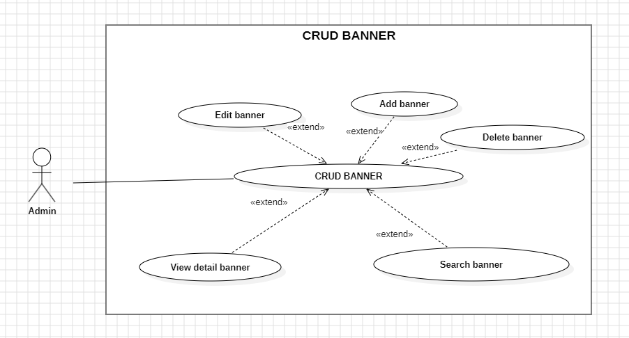

Figure 2.8 Use case banner management

Table 2.6 Scenario Use-case “Banner”

|  |  |
| --- | --- |
| **Use case name** | **Banner** |
| **Description** | Used to manage banner |
| **Actors** | Admin |
| **Input** | Actor successfully logged in with admin rights |
| **Output** | Show list of banner |
| **Basic flow** | 1. Actor clicks on the “Banner” menu in the side-bar -> Start Use case  2. Actor performs the necessary operations (view details, create, edit, delete, search) for the banner.  3. The system records and updates user edits if any. -> End of use case |
| **Alternative flow** |  |
| **Exception flow** | If the edited information is invalid (incorrect format, empty task name, etc.), the system will display an error message and request re-editing. |

### Brand

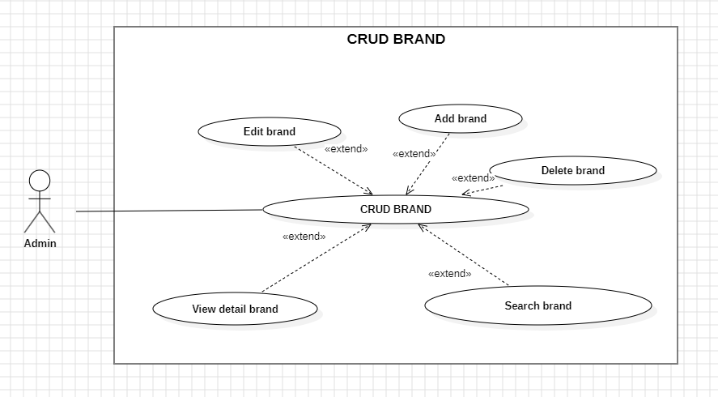

Figure 2.9 Use case brand management

Table 2.7 Scenario Use-case “Brand”

|  |  |
| --- | --- |
| **Use case name** | **Brand** |
| **Description** | Used to manage brand |
| **Actors** | Admin |
| **Input** | Actor successfully logged in with admin rights |
| **Output** | Show list of brand |
| **Basic flow** | 1. Actor clicks on the “Brand” menu in the side-bar -> Start Use case  2. Actor performs the necessary operations (view details, create, edit, search) for the brand.  3. The system records and updates user edits if any. -> End of use case |
| **Alternative flow** |  |
| **Exception flow** | If the edited information is invalid (incorrect format, empty task name, etc.), the system will display an error message and request re-editing. |

### Category

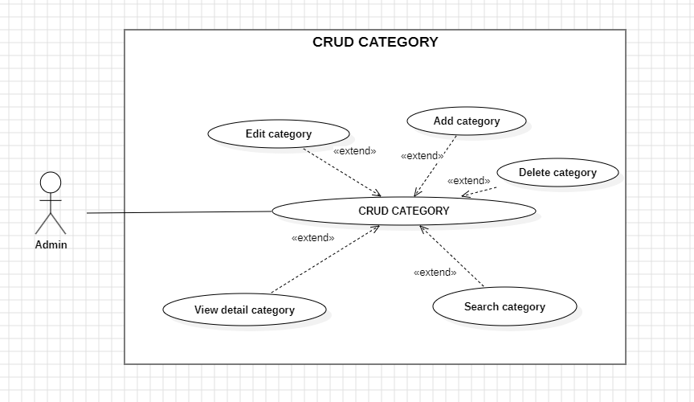

Figure 2.10 Use case category management

Table 2.8 Scenario Use-case “Category”

|  |  |
| --- | --- |
| **Use case name** | **Category** |
| **Description** | Used to manage category |
| **Actors** | Admin |
| **Input** | Actor successfully logged in with admin rights |
| **Output** | Show list of category |
| **Basic flow** | 1. Actor clicks on the “Category” menu in the side-bar -> Start Use case  2. Actor performs the necessary operations (view details, create, edit, delete, search) for the category.  3. The system records and updates user edits if any. -> End of use case |
| **Alternative flow** |  |
| **Exception flow** | If the edited information is invalid (incorrect format, empty task name, etc.), the system will display an error message and request re-editing. |

### Media

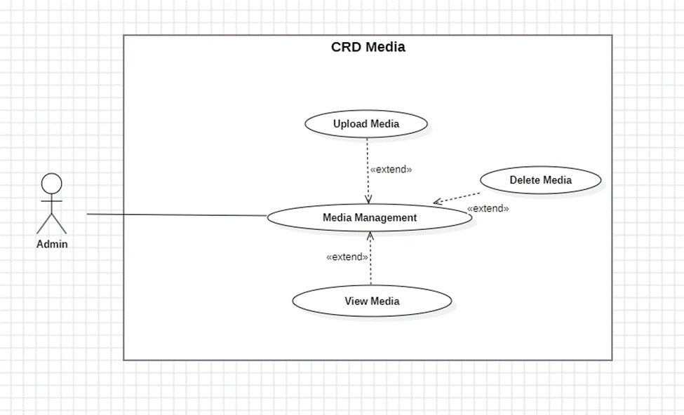

Figure 2.11 Use case media management

Table 2.9 Scenario Use-case “Media”

|  |  |
| --- | --- |
| **Use case name** | **Media** |
| **Description** | Used to manage media |
| **Actors** | Admin |
| **Input** | Actor successfully logged in with admin rights |
| **Output** | Show list of media |
| **Basic flow** | 1. Actor clicks on the “Media” menu in the side-bar -> Start Use case  2. Actor performs the necessary operations (view details, create, delete, search) for the media.  3. The system records user uploads if any. -> End of use case |
| **Alternative flow** |  |
| **Exception flow** | If the newly created information is invalid (incorrect format, empty task name, etc.), the system will display an error message and ask for correction. |

### Order

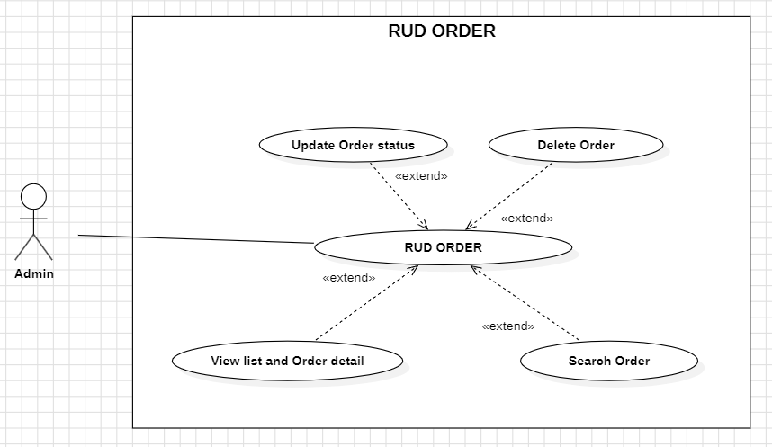

Figure 2.12 Use case order management

Table 2.10 Scenario Use-case “Order”

|  |  |
| --- | --- |
| **Use case name** | **Order** |
| **Description** | Used to manage order |
| **Actors** | Admin |
| **Input** | Actor successfully logged in with admin rights |
| **Output** | Show list of order |
| **Basic flow** | 1. Actor clicks on the “Order” menu in the side-bar -> Start Use case  2. Actor performs the necessary operations (view details, edit, delete, search) for the order.  3. The system records and updates user edits if any. -> End of use case |
| **Alternative flow** |  |
| **Exception flow** | If the edited information is invalid (incorrect format, empty task name, etc.), the system will display an error message and request re-editing. |

### Profile

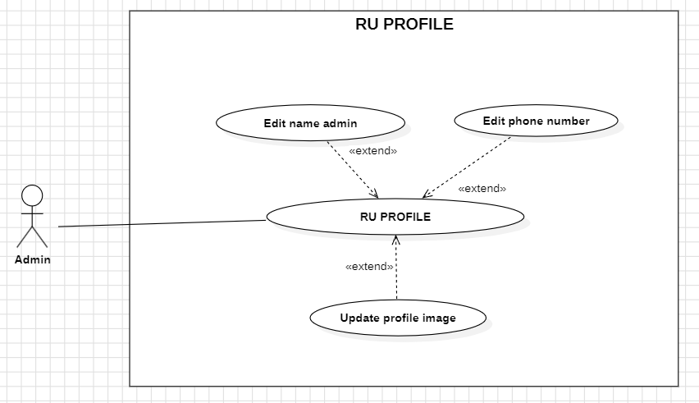

Figure 2.13 Use case profile management

Table 2.11 Scenario Use-case “Profile”

|  |  |
| --- | --- |
| **Use case name** | **Profile** |
| **Description** | Used to manage profile |
| **Actors** | Admin |
| **Input** | Actor successfully logged in with admin rights |
| **Output** | Show profile detail |
| **Basic flow** | 1. Actor clicks on the “Profile” menu in the side-bar -> Start Use case  2. Actor performs the necessary operations (view details, edit) for the profile.  3. The system records and updates user edits if any. -> End of use case |
| **Alternative flow** |  |
| **Exception flow** | If the edited information is invalid (incorrect format, empty task name, etc.), the system will display an error message and request re-editing. |

### Setting

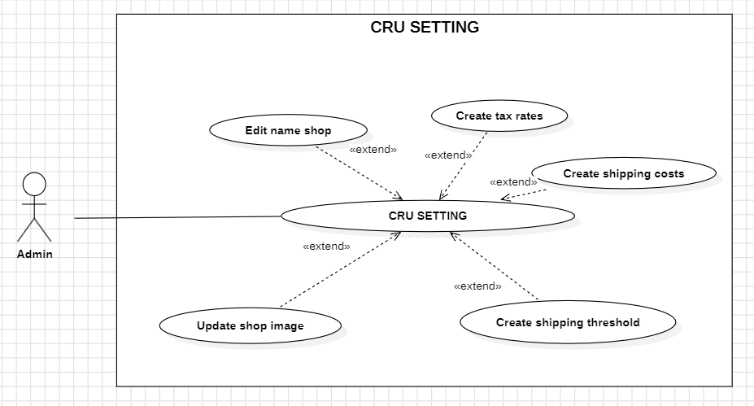

Figure 2.14 Use case setting management

Table 2.12 Scenario Use-case “Setting”

|  |  |
| --- | --- |
| **Use case name** | **Setting** |
| **Description** | Used to manage setting |
| **Actors** | Admin |
| **Input** | Actor successfully logged in with admin rights |
| **Output** | Show setting detail |
| **Basic flow** | 1. Actor clicks on the “Setting” menu in the side-bar -> Start Use case  2. Actor performs the necessary operations (view details, create, edit) for the setting.  3. The system records and updates user edits if any. -> End of use case |
| **Alternative flow** |  |
| **Exception flow** | If the edited information is invalid (incorrect format, empty task name, etc.), the system will display an error message and request re-editing. |

## Workflow Diagram

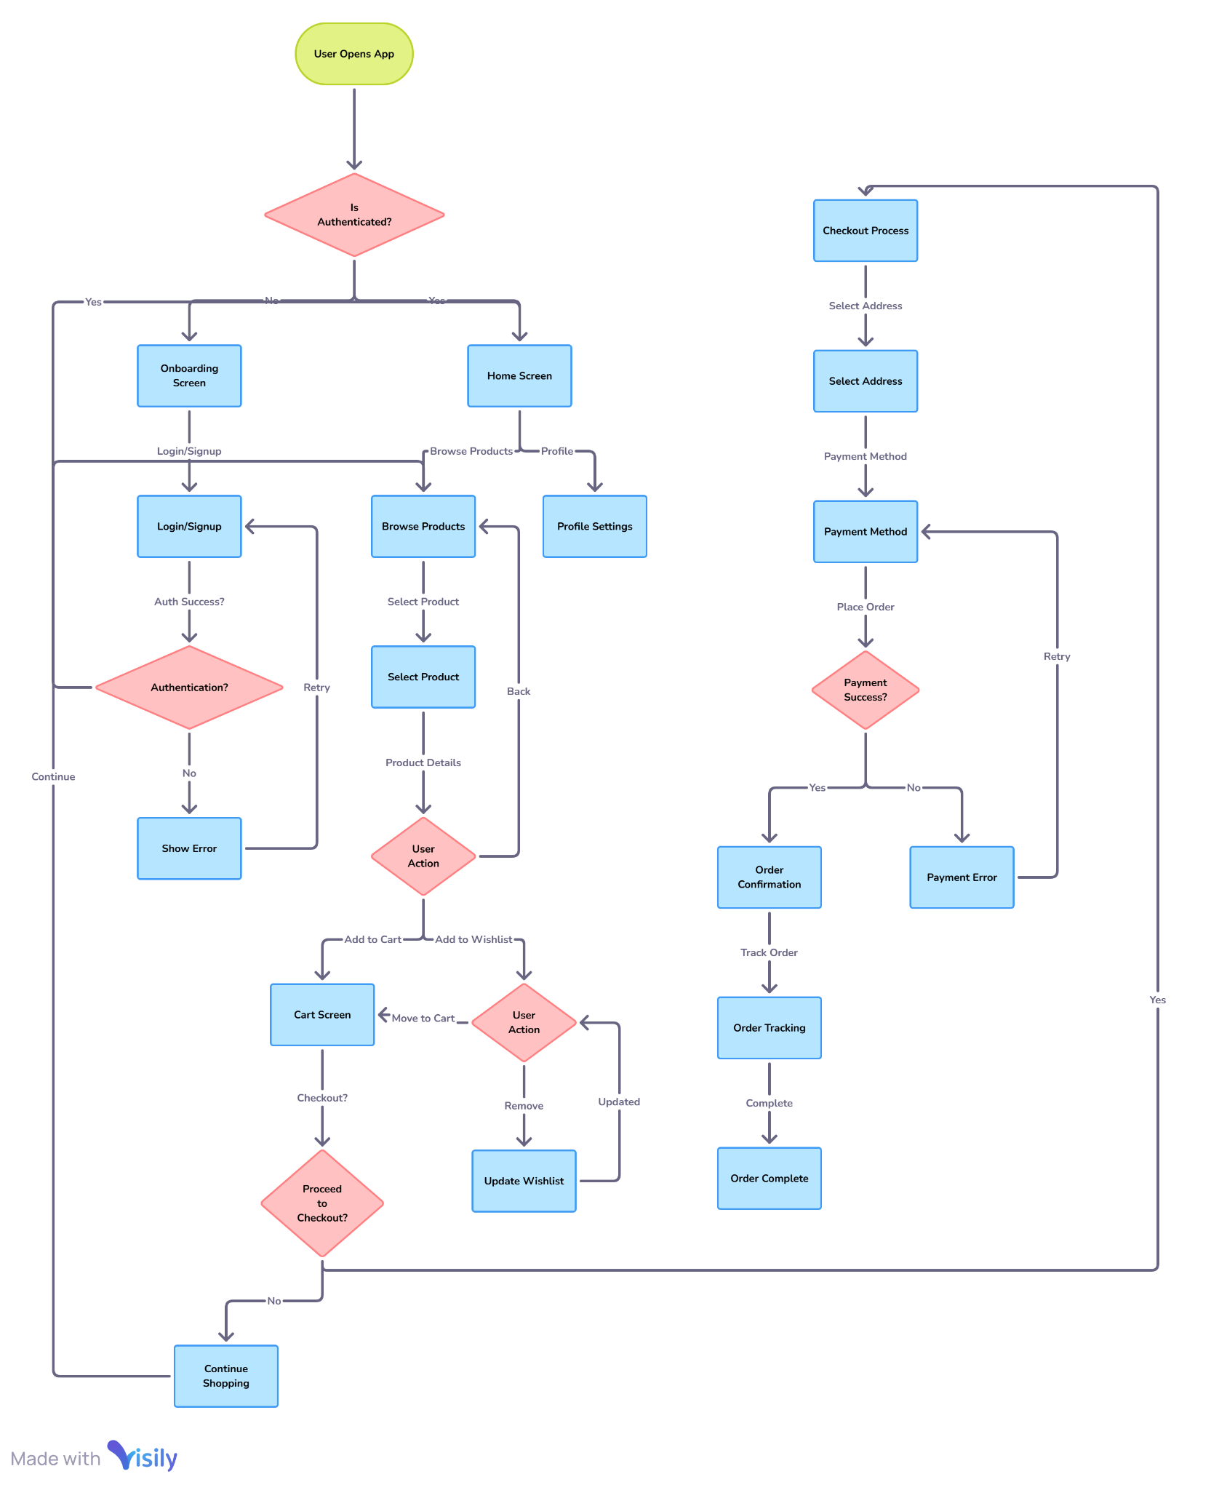

Figure 2.15 Workflow diagram

## Operational diagram

### Register and login

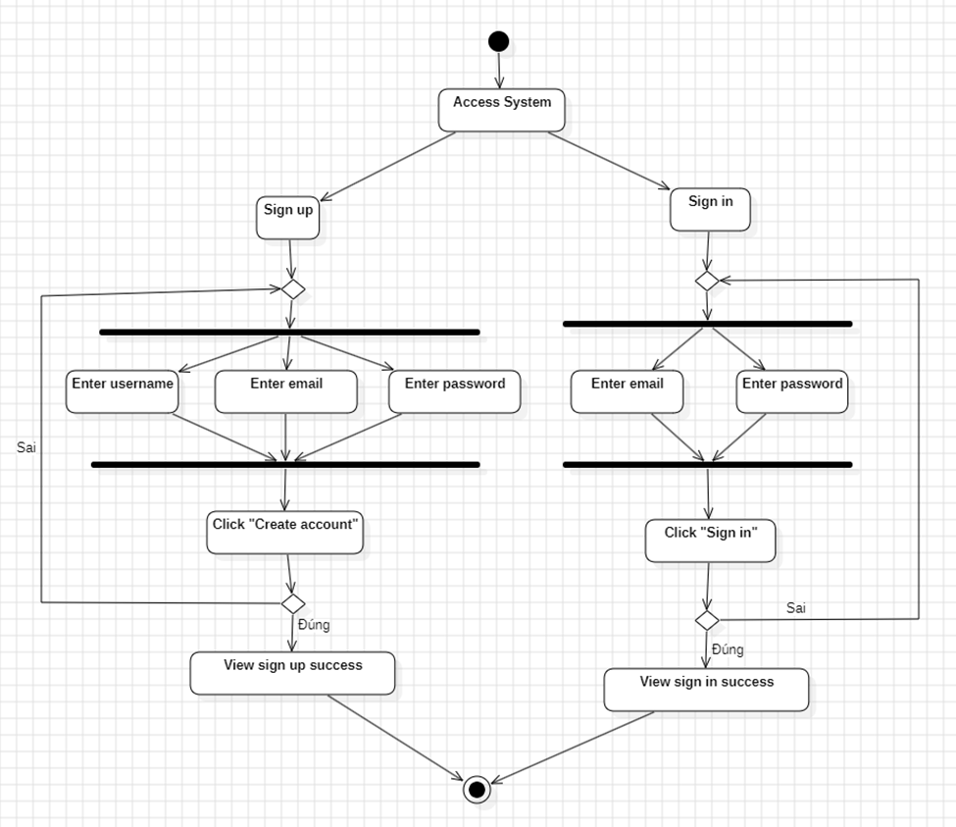

*Figure 2.16 Activity “Register and Login”*

### User

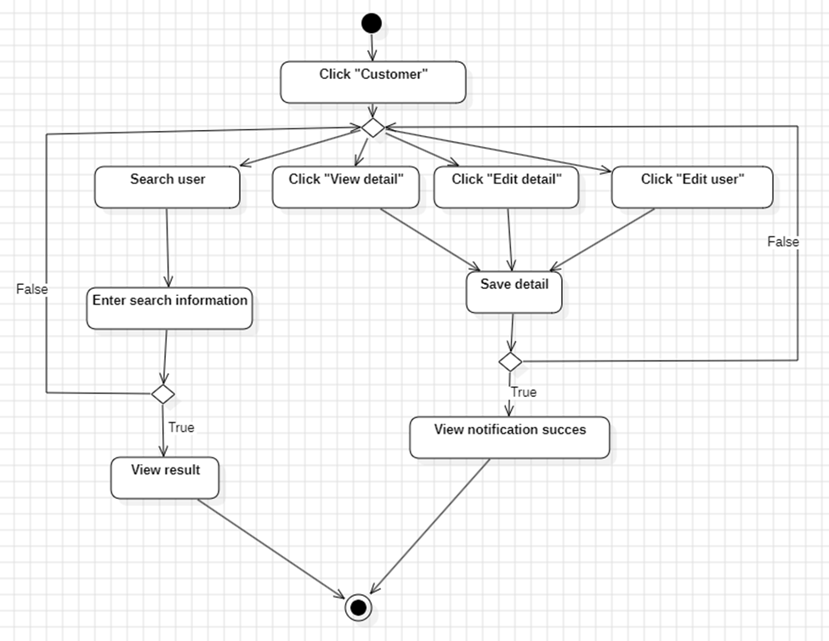

*Figure 2.17 Activity “User”*

### Banner

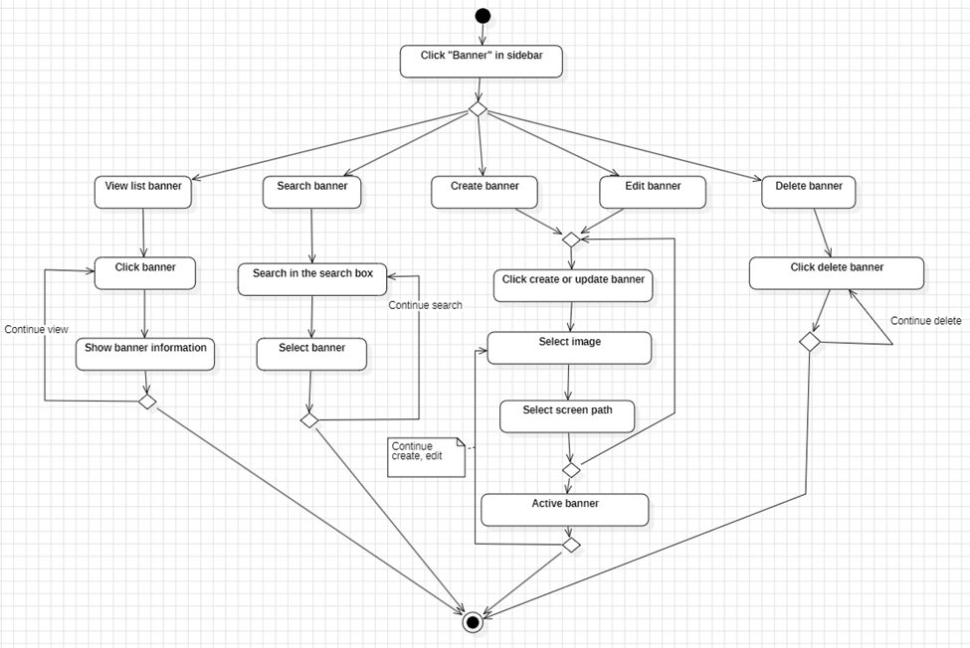

*Figure 2.* *18 Activity “Banner”*

### Brand

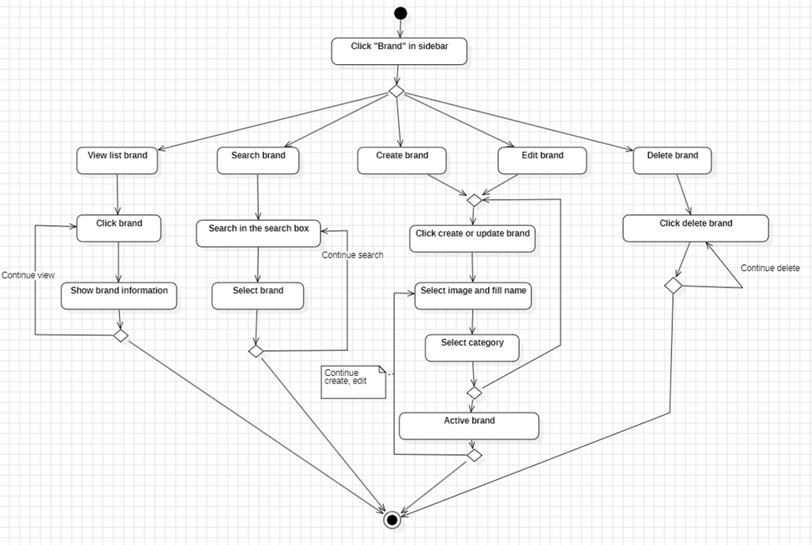

*Figure 2.* *19 Activity “Brand”*

### Category

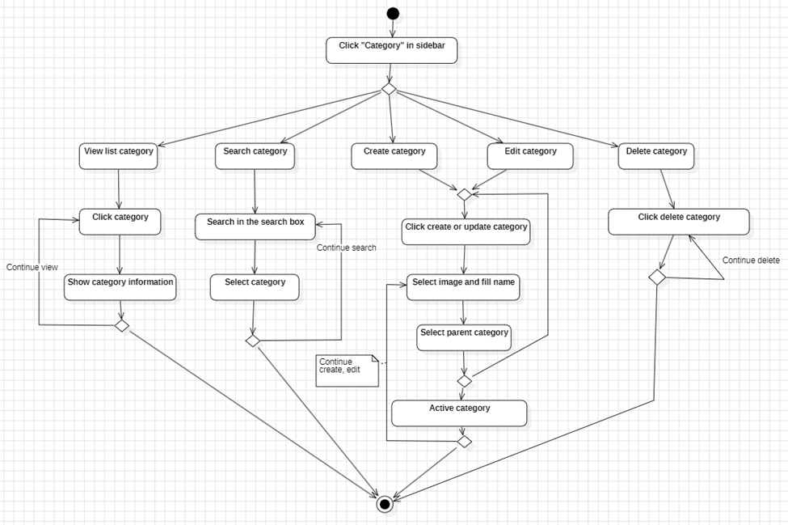

*Figure 2.* *20 Activity “Category”*

### Product

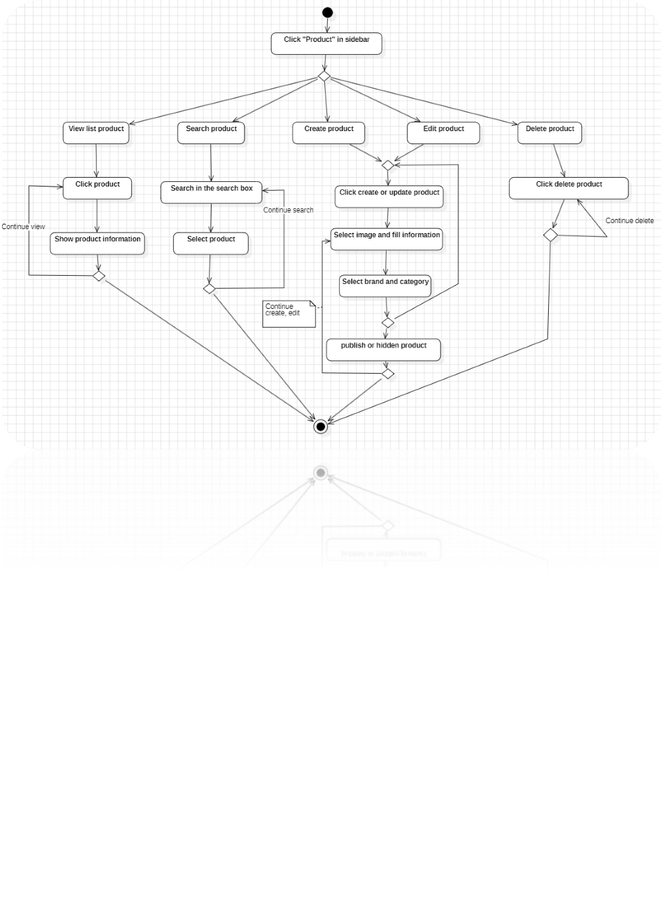

*Figure 2.* *21 Activity “Product”*

### Order

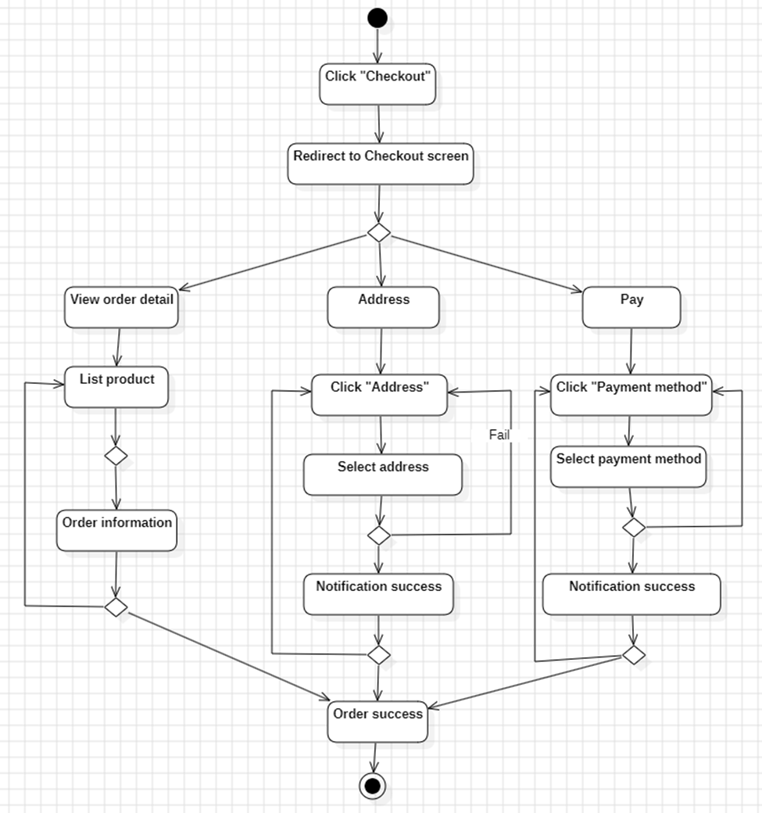

*Figure 2.22 Activity “Order”*

## Sequential sketch

### Register

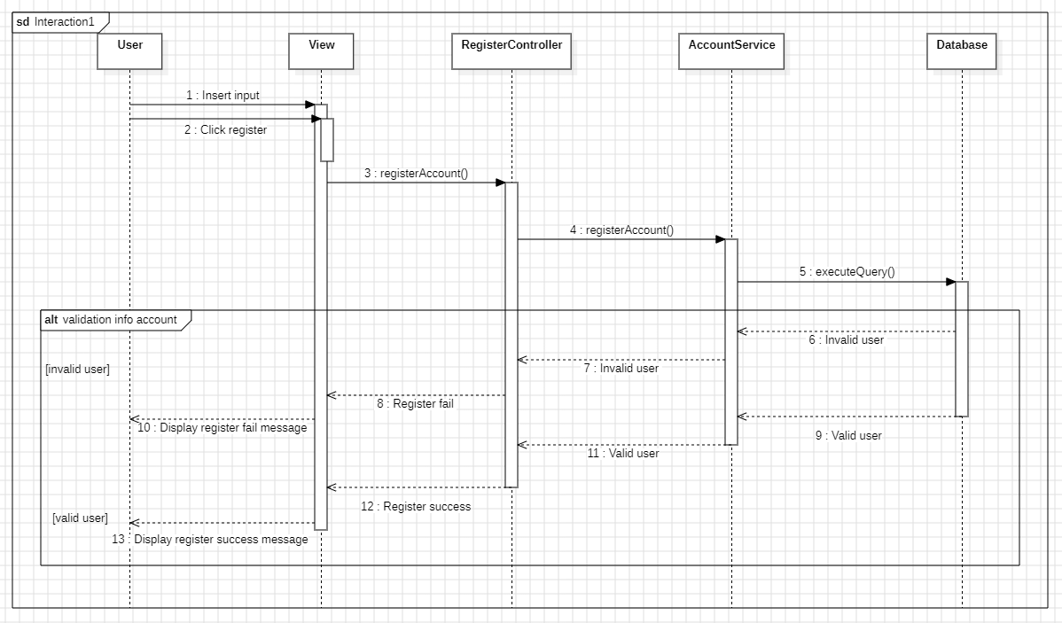

Figure 2.16 Sequential Sketch Register

### Login

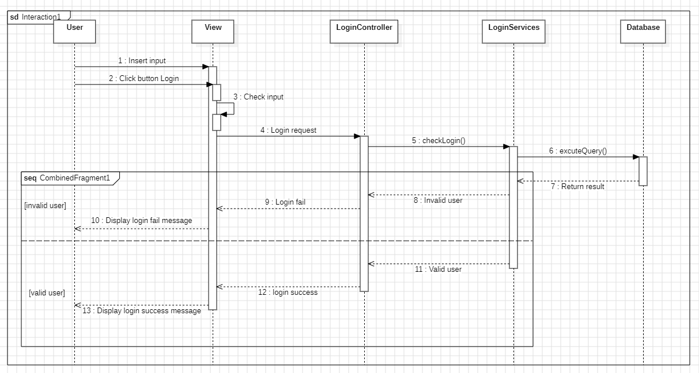

Figure 2.17 Sequential Sketch Login

### Product

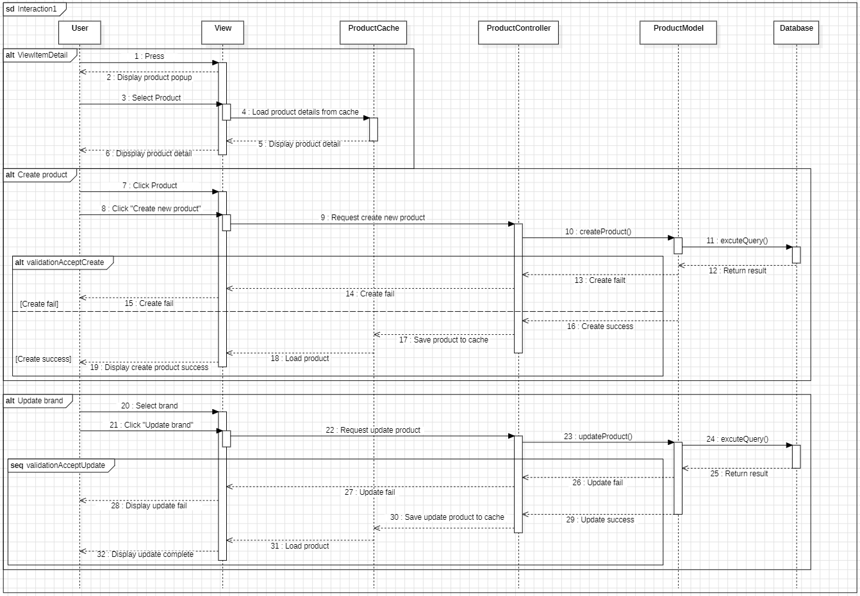

Figure 2.18 Sequential sketch Product

### Banner

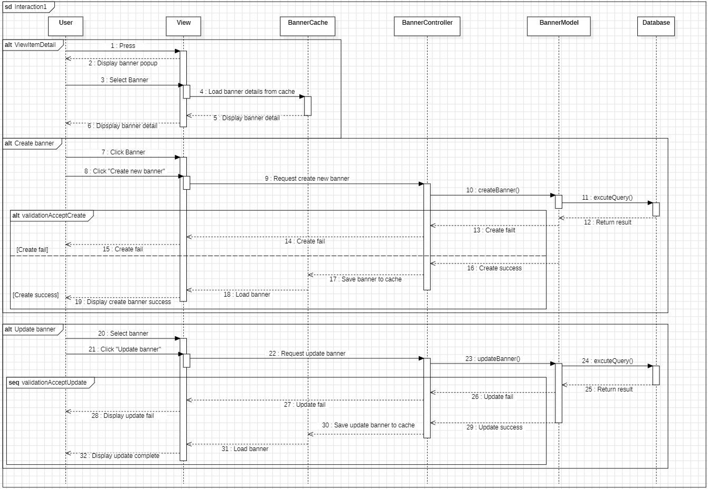

Figure 2.19 Sequential sketch Banner

### Brand

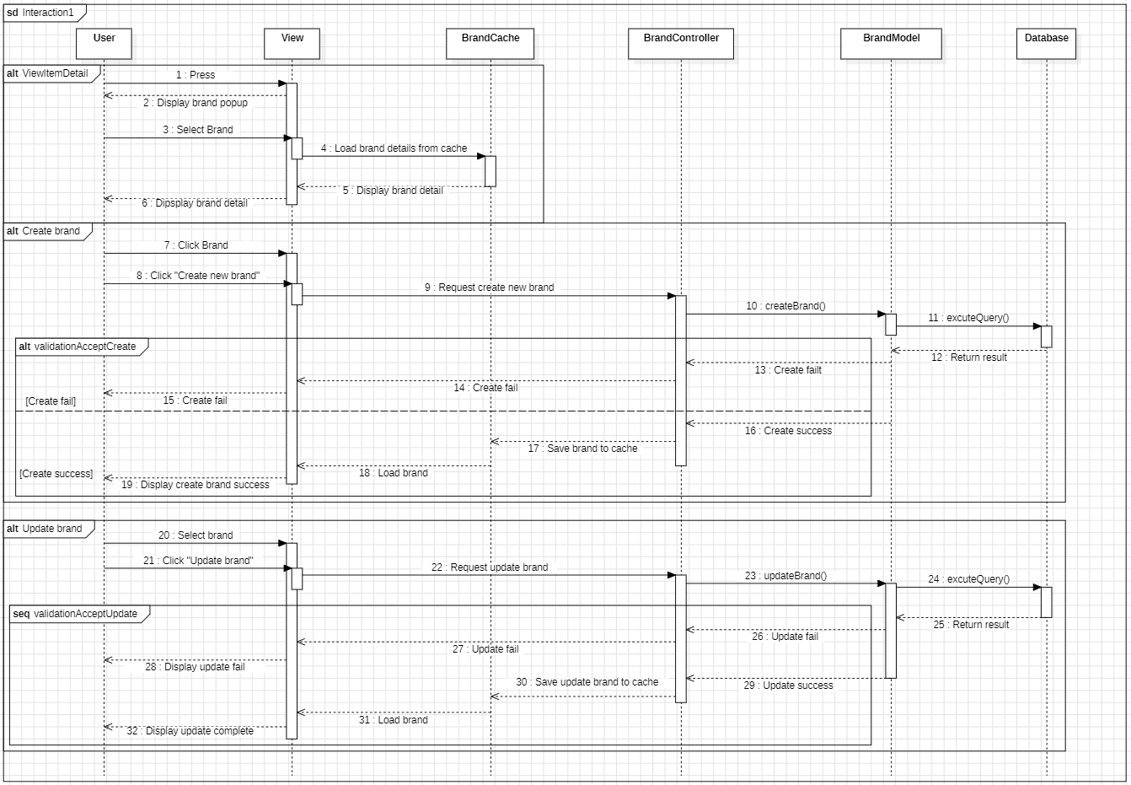

Figure 2.20 Sequential sketch Brand

### Category

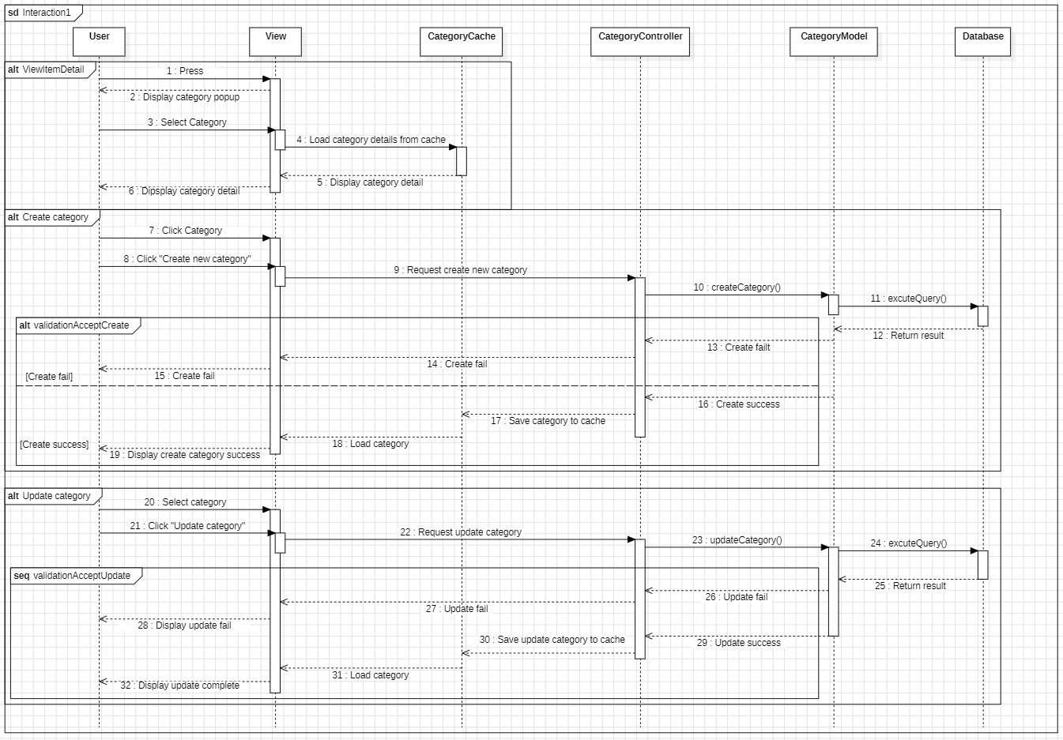

Figure 2.21 Sequential Sketch Category

### Order

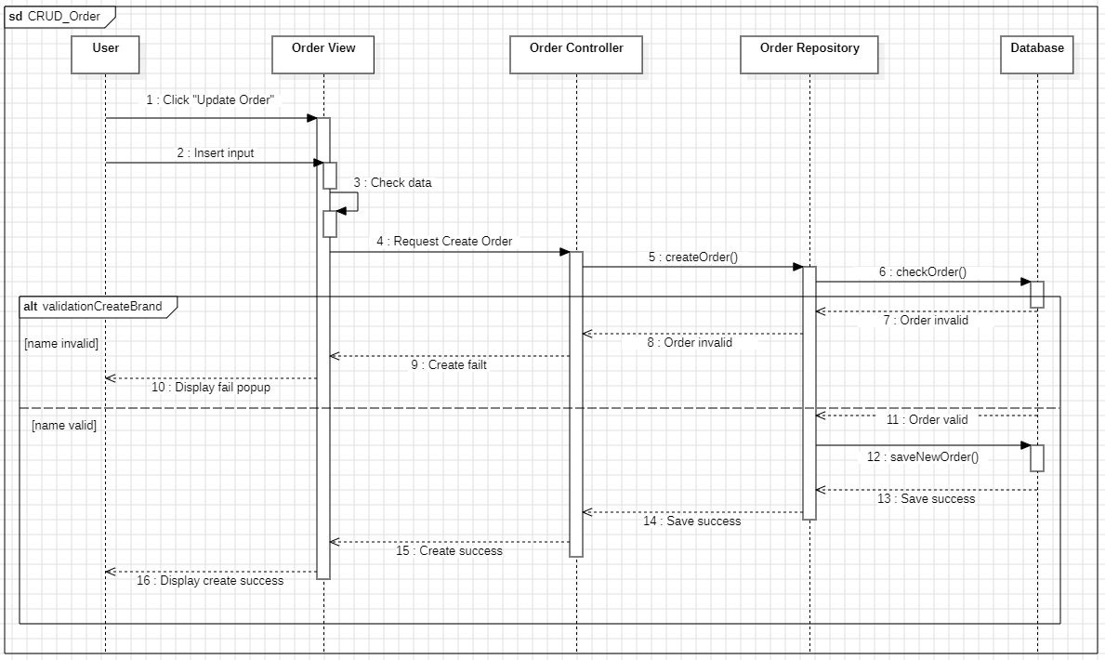

Figure 2.22 Sequential sketch Order

### Media

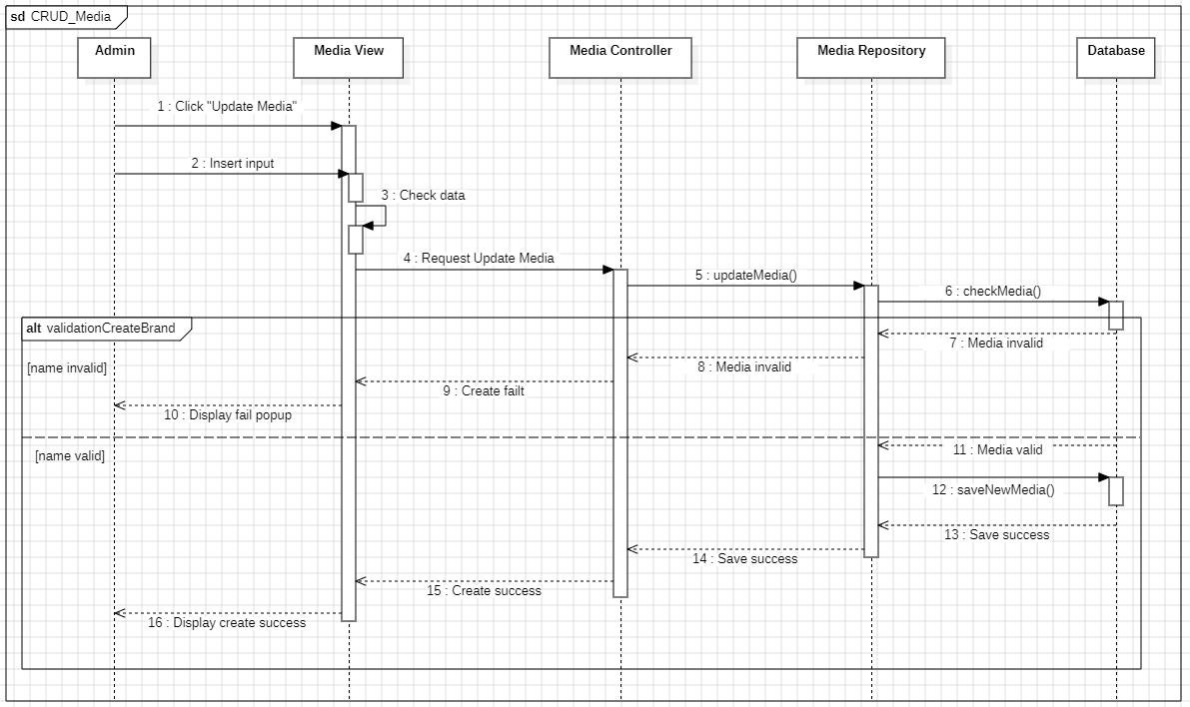

Figure 2.23 Sequential sketch Media

### Shopping cart Management

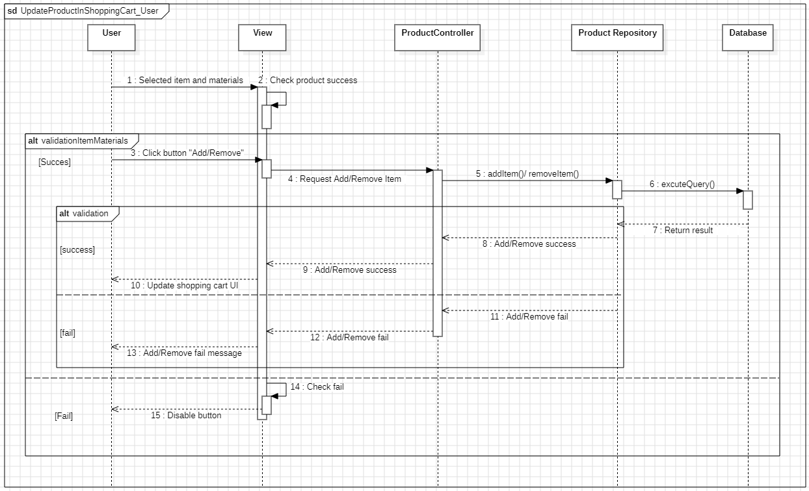

Figure 2.24 Sequential Sketch Shopping Cart

### User Management

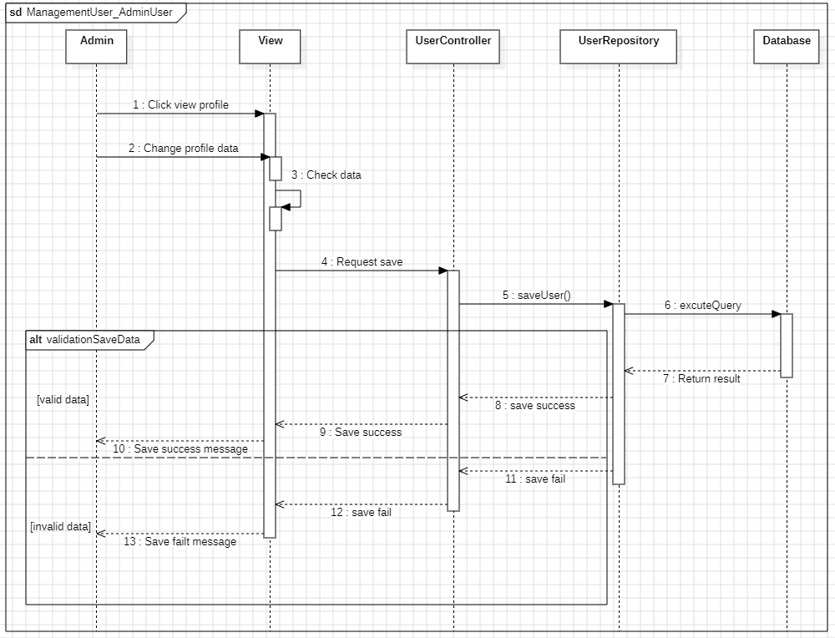

Figure 2.25 Sequential Sketch User

## Class diagram

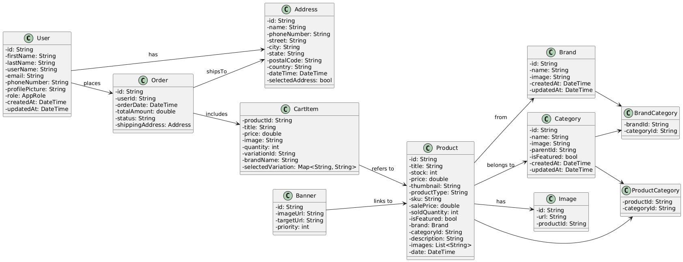

Figure 2.26 Class Diagram

## Database Table Design

### User

Table 2.13 “User” database

|  |  |  |  |
| --- | --- | --- | --- |
| **Attribute** | **Describe** | **Type data** | **Note** |
| id | User unique identifier | String? | Optional |
| firstName | User first name | String |  |
| lastName | User last name | String |  |
| userName | User username | String |  |
| email | User email address | String | Required |
| phoneNumber | User phone number | String |  |
| profilePicture | User profile picture URL | String |  |
| role | User role in system | AppRole | Default: user |
| createdAt | Account creation date | DateTime? | Optional |
| updatedAt | Last update date | DateTime? | Optional |
| orders | User order history | List<OrderModel>? | Optional |
| addresses | User saved addresses | List<AddressModel>? | Optional |

### Address

*Table 2.14 “Address” database*

|  |  |  |  |
| --- | --- | --- | --- |
| **Attribute** | **Describe** | **Type data** | **Note** |
| id | Address unique identifier | String | Required |
| name | Recipient name | String | Required |
| phoneNumber | Recipient phone number | String | Required |
| street | Street address | String | Required |
| city | City name | String | Required |
| state | State/Province | String | Required |
| postalCode | Postal/ZIP code | String | Required |
| country | Country name | String | Required |
| dateTime | Address creation date | DateTime? | Optional |
| selectedAddress | Is selected address | bool | Default: true |

### CartItem

Table 2.15 “CartItem” database

|  |  |  |  |
| --- | --- | --- | --- |
| **Attribute** | **Describe** | **Type data** | **Note** |
| productId | Product identifier | String | Required |
| title | Product title | String | Default: '' |
| price | Product price | double | Default: 0.0 |
| image | Product image URL | String? | Optional |
| quantity | Item quantity | int | Required |
| variationId | Product variation ID | String | Default: '' |
| brandName | Product brand name | String? | Optional |
| selectedVariation | Selected variation options | Map<String, String>? | Optional |

### Order

Table 2.16 “Order” database

|  |  |  |  |
| --- | --- | --- | --- |
| **Attribute** | **Describe** | **Type data** | **Note** |
| id | Order unique identifier | String | Required |
| docId | Document ID in Firebase | String | Default: '' |
| userId | User identifier | String | Default: '' |
| status | Order status | OrderStatus | Required |
| totalAmount | Total order amount | double | Required |
| shippingCost | Shipping cost | double | Required |
| taxCost | Tax amount | double | Required |
| orderDate | Order creation date | DateTime | Required |
| paymentMethod | Payment method used | String | Default: 'Cash on Delivery' |
| shippingAddress | Shipping address | AddressModel? | Optional |
| billingAddress | Billing address | AddressModel? | Optional |
| deliveryDate | Expected delivery date | DateTime? | Optional |
| items | Order items list | List<CartItemModel> | Required |
| billingAddressSameAsShipping | Same billing and shipping address | bool | Default: true |

### Banner

Table 2.17 “Banner” database

|  |  |  |  |
| --- | --- | --- | --- |
| **Attribute** | **Describe** | **Type data** | **Note** |
| id | Banner unique identifier | String? | Optional |
| imageUrl | Banner image URL | String | Required |
| active | Is banner active | bool | Required |
| targetScreen | Target screen navigation | String | Required |

### 

### Product

Table 2.18 “Product” database

|  |  |  |  |
| --- | --- | --- | --- |
| **Attribute** | **Describe** | **Type data** | **Note** |
| id | Product unique identifier | String | Required |
| title | Product title | String | Required |
| stock | Available stock quantity | int | Required |
| price | Product price | double | Required |
| thumbnail | Product thumbnail image | String | Required |
| productType | Product type classification | String | Required |
| sku | Stock Keeping Unit | String? | Optional |
| salePrice | Sale/discount price | double | Default: 0.0 |
| soldQuantity | Total sold quantity | int | Default: 0 |
| isFeatured | Is featured product | bool? | Optional |
| brand | Product brand | BrandModel? | Optional |
| categoryId | Category identifier | String? | Optional |
| description | Product description | String? | Optional |
| images | Product images list | List<String>? | Optional |
| date | Product creation date | DateTime? | Optional |
| productAttributes | Product attributes list | List<ProductAttributeModel>? | Optional |
| productVariations | Product variations list | List<ProductVariationModel>? | Optional |

### Category

Table 2.19 “Category” database

|  |  |  |  |
| --- | --- | --- | --- |
| **Attribute** | **Describe** | **Type data** | **Note** |
| id | Category unique identifier | String | Required |
| name | Category name | String | Required |
| image | Category image URL | String | Required |
| parentId | Parent category ID | String | Default: '' |
| isFeatured | Is featured category | bool | Default: false |
| createdAt | Category creation date | DateTime? | Optional |
| updatedAt | Last update date | DateTime? | Optional |

### Brand

Table 2.20 “Brand” database

|  |  |  |  |
| --- | --- | --- | --- |
| **Attribute** | **Describe** | **Type data** | **Note** |
| id | Brand unique identifier | String | Required |
| name | Brand name | String | Required |
| image | Brand logo/image URL | String | Required |
| isFeatured | Is featured brand | bool | Default: false |
| productsCount | Number of products | int? | Optional |
| createdAt | Brand creation date | DateTime? | Optional |
| updatedAt | Last update date | DateTime? | Optional |
| brandCategories | Brand categories list | List<CategoryModel>? | Not mapped |

### Image

Table 2.21 “Image” database

|  |  |  |  |
| --- | --- | --- | --- |
| **Attribute** | **Describe** | **Type data** | **Note** |
| id | Image unique identifier | String | Default: '' |
| url | Image download URL | String | Required |
| folder | Storage folder path | String | Required |
| filename | Image filename | String | Required |
| sizeBytes | File size in bytes | int? | Optional |
| mediaCategory | Media category type | String | Default: '' |
| fullPath | Full storage path | String? | Optional |
| createdAt | Image creation date | DateTime? | Optional |
| updatedAt | Last update date | DateTime? | Optional |
| contentType | File MIME type | String? | Optional |
| file | HTML File object | File? | Not mapped |
| isSelected | Selection state | RxBool | Not mapped |
| localImageToDisplay | Local image bytes | Uint8List? | Not mapped |

### ProductCategory

Table 2.22 “ProductCategory” database

|  |  |  |  |
| --- | --- | --- | --- |
| **Attribute** | **Describe** | **Type data** | **Note** |
| id | Relation unique identifier | String | Default: '' |
| productId | Product identifier | String | Required |
| categoryId | Category identifier | String | Required |

### BrandCategory

Table 2.23 “BrandCategory” database

|  |  |  |  |
| --- | --- | --- | --- |
| **Attribute** | **Describe** | **Type data** | **Note** |
| id | Relation unique identifier | String? | Optional |
| brandId | Brand identifier | String | Required |
| categoryId | Category identifier | String | Required |

## Interface design

### User

#### Onboarding

When the user first installs and opens the application, the onboarding screen will appear. Onboarding consists of 3 screens, after clicking next on the 3rdonboarding screen, they will be redirected to the sign in screen.

|  |  |
| --- | --- |
| Figure 2.27 “Onboarding 1” interface | Figure 2.28 “Onboarding 2” interface |

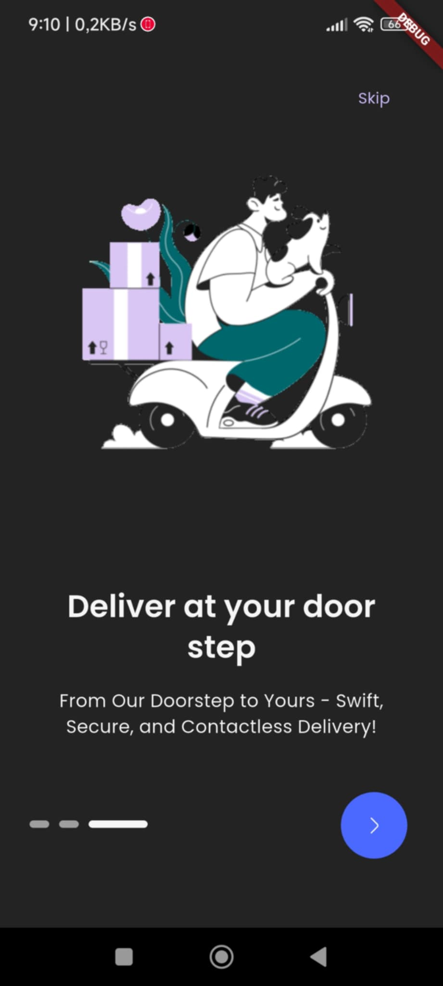

Figure 2.29 “Onboarding 3” interface

#### Login

In the login screen, if the user already has an account, they can enter their email and password to log in, or they can log in with their Google or Facebook account. If the user forgets their password, click "Forget password" to get a new password. Click "Remember me" if you want to save your account for future logins. If you don't have an account, click "Create account" to register for an account.

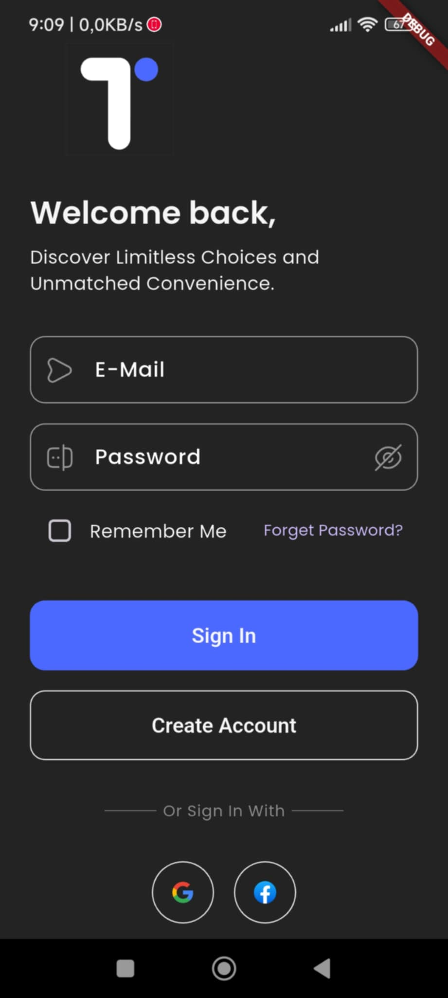

Figure 2.30 “Sign in” interface

Table 2.24 “Sign in” interface

|  |  |  |  |  |
| --- | --- | --- | --- | --- |
| **Interface** | Sign in | | | |
| **Describe** | The interface allows users to log in to use other functions. | | | |
| **Access** | User clicks on sign in button | | | |
| **Interface content** | | | | |
| **Item** | **Type** | **Data** | **Describe** | |
| Email | Textbox-String | N/A | Where to enter login email | |
| Password | Textbox-String | N/A | Where to enter password | |
| Remember Me | Button | N/A | Where to remember passwords | |
| Sign in | Linked Button | N/A | Log in to the system | |
| Forget Password | Linked Button | N/A | Leads to forgot password page | |
| Create account | Linked  Button | N/A | Leads to registration page | |
| **Work** | | | | |
| **Name** | **Describe** | | **Success** | **Failure** |
| No email entered | Do not enter email then press sign in button | |  | “Invalid email address” message |
| No password entered | Do not enter password then press sign in button | |  | “Password is required” message |
| Sign in with account and password | Process login to the system with the entered user name and password | | Redirect to home screen | “Something went wrong. Please try again” message |

#### Register

In the register screen, the user must enter all information in the correct format (firstname, lastname, username, email, phone number, password). Then must accept the terms of use. Next, click "Create account" to register an account. Or the user can log in directly with a google or facebook account without having to register.

|  |  |
| --- | --- |
| Figure 2.31 “Register 1” interface | Figure 2.32 “Register 2” interface |

Table 2.25 “Sign up” interface

|  |  |  |  |  |
| --- | --- | --- | --- | --- |
| **Interface** | Sign up | | | |
| **Describe** | Interface allows users to sign up for an account | | | |
| **Access** | User clicks on create account button | | | |
| **Interface content** | | | | |
| **Item** | **Type** | **Data** | **Describe** | |
| First name | Textbox-String | N/A | Where to enter first name | |
| Last name | Textbox-String | N/A | Where to enter last name | |
| Username | Textbox-String | N/A | Where to enter login name | |
| Email | Textbox-String | N/A | Where to enter email | |
| Password | Textbox-String | N/A | Where to enter password | |
| Phone Number | Textbox-String | N/A | Where to enter phone number | |
| Check box | Button | N/A | Accept the policy | |
| Create Account | Linked  Button | N/A | Leads to registration page | |
| Google sign in | Linked  Button | N/A | Log in with account Google | |
| **Work** | | | | |
| **Name** | **Describe** | | **Success** | **Failure** |
| No first name entered | Do not enter first name then press create account | |  | “First name is required” message |
| No last name entered | Do not enter last name then press create account | |  | “Last name is required” message |
| No username entered | Do not enter username then press create account | |  | “Username is required” message |
| No email entered | Do not enter email then press create account | |  | “Invalid email address” message |
| No phone number entered | Do not enter phone number then press create account | |  | “Phone number is required” message |
| No password entered | Do not enter password then press create account button | |  | “Password is required” message |
| No agree policy | Do not click agree checkbox | |  |  |
| Sign up with Google account | Sign in app with Google account | | Redirect to login screen | “Something went wrong. Please try again” message |

#### Forget Password

If you forget your password, user can click "Forget password" in the login screen. Then enter your email, check gmail and reset new password.

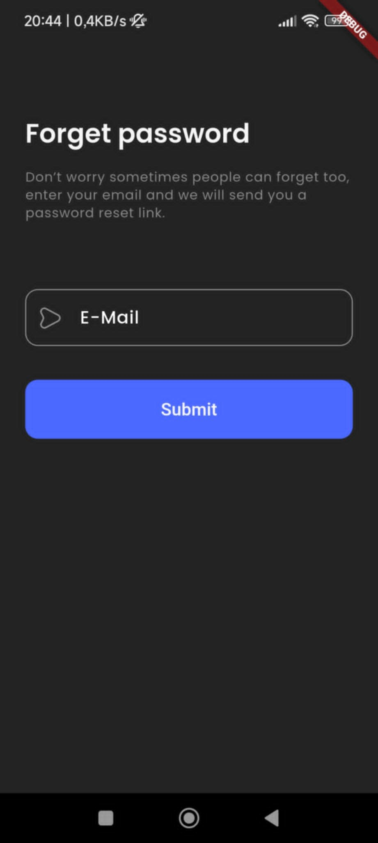

Figure 2.33 “Forget Password” interface

Table 2.26 “Forget” interface

|  |  |  |  |  |
| --- | --- | --- | --- | --- |
| **Interface** | Forget password | | | |
| **Describe** | Allow users to update their passwords | | | |
| **Access** | User clicks on “Forget password” button in sign in screen | | | |
| **Interface content** | | | | |
| **Item** | **Type** | **Data** | **Describe** | |
| Email | Textbox-String | N/A | Fill in registered email | |
| Submit | Linked Button | N/A | Confirm email | |
| **Work** | | | | |
| **Name** | **Describe** | | **Success** | **Failure** |
| Click Email | Fill in registered email | | Select the email of the account whose password you want to reset. |  |
| Click Favourite icon | Confirm email | | Password reset notification sent to email |  |

#### Home

In the home interface, user can see products in categories, popular products, advertising banners. User can also click on the shopping cart to see product details

|  |  |
| --- | --- |
| Figure 2.34 “Home 1” interface | Figure 2.35 “Home 2” interface |

Table 2.27 “Home” interface

|  |  |  |  |  |
| --- | --- | --- | --- | --- |
| **Interface** | Home | | | |
| **Describe** | The interface allows users to access the app to use other functions. | | | |
| **Access** | User clicks on “Sign in” button | | | |
| **Interface content** | | | | |
| **Item** | **Type** | **Data** | **Describe** | |
| Text heading | Text | N/A | Greeting and username | |
| Shopping cart | Linked  Button | N/A | Show cart details | |
| Search | Textbox-String | N/A | Search for products and brands | |
| Popular Category | Linked  Button | N/A | Featured categories | |
| Banner | Linked  Button | N/A | Navigate to the screens | |
| Popular Product | Linked  Button | N/A | Featured products | |
| **Work** | | | | |
| **Name** | **Describe** | | **Success** | **Failure** |
| Click shopping cart | View products in shopping cart | | Redirect to shopping cart screen |  |
| Click search | Search for products and brands | | Redirect to search screen |  |
| Banner roll | Scroll the banner left or right | | View other banners |  |
| Click “View all” button in popular products | View all product | | Redirect to all product screen |  |

#### Shopping cart

When the user clicks on the shopping cart icon on the home screen, the shopping cart details can be viewed. The user can add, reduce or delete products in the shopping cart. If the user wants to pay for the order, click "Checkout"

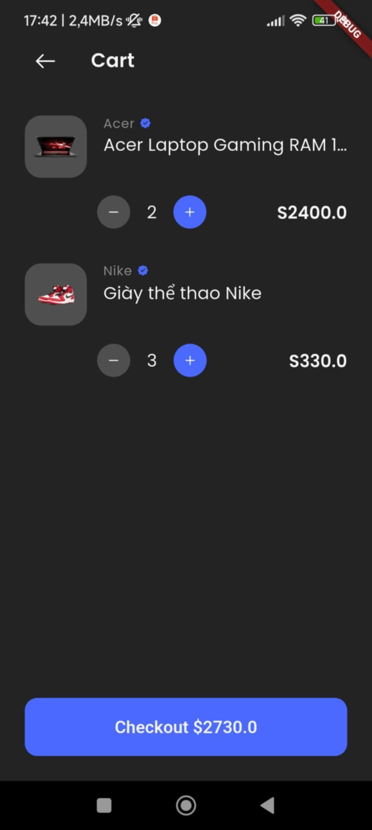

Figure 2.36 “Register” interface

Table 2.28 “Shopping cart” interface

|  |  |  |  |  |  |
| --- | --- | --- | --- | --- | --- |
| **Interface** | Shopping cart | | | | |
| **Describe** | | Allows users to manage items in their shopping cart | | | |
| **Access** | | User clicks on “Shopping cart” button | | | |
| **Interface content** | | | | | |
| **Item** | | **Type** | **Data** | **Describe** | |
| Name screen | | Text | N/A | Name of screen is Cart | |
| Product | | List | N/A | List of items in shopping cart | |
| Check out | | Linked  Button | N/A | Redirect to order screen | |
| **Work** | | | | | |
| **Name** | | **Describe** | | **Success** | **Failure** |
| Click - button | | Remove product quantity | | Each time you press the products quantity decreases by 1 |  |
| Click + button | | Add product quantity | | Each time you press the product quantity increases by 1 |  |
| Click Check out button | | Pay for the product | | Redirect to checkout screen to check information |  |

#### Checkout

In the checkout screen, users can view the details of the order they want to pay for (fees, prices, product quantities). They can choose the payment method (Paypal, Google pay, Apple pay, Master card, Visa) and address. Users can check the information before purchasing.

|  |  |
| --- | --- |
| Figure 2.37 “Checkout 1” interface | Figure 2.38 “Checkout 2” interface |

|  |  |
| --- | --- |
| Figure 2.39 “Checkout 3” interface | Figure 2.40 “Checkout 4” interface |

Table 2.29 “Checkout” interface

|  |  |  |  |  |
| --- | --- | --- | --- | --- |
| **Interface** | Checkout | | | |
| **Describe** | Allows users to checkout product | | | |
| **Access** | User clicks on “Checkout” button in shopping cart | | | |
| **Interface content** | | | | |
| **Item** | **Type** | **Data** | **Describe** | |
| Name screen | Text | N/A | Name of screen is Order Review | |
| Product | List | N/A | List of product in shopping cart | |
| Coupon | Textbox-String | N/A | Redirect to order screen | |
| Bill | Text | N/A | Invoice information | |
| Payment method | List | N/A | Choose payment method | |
| Address | List | N/A | Choose address or create address | |
| Checkout | Linked  Button | N/A | Redirect to the order success screen | |
| **Work** | | | | |
| **Name** | **Describe** | | **Success** | **Failure** |
| Click change payment method button | Choose payment method | | Successfully change the payment method |  |
| Click change address | Choose address or create address | | Successfully change the payment method or create new address |  |
| Click Check out button | Pay for the product | | Redirect to the order success screen |  |

#### Search

When the user clicks on the search box in the home screen or store, they can search for products or brands.

|  |  |
| --- | --- |
| Figure 2.41 “Search 1” interface | Figure 2.42 “Search 2” interface |

Table 2.30 “Search” interface

|  |  |  |  |  |  |
| --- | --- | --- | --- | --- | --- |
| **Interface** | Search | | | | |
| **Describe** | Allows users to search product or brand | | | |
| **Access** | User clicks on “Search” button | | | |
| **Interface content** | | | | | |
| **Item** | **Type** | **Data** | **Describe** | |
| Search box | Textbox-String | N/A | Enter the product or brand name you want to search for | |
| Brand | List | N/A | List of featured brands | |
| Product | List | N/A | List of Popular products | |
| **Work** | | | | | |
| **Name** | **Describe** | | **Success** | **Failure** |
| Click search box | Enter the product or brand name you want to search for | | Display suggestions by product name or brand you want to search for |  |
| Click brand icon button | Choose brand | | Redirect to brand detail screen |  |
| Click “View all” button in featured brands | View all brand | | Redirect to all brand screen |  |
| Click icon product button | Choose product | | Redirect to product detail screen |  |
| Click “View all” button in popular products | View all product | | Redirect to all product screen |  |

#### Category

In the category screen, the user can see all the products in that category

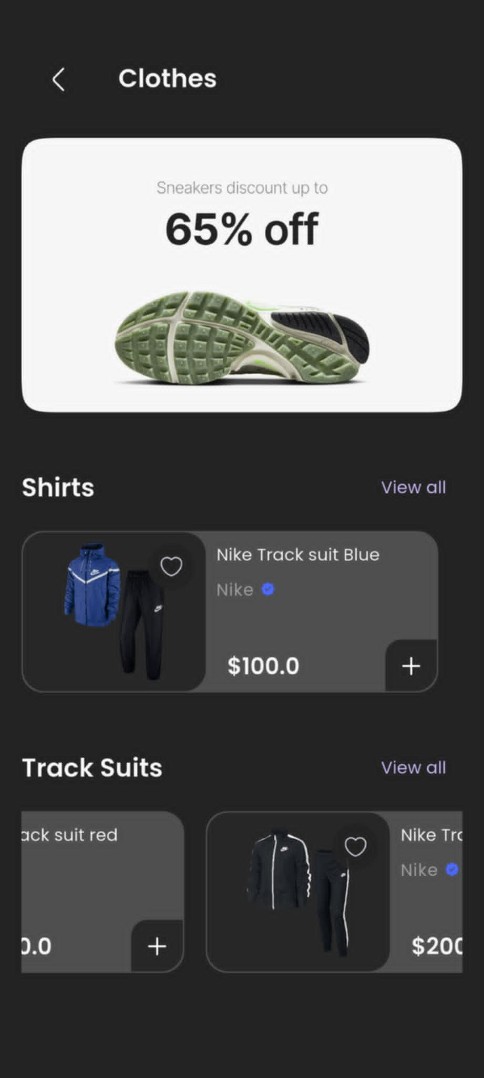

Figure 2.43 “Category” interface

Table 2.31 “Category” interface

|  |  |  |  |  |
| --- | --- | --- | --- | --- |
| **Interface** | Category | | | |
| **Describe** | Allows users to view detail category | | | |
| **Access** | User clicks on “Category icon” button in home | | | |
| **Interface content** | | | | |
| **Item** | **Type** | **Data** | **Describe** | |
| Name screen | Text | N/A | Name of category | |
| Banner | Image | N/A | Banner for category | |
| Child category | List | N/A | List of child category | |
| **Work** | | | | |
| **Name** | **Describe** | | **Success** | **Failure** |
| Click icon product button | Choose product | | Redirect to product detail screen |  |
| Click “View all” button in child category | View all product | | Redirect to all product screen |  |

#### Product

In the product detail screen, users can see product images, price, status, brand, variations such as color, material... Users can add products to cart.

|  |  |
| --- | --- |
| Figure 2.44 “Product 1” interface | Figure 2.45 “Product 2” interface |

Table 2.32 “Product” interface

|  |  |  |  |  |
| --- | --- | --- | --- | --- |
| **Interface** | Product | | | |
| **Describe** | Allows users to view detail product | | | |
| **Access** | User clicks on “product icon” button | | | |
| **Interface content** | | | | |
| **Item** | **Type** | **Data** | **Describe** | |
| Image product | Image | N/A | Banner for category | |
| Thumbnail image | Image | N/A | List of image product | |
| Favourite icon | Button | N/A | Add product to wishlist | |
| Price | Number | N/A | Price of the product | |
| Name product | Text | N/A | Name of product | |
| Status | Text | N/A | Status of product: In stock or out stock | |
| Brand | Text | N/A | Brand of product | |
| Variation | Text | N/A | Variation of product : Size, Color, Material … | |
| Checkout button | Linked Button | N/A | Redirect to checkout screen | |
| Description | Text | N/A | Description for product | |
| Review | Linked Button | N/A | Redirect to review screen | |
| Add, Remove button | Button | N/A | Increase or decrease the quantity of products | |
| Add to cart button | Linked Button | N/A | Add products to shopping cart | |
| **Work** | | | | |
| **Name** | **Describe** | | **Success** | **Failure** |
| Click thumbnail image | View product thumbnails | | Display thumbnail image |  |
| Click favourite icon | Add product to wishlist | | The product were added to wishlist |  |
| Click variable | Choose variation of product | | Display price, status, description of variation |  |

#### All Product

In the product detail screen, users can see product images, price, status, brand, variations such as color, material... Users can add products to cart.

|  |  |
| --- | --- |
| Figure 2.46 “All Product 1” interface | Figure 2.47 “All Product 2” interface |

Table 2.33 “All Product” interface

|  |  |  |  |  |
| --- | --- | --- | --- | --- |
| **Interface** | All Product | | | |
| **Describe** | Allows users to view all product | | | |
| **Access** | User clicks on “view all” button in popular products | | | |
| **Interface content** | | | | |
| **Item** | **Type** | **Data** | **Describe** | |
| Name screen | Text | N/A | Name of screen is All Products | |
| Sortable product | List | N/A | Choose ways to arrange products | |
| Product | List | N/A | List of all product | |
| **Work** | | | | |
| **Name** | **Describe** | | **Success** | **Failure** |
| Click sortable product | Choose ways to arrange products | | The products are sorted by selection |  |
| Click product | View detail product | | Redirect to product detail screen |  |

#### Brand

In the brand screen, the user can see all products belonging to the brand.

|  |  |
| --- | --- |
| Figure 2.48 “Brandt 1” interface | Figure 2.49 “Brand 2” interface |

Table 2.34 “Brand” interface

|  |  |  |  |  |
| --- | --- | --- | --- | --- |
| **Interface** | Brand | | | |
| **Describe** | Allows users to view brand detail | | | |
| **Access** | User clicks on “icon brand” button in store screen | | | |
| **Interface content** | | | | |
| **Item** | **Type** | **Data** | **Describe** | |
| Name brand | Text | N/A | Name of brand | |
| Sortable product | List | N/A | Choose ways to arrange products | |
| Product | List | N/A | List of products included in the brand | |
| **Work** | | | | |
| **Name** | **Describe** | | **Success** | **Failure** |
| Click sortable product | Choose ways to arrange products | | The products are sorted by selection |  |
| Click product | View detail product | | Redirect to product detail screen |  |

#### All Brand

Users can view all brand in the store

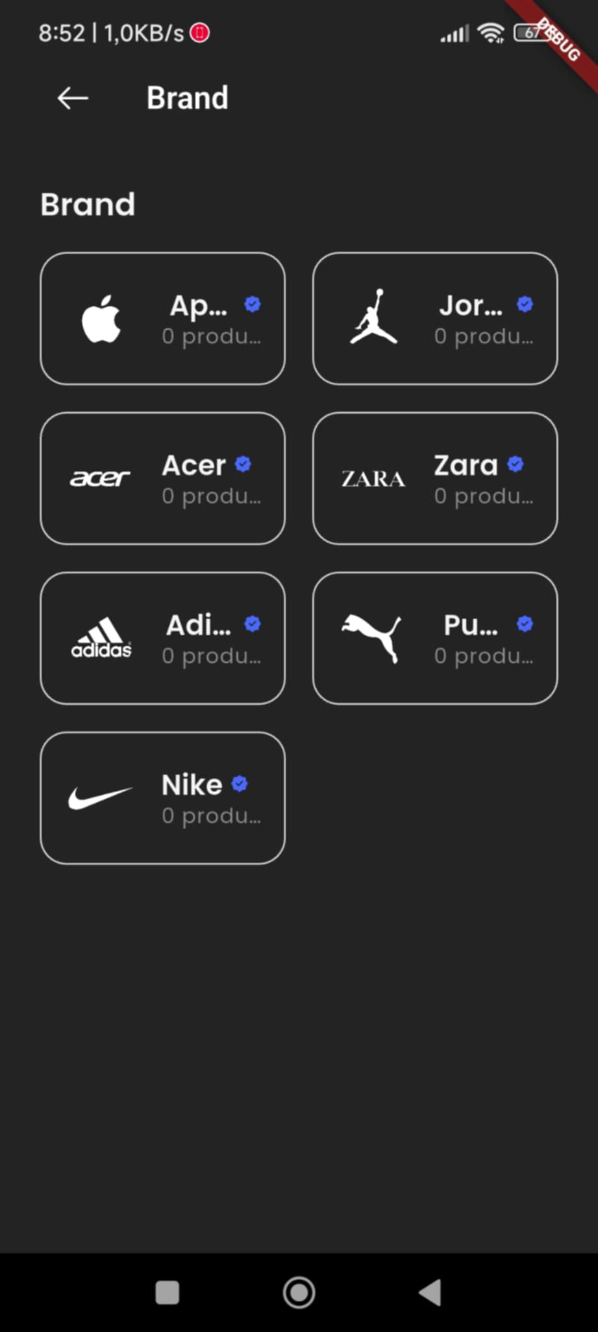

Figure 2.50 “All Brand” interface

Table 2.35 “All Product” interface

|  |  |  |  |  |
| --- | --- | --- | --- | --- |
| **Interface** | All Product | | | |
| **Describe** | Allows users to view all product | | | |
| **Access** | User clicks on “view all” button in popular products | | | |
| **Interface content** | | | | |
| **Item** | **Type** | **Data** | **Describe** | |
| Name screen | Text | N/A | Name of screen is All Brand | |
| Brand | List | N/A | List of all brand | |
| **Work** | | | | |
| **Name** | **Describe** | | **Success** | **Failure** |
| Click brand | View detail brand | | Redirect to brand detail screen |  |

#### Store

In the store screen, users can search for products or brands. The store displays featured brands and products in each category.

|  |  |
| --- | --- |
| Figure 2.51 “Store 1” interface | Figure 2.52 “Store 2” interface |

Table 2.36 “Store” interface

|  |  |  |  |  |  |
| --- | --- | --- | --- | --- | --- |
| **Interface** | Store | | | | |
| **Describe** | | The interface allows users to access the app to use other functions. | | | |
| **Access** | | User clicks on “Store” button | | | |
| **Interface content** | | | | | |
| **Item** | | **Type** | **Data** | **Describe** | |
| Name screen | | Text | N/A | Name of screen is Store | |
| Search box | | Text | N/A | Enter the product or brand name you want to search for | |
| Brand | | List | N/A | List of featured brands | |
| Category | | List | N/A | List of featured categories | |
| Product | | List | N/A | List of product in category | |
| **Work** | | | | | |
| **Name** | | **Describe** | | **Success** | **Failure** |
| Click search box | | Enter the product or brand name you want to search for | | Display suggestions by product name or brand you want to search for |  |
| Click brand icon button | | Choose brand | | Redirect to brand detail screen |  |
| Click “View all” button in featured brands | | View all brand | | Redirect to all brand screen |  |
| Scroll and click category | | Scroll to view the list of category | | Brands and products featured of category |  |
| Click icon product button | | Choose product | | Redirect to product detail screen |  |

#### Wishlist

In the wishlist screen, users can see the products they have liked. Click the favourite icon in the product to add or remove from the wishlist.

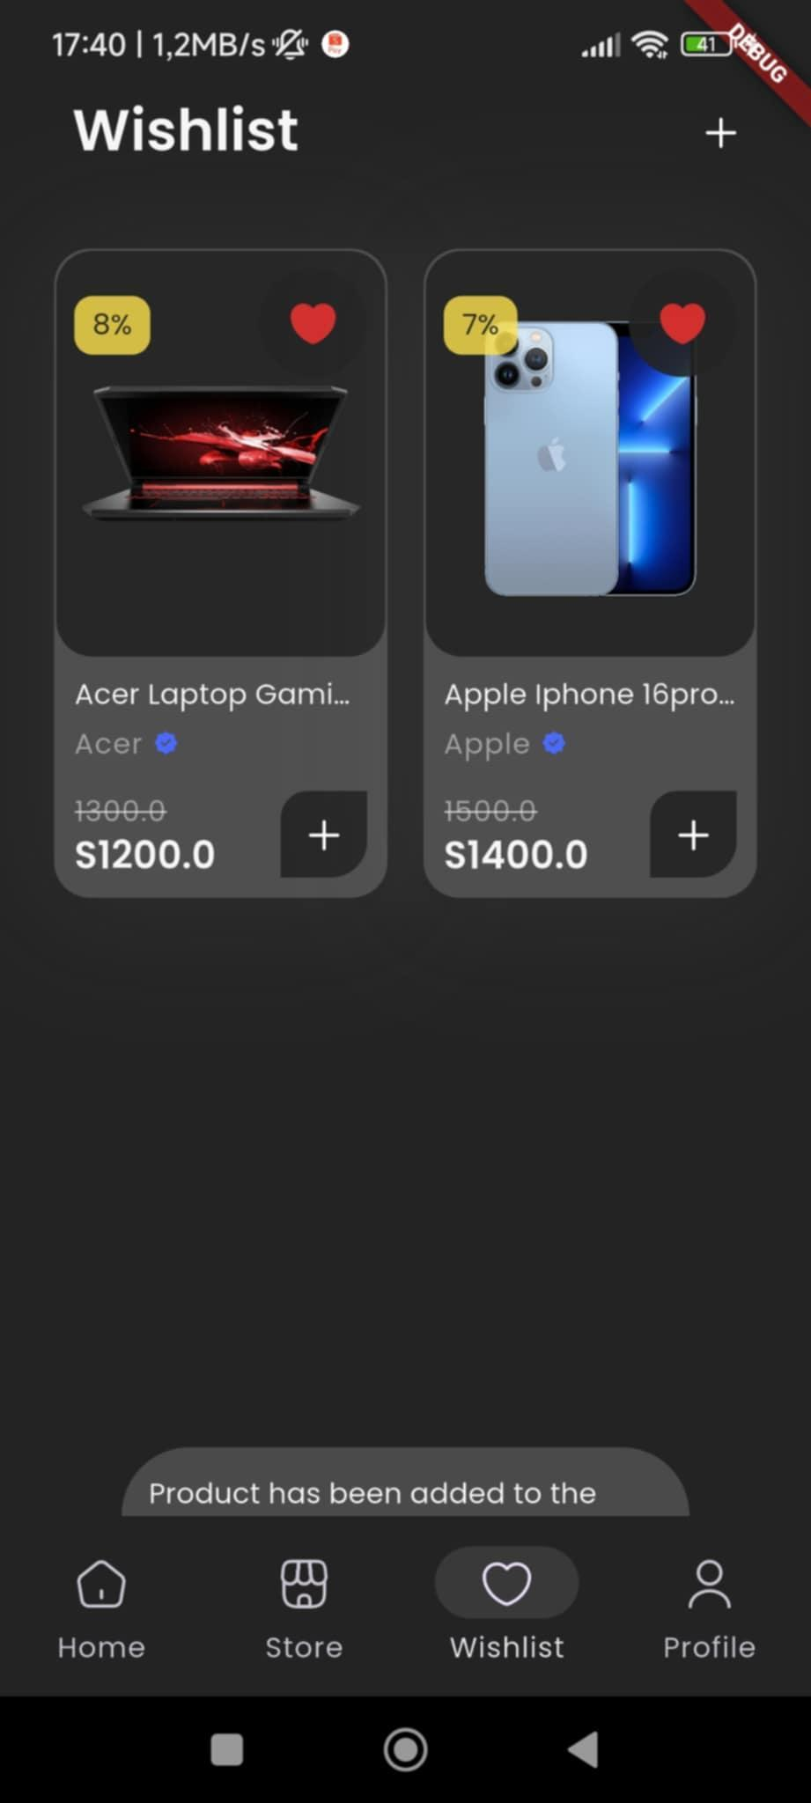

Figure 2.53 “Wishlist” interface

Table 2.37 “Wishlist” interface

|  |  |  |  |  |  |
| --- | --- | --- | --- | --- | --- |
| **Interface** | Wishlist | | | | |
| **Describe** | Allows users to view favourite products list | | | |
| **Access** | User clicks on “Wishlist” button | | | |
| **Interface content** | | | | | |
| **Item** | **Type** | **Data** | **Describe** | |
| Name screen | Text | N/A | Name of screen is Wishlist | |
| Add icon | Linked Button | N/A | Choose more products | |
| Product | List | N/A | List of all favourite product | |
| **Work** | | | | | |
| **Name** | **Describe** | | **Success** | **Failure** |
| Click Add button | Add products to the wishlist | | Redirect to home screen to choose products |  |
| Click Favourite icon | Remove product from wishlist | | Remove product from wishlist |  |

#### Review & Ratings

In the store screen, users can search for products or brands. The store displays featured brands and products in each category.

|  |  |
| --- | --- |
| Figure 2.54 “Review & Ratings 1” interface | Figure 2.55 “Review & Ratings 2” interface |

Table 2.38 “Reviews & Rating” interface

|  |  |  |  |  |  |
| --- | --- | --- | --- | --- | --- |
| **Interface** | Reviews & Rating | | | | |
| **Describe** | | Allows users to view all review and rating | | | |
| **Access** | | User clicks arrow right “Reviews” button in product detail | | | |
| **Interface content** | | | | | |
| **Item** | | **Type** | **Data** | **Describe** | |
| Name screen | | Text | N/A | Name of screen is Reviews & Rating | |
| Review | | Textbox-String | N/A | Write a review about the product | |
| Rating | | Button | N/A | Rating of product | |
| **Work** | | | | | |
| **Name** | | **Describe** | | **Success** | **Failure** |
| Click box review | | Write a review about the product | | Successful product reviews |  |
| Click rating icon | | Select rating: 1 - 5 star | | Successful product rating |  |

#### Setting

In the setting screen, users can change their information or can experience extensions.

|  |  |
| --- | --- |
| Figure 2.56 “Setting 1” interface | Figure 2.57 “Setting 2” interface |

Table 2.39 “Setting” interface

|  |  |  |  |  |  |
| --- | --- | --- | --- | --- | --- |
| **Interface** | Setting | | | | |
| **Describe** | Allows users to view detail setting screen | | | |
| **Access** | User clicks on “profile icon” button | | | |
| **Interface content** | | | | | |
| **Item** | **Type** | **Data** | **Describe** | |
| Name screen | Text | N/A | Name of screen is Account | |
| Image User | Image | N/A | User's photo | |
| Username and email | Text | N/A | Username and account registration email | |
| Edit profile icon | Linked Button | N/A | Edit user’s profile | |
| Address setting | Linked Button | N/A | Edit user’s address | |
| Order setting | Linked Button | N/A | View all orders | |
| Logout | Linked Button | N/A | Sign out of your account | |
| **Work** | | | | | |
| **Name** | **Describe** | | **Success** | **Failure** |
| Click edit profile | Click edit profile icon button image | | Redirect to profile screen |  |
| Click My Addresses | Click My Address button | | Redirect to address screen |  |
| Click My Orders | Click My Orders button | | Redirect to Order screen |  |
| Click Logout | Click Logout button | | Sign out of your account |  |

#### Profile

In the profile screen, users can view their details and can also change their photo or name

|  |  |
| --- | --- |
| Figure 2.58 “Profile 1” interface | Figure 2.59 “Profile 2” interface |

Table 2.40 “Profile” interface

|  |  |  |  |  |  |
| --- | --- | --- | --- | --- | --- |
| **Interface** | Profile | | | | |
| **Describe** | Allows users to view profile detail | | | |
| **Access** | User clicks on “Click edit profile image” button | | | |
| **Interface content** | | | | | | |
| **Item** | **Type** | **Data** | **Describe** | |
| Name screen | Text | N/A | Name of screen is Profile | |
| Image profile | Image | N/A | User's photo | |
| Change Profile Picture | Linked Button | N/A | Change User’s avatar | |
| Profile information | Text | N/A | Name and Username of customer | |
| Personal information | Text | N/A | Personal information: User Id, Email, Phone Number, Gender, Date of birth | |
| **Work** | | | | | | |
| **Name** | **Describe** | | **Success** | **Failure** |
| Click Change Profile Picture | Select photo to change | | Change User’s avatar |  |
| Click arrow right in Name text | Change User’s name | | Redirect to Change name screen |  |

#### Address

In the address screen, users can view or select addresses. They can also create new addresses when they have filled in all the information.

|  |  |
| --- | --- |
| Figure 2.60 “Address 1” interface | Figure 2.61 “Address 2” interface |

Table 2.41 “Address and Add new address” interface

|  |  |  |  |  |  |
| --- | --- | --- | --- | --- | --- |
| **Interface** | Address and Add new address | | | | |
| **Describe** | | Interface allows users select and create new address | | | |
| **Access** | | User clicks My address button in setting screen | | | |
| **Interface content** | | | | | |
| **Item** | | **Type** | **Data** | **Describe** | |
| Name screen | | Text | N/A | Name of screen is Address and Add new address | |
| List address | | List | N/A | Select address | |
| Last name | | Textbox-String | N/A | Where to enter last name | |
| Add new address button | | Linked Button | N/A | Create new address | |
| Name | | Textbox-String | N/A | Where to enter username | |
| Phone Number | | Textbox-String | N/A | Where to enter phone number | |
| Street | | Textbox-String | N/A | Street of the user is live | |
| Postal Code | | Textbox-String | N/A | User’s postal code | |
| City | | Textbox-String | N/A | City of the user is live | |
| State | | Textbox-String | N/A | the State of user | |
| Country | | Textbox-String | N/A | User’s country | |
| Save button | | Linked  Button | N/A | Redirect to address screen | |
| **Work** | | | | | |
| **Name** | | **Describe** | | **Success** | **Failure** |
| No address name entered | | Do not enter name then press save | |  | “Something went wrong. Please try again” message |
| No phone number entered | | Do not enter phone number then press save button | |  | “Something went wrong. Please try again” message |
| No street entered | | Do not enter street then press save | |  | “Something went wrong. Please try again” message |
| No postal code entered | | Do not enter postal code then press save button | |  | “Something went wrong. Please try again” message |
| No city entered | | Do not enter city then press save | |  | “Something went wrong. Please try again” message |
| No state entered | | Do not enter state then press save button | |  | “Something went wrong. Please try again” message |
| No country entered | | Do not enter country then press save | |  | “Something went wrong. Please try again” message |
| Click save button | | Save changes | | Redirect to address screen |  |

#### Order detail

In the order detail screen, users can view order details including status, information, shipping address, payment method, pricing details.

|  |  |
| --- | --- |
| Figure 2.62 “Order detail 1” interface | Figure 2.63 “Order detail 2” interface |

Table 2.42 “Order Details screen” interface

|  |  |  |  |  |  |
| --- | --- | --- | --- | --- | --- |
| **Interface** | Order Details screen | | | | |
| **Describe** | Allows users to view detail order | | | | |
| **Access** | User clicks on “My order” button in setting screen | | | | |
| **Interface content** | | | | | |
| **Item** | **Type** | **Data** | **Describe** | | |
| Name screen | Text | N/A | Name of screen is Order Details | | |
| Status order | Text | N/A | Status order: pending, processing, shipped, delivered, cancelled.Date order | | |
| Order information | Text | N/A | Order information: Order Id, Order Date, Delivery Date, Total amount | | |
| Shipping address | Text | N/A | Shipping address: username, phone number, address | | |
| Payment Method | Text | N/A | Payment Method: Paypal, Google Pay, Apple Pay, Visa, Master Card, Credit Card | | |
| Order items | Image- Text | N/A | All products are to order | | |
| Pricing Details | Text | N/A | Pricing Details:SubTotal, Shipping Fee, Tax Fee, Total Amount | | |
| **Work** | | | | | |
| **Name** | **Describe** | | | **Success** | **Failure** |
| Scroll | Scroll to view details | | | Display Order details |  |

### Admin

#### Login

In the login screen, the admin must enter the correct email and password to be able to log in to the management page.

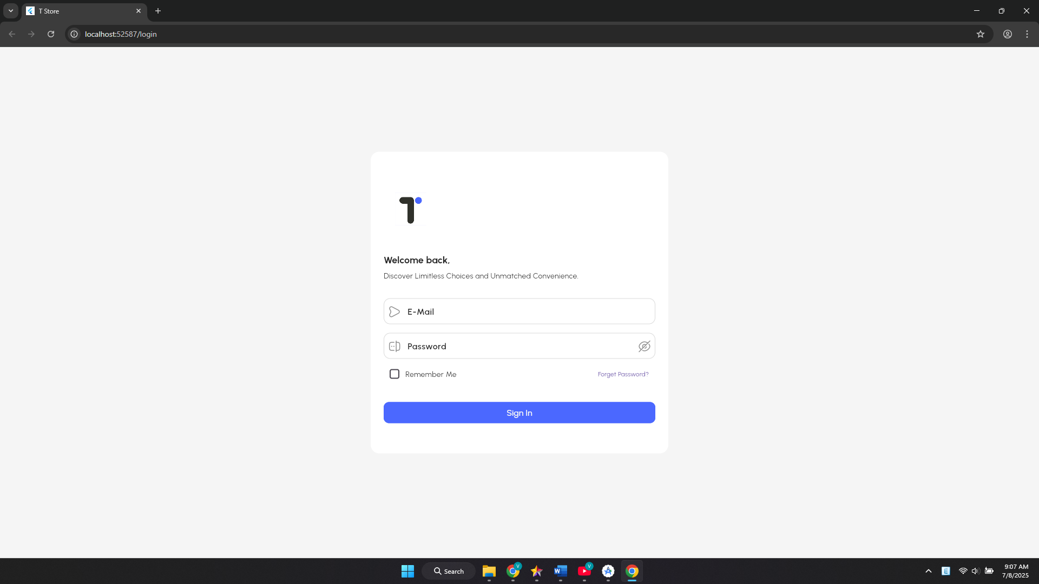

Figure 2.64 “Login” interface

Table 2.43 “Admin Login” interface

|  |  |  |  |  |  |
| --- | --- | --- | --- | --- | --- |
| **Interface** | Admin Login | | | | |
| **Describe** | | The interface allows the admin to login to use other functions. | | | |
| **Access** | | Admin access the website | | | |
| **Interface content** | | | | | |
| **Item** | | **Type** | **Data** | **Describe** | |
| Email | | Textbox-String | N/A | Where to enter email | |
| Password | | Textbox-String | N/A | Where to enter password | |
| Forget Password | | Linked Button | N/A | Leads to forgot password page | |
| Remember Me | | Button | N/A | Where to remember passwords | |
| Sign in | | Linked Button | N/A | Log in to the system | |
| **Name** | | **Describe** | | **Success** | **Failure** |
| No email entered | | Do not enter email then press sign in button | |  | “Invalid email address” message |
| No password entered | | Do not enter password then press sign in button | |  | “Password is required” message |
| Sign in with email and password | | Process login to the system with the entered user name and password | | Redirect to dashboard screen | “Something went wrong. Please try again” message |

#### Dashboard

In the dashboard screen, admin can view statistics using bar and pie charts. In addition, admin can also view total sale, average order value, total order, list order.

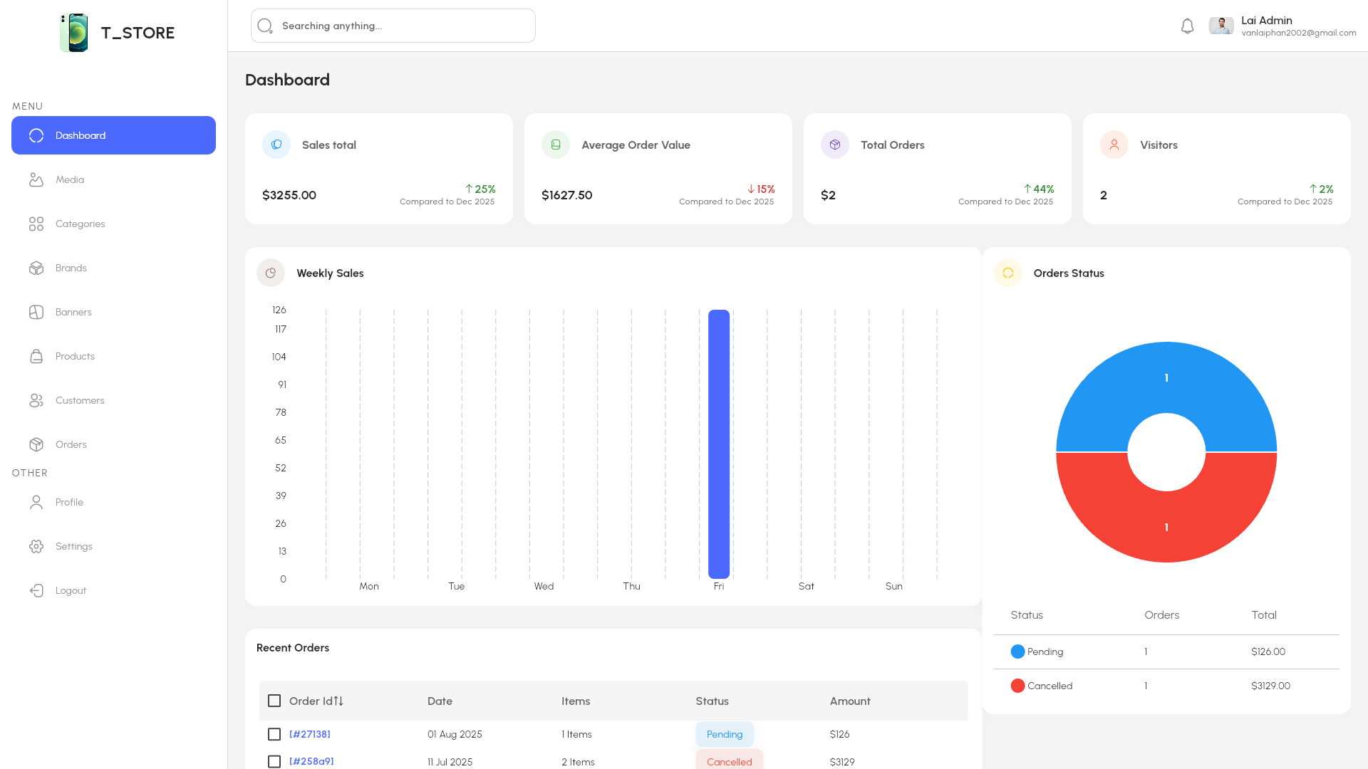

Figure 2.65 “Dashboard 1” interface

Table 2.44 “Dashboard” interface

|  |  |  |  |  |  |
| --- | --- | --- | --- | --- | --- |
| **Interface** | Dashboard | | | | |
| **Describe** | | Allows admin to view sales statistics | | | |
| **Access** | | Admin clicks Dashboard in sidebar | | | |
| **Interface content** | | | | | |
| **Item** | | **Type** | **Data** | **Describe** | |
| Dashboard Card | | Text | N/A | Dashboard Card: Sales total, Average order value, Total Orders, Visitors | |
| Barchart | | Chart | N/A | Order statistics using bar chart | |
| Piechart | | Chart | N/A | Order statistics using pie chart | |
| Table recent orders | | Table | N/A | List orders | |
| **Work** | | | | | |
| **Name** | | **Describe** | | **Success** | **Failure** |
| Click dashboard in sidebar | | View order statistics | | Displays all order statistics |  |

#### Media

In the media screen, the admin can upload photos and select a storage folder for the photos.

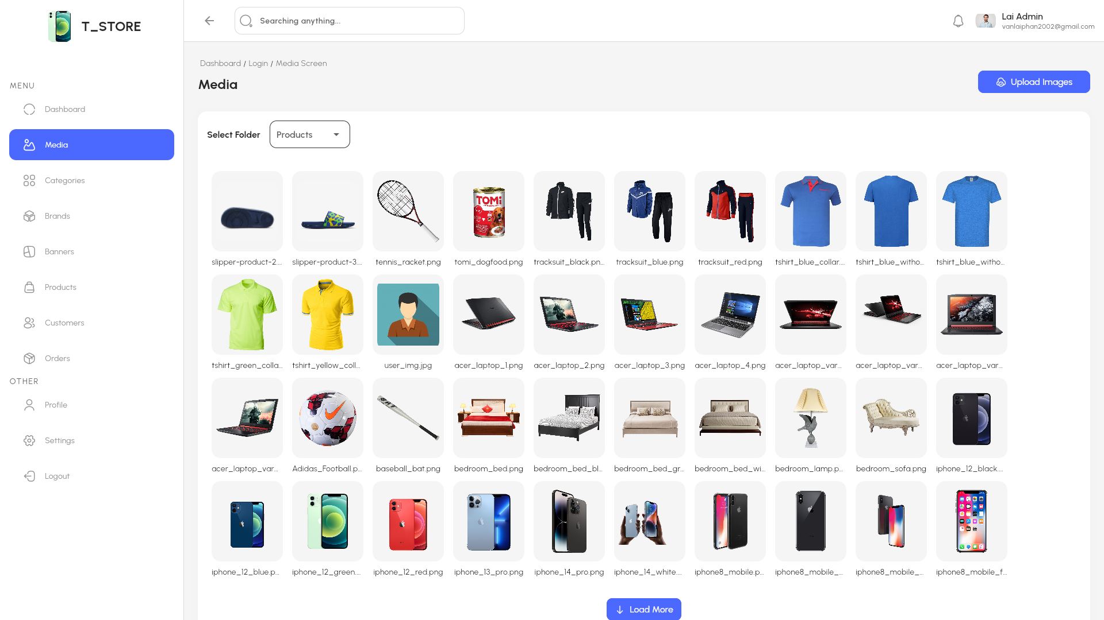

Figure 2.66 “Media” interface

Table 2.45 “Media” interface

|  |  |  |  |  |  |
| --- | --- | --- | --- | --- | --- |
| **Interface** | Media | | | | |
| **Describe** | | Allows admin to view all image upload | | | |
| **Access** | | Admin clicks Media in sidebar | | | |
| **Interface content** | | | | | |
| **Item** | | **Type** | **Data** | **Describe** | |
| Name screen | | Text | N/A | Name of screen is Media | |
| Select Folder | | Button | N/A | Admin can choose upload folder | |
| Upload Image | | Button | N/A | Admin can upload images | |
| **Work** | | | | | |
| **Name** | | **Describe** | | **Success** | **Failure** |
| Click select folder | | Admin can choose upload folder | | Image has been successfully added to the folder |  |
| Click upload image | | Admin can upload images | | Image has been successfully added to the folder |  |

#### Category

In the category screen, admin can view the category list, create, update or delete a category.

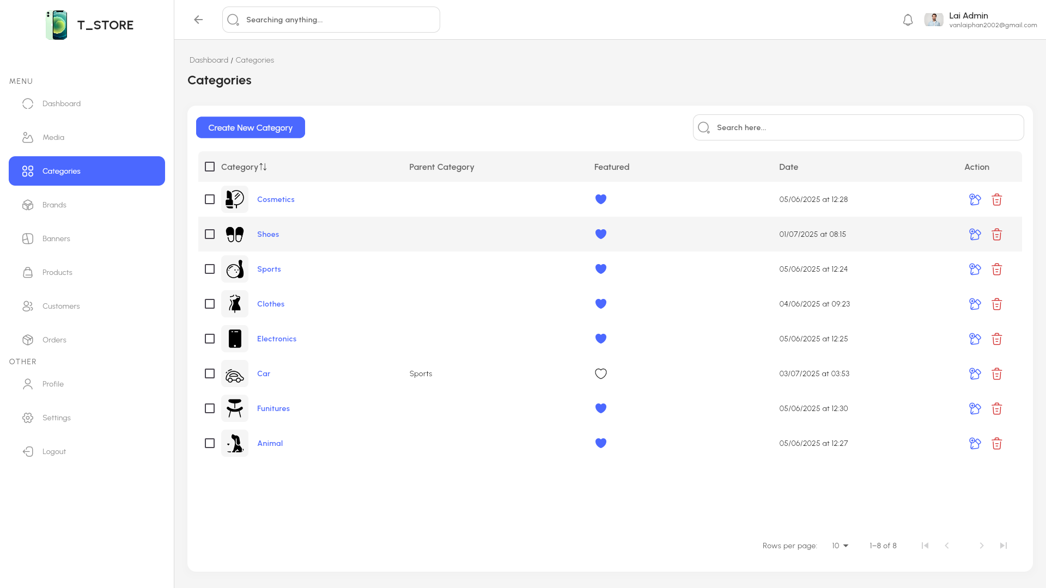

Figure 2.67 “Category” interface

In the create category screen, admin fills in the name, selects the parent category, selects the image, featured category or not to display in the store then clicks “Create” to save.

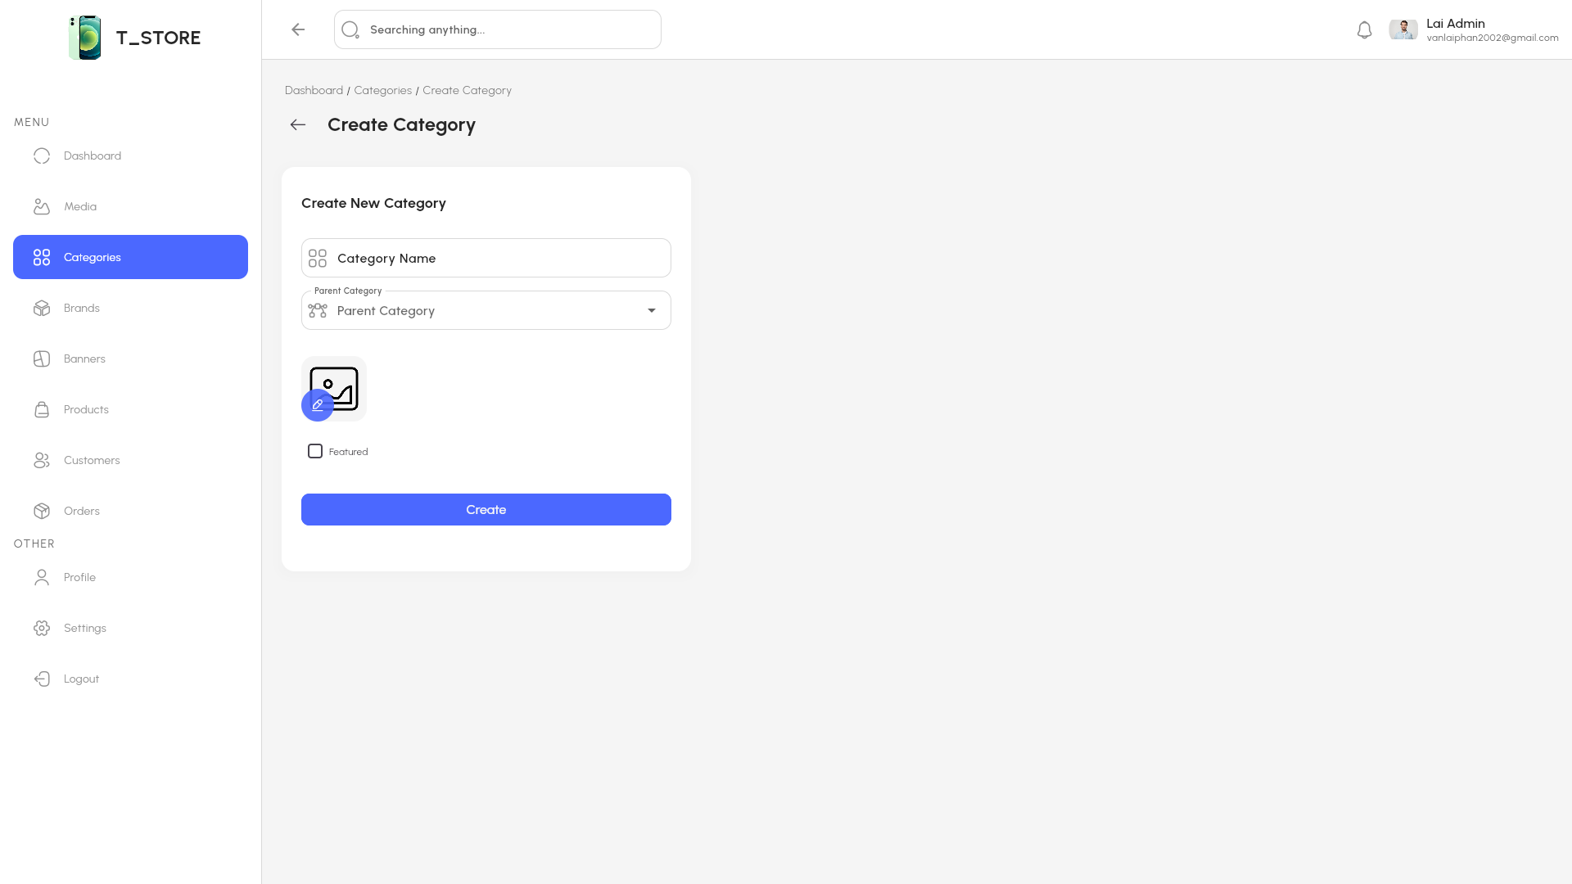

Figure 2.68 “Create category” interface

In the update category screen, admin can change the name, parent category, image, featured category or not to display in the store then clicks “Update” to save.

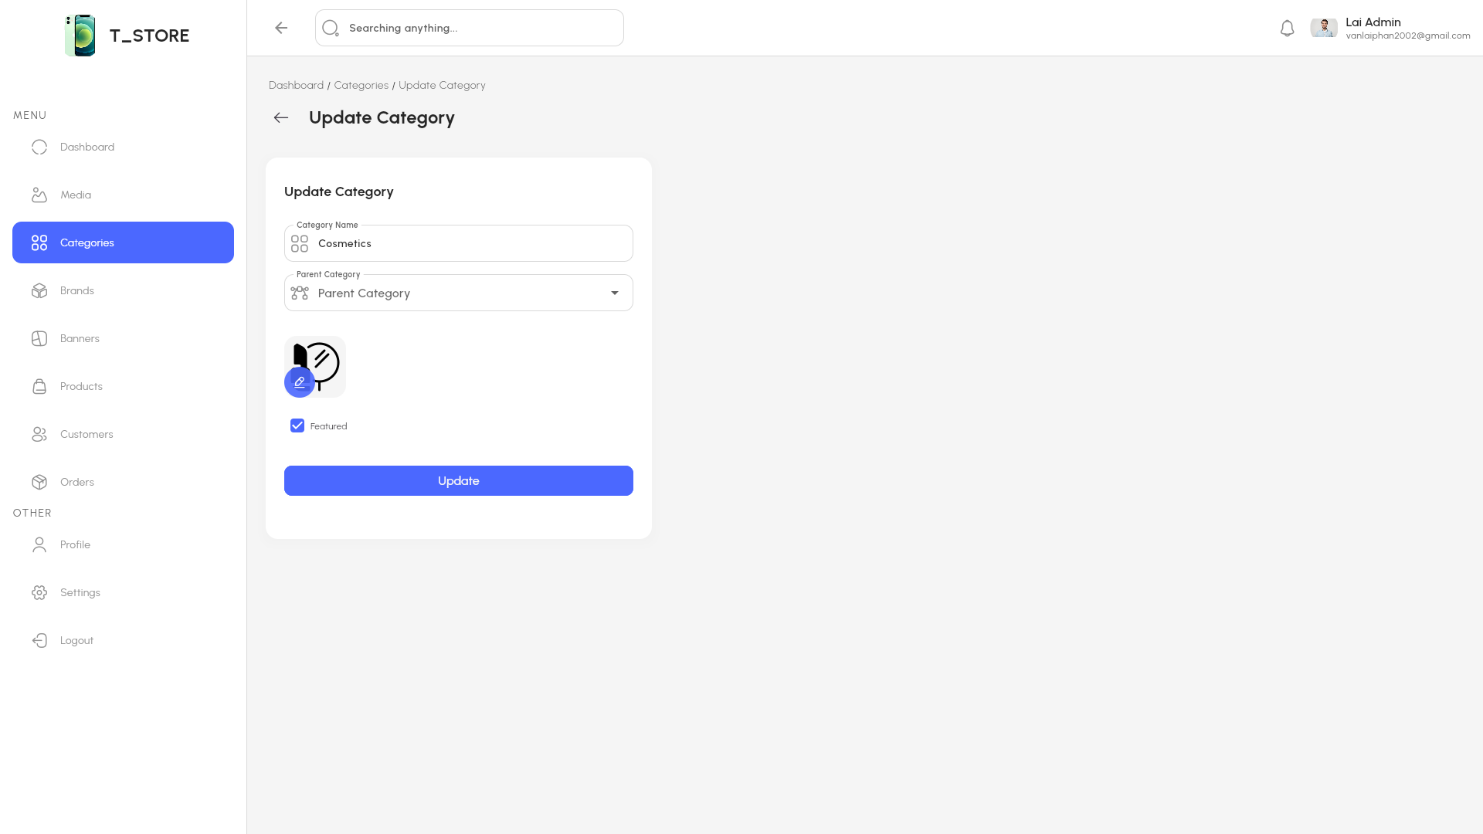

Figure 2.69 “Update category” interface

Table 2.46 “Category” interface

|  |  |  |  |  |  |  |
| --- | --- | --- | --- | --- | --- | --- |
| **Interface** | | Category | | | | |
| **Describe** | | Show list category and admin can create, update, delete category | | | | |
| **Access** | | Admin clicks Category button in sidebar | | | | |
| **Content** | | | | | | |
| **Item** | | **Type** | **Data** | | **Describe** | |
| Create new category | | Linked Button | N/A | | Create new category for app | |
| Table category | | Table | N/A | | Show all category | |
| Search | | Textbox-String | N/A | | Search name category | |
| Featured button | | Button | N/A | | When pressed, the category will be displayed in the app | |
| Update Action Button | | Linked Button | N/A | | Update category | |
| Delete Action Button | | Button | N/A | | Delete category | |
| **Act** | | | | | | |
| **Name** | **Describe** | | | **Success** | | **Failure** |
| Click Create new category Button | Admin click Create new category | | | Redirect to Create category screen | |  |
| Fill in the search box | Enter the word you want to search for in the search box | | | Suggest categories by characters typed | |  |
| Click Featured button | Admin click Featured category button | | | Featured categories appear in the category list in the app | |  |
| Click Update action button | Admin click Update category button | | | Redirect to Update category screen | |  |
| Click Delete action button | Admin click Delete category button | | | Remove categories from the table | |  |

#### Brand

In the brand screen, admin can view the brand list, create, update or delete brand.

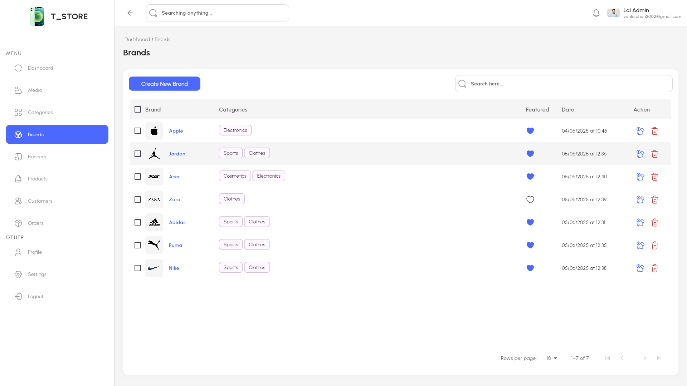

Figure 2.70 “Brand” interface

In the create brand screen, admin fills in the name, selects the category, selects the image, features the brand or not to display in the store then clicks “Create” to save.

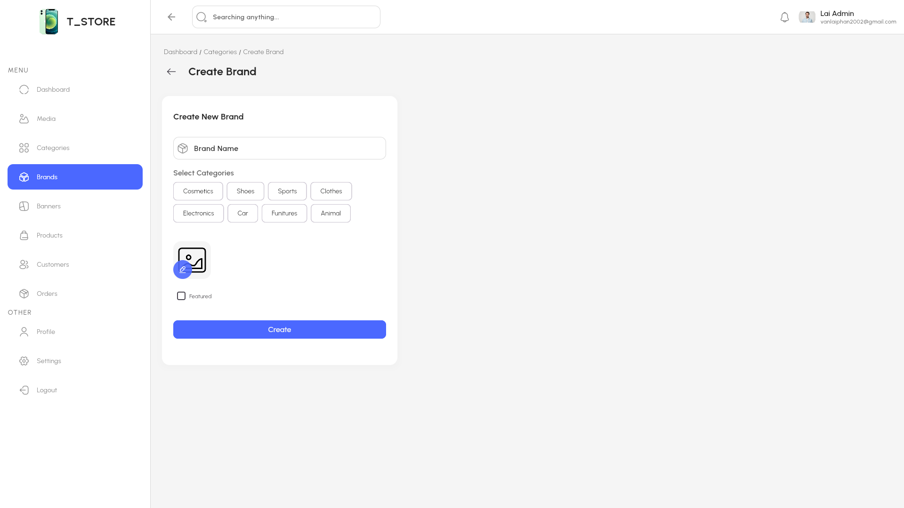

Figure 2.71 “Create brand” interface

In the update brand screen, admin can change the name, category, image, features or not to display in the store then clicks “Update” to save.

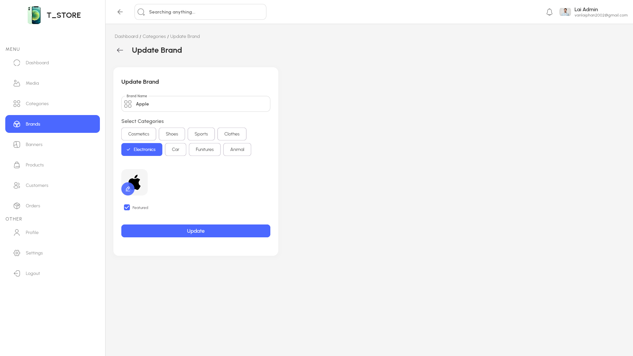

Figure 2.72 “Update brand interface” interface

Table 2.47 “Brands” interface

|  |  |  |  |  |  |  |
| --- | --- | --- | --- | --- | --- | --- |
| **Interface** | | Brands | | | | |
| **Describe** | | Show list Brand and admin can create, update, delete brand | | | | |
| **Access** | | Admin clicks Brand button in sidebar | | | | |
| **Content** | | | | | | |
| **Item** | | **Type** | **Data** | | **Describe** | |
| Create new brand | | Linked Button | N/A | | Create new brand for app | |
| Table brand | | Table | N/A | | Show all brand | |
| Search | | Textbox-String | N/A | | Search name category | |
| Featured button | | Button | N/A | | When pressed, the brand will be displayed in the app | |
| Update Action Button | | Linked Button | N/A | | Update brand | |
| Delete Action Button | | Button | N/A | | Delete brand | |
| **Act** | | | | | | |
| **Name** | **Describe** | | | **Success** | | **Failure** |
| Click Create new brand Button | Admin click Create new brand | | | Redirect to Create brand screen | |  |
| Fill in the search box | Enter the word you want to search for in the search box | | | Suggest brand by characters typed | |  |
| Click Featured button | Admin click Featured brand button | | | Featured brand appear in the category list in the app | |  |
| Click Update action button | Admin click Update brand button | | | Redirect to Update brands screen | |  |
| Click Delete action button | Admin click Delete brand button | | | Remove brands from the table | |  |

#### Banner

In the banner screen, admin can view the banner list, create, update or delete banners.

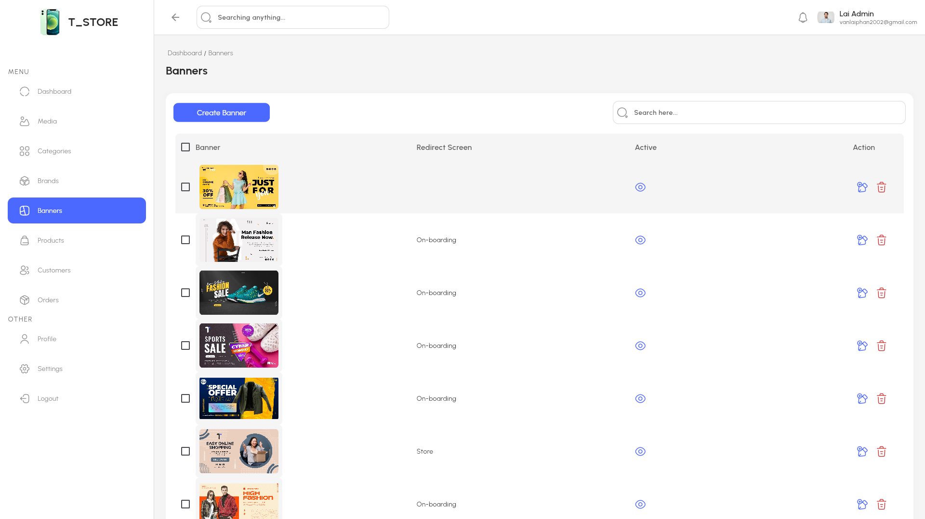

Figure 2.73 “Banner” interface

In the create banner screen, admin selects the image, selects the navigation screen, actives the banner or not to display in the store then clicks” Create” to save

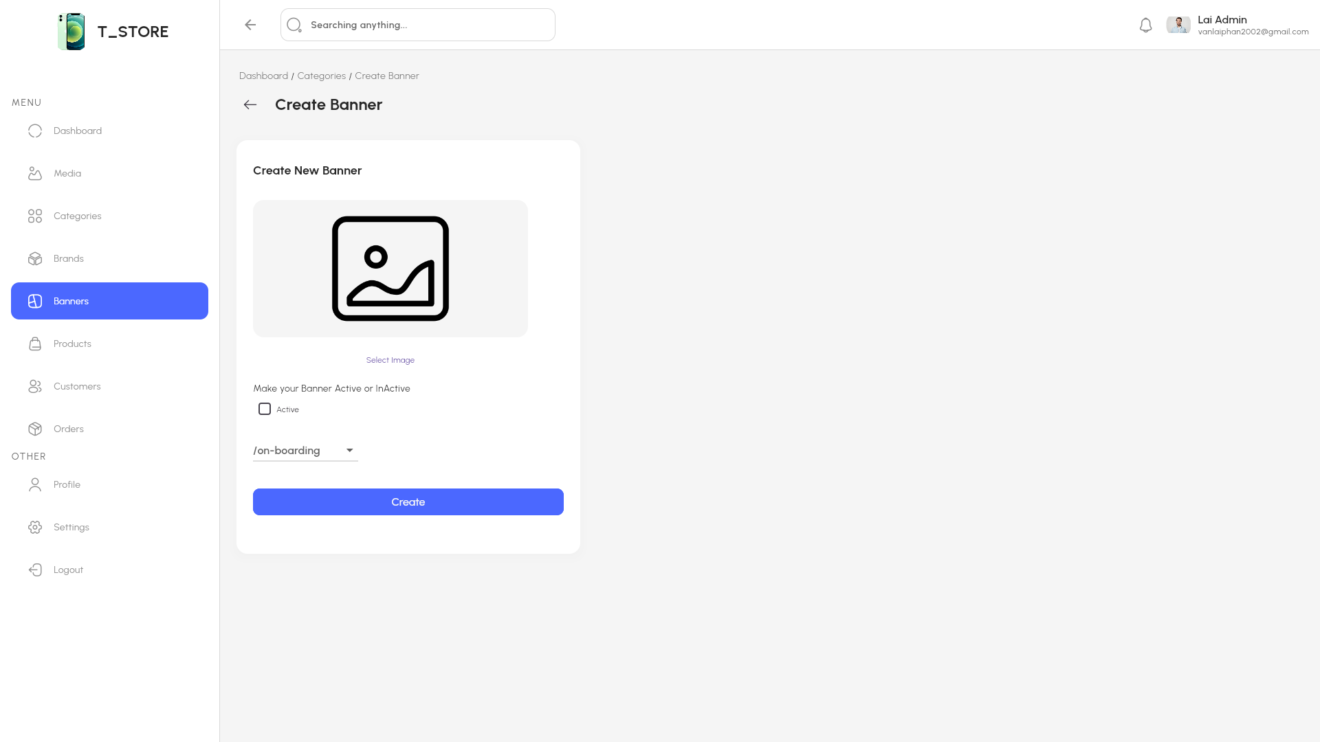

Figure 2.74 “Create banner” interface

In the update banner screen, admin can change the image, navigation screen, actives or not to display in the store then clicks “Update“ to save.

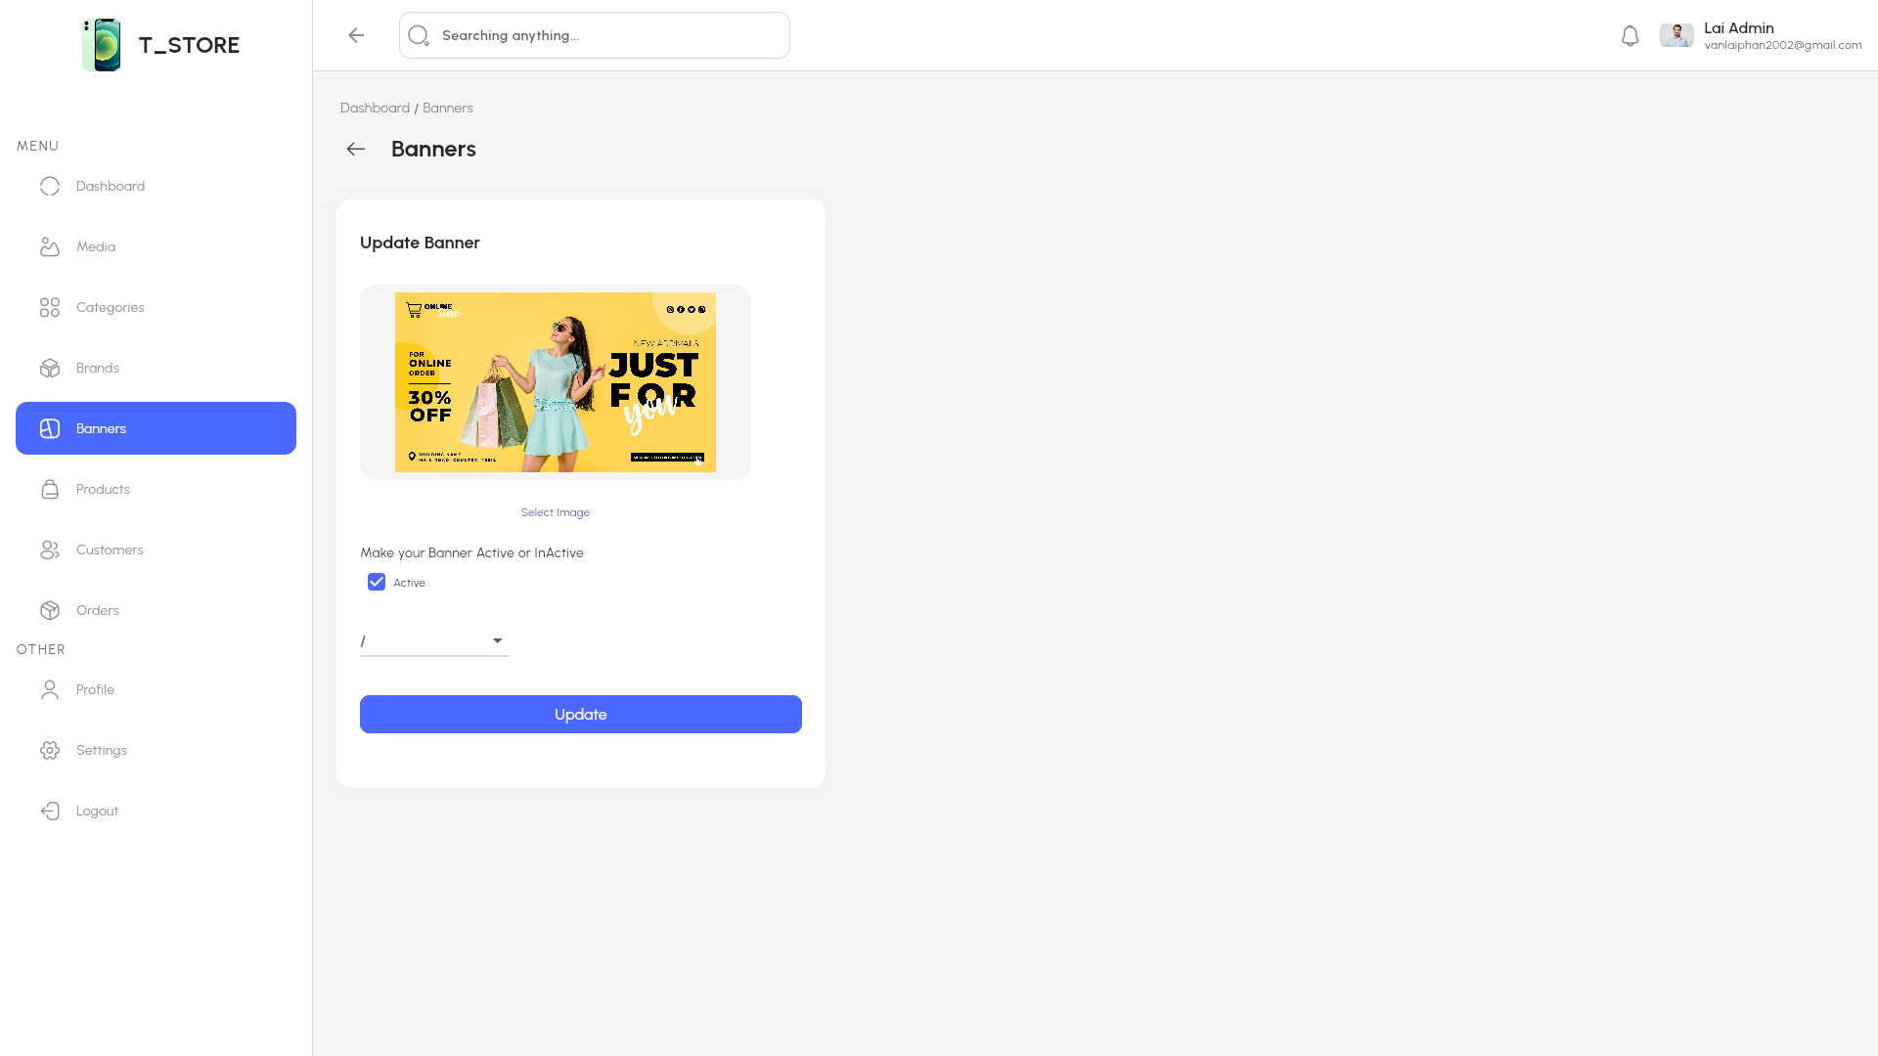

Figure 2.75 “Update banner” interface

Table 2.48 “Banner” interface

|  |  |  |  |  |  |  |
| --- | --- | --- | --- | --- | --- | --- |
| **Interface** | | Banner | | | | |
| **Describe** | | Show list banner and admin can create, update, delete banner | | | | |
| **Access** | | Admin clicks Banners button in sidebar | | | | |
| **Content** | | | | | | |
| **Item** | | **Type** | **Data** | | **Describe** | |
| Create new banner | | Linked Button | N/A | | Create new banner for app | |
| Table banner | | Table | N/A | | Show all banner | |
| Search | | Textbox-String | N/A | | Search name banner | |
| Featured button | | Button | N/A | | When pressed, the banner will be displayed in the app | |
| Update Action Button | | Linked Button | N/A | | Update banner | |
| Delete Action Button | | Button | N/A | | Delete banner | |
| **Act** | | | | | | |
| **Name** | **Describe** | | | **Success** | | **Failure** |
| Click Create new banner Button | Admin click Create new banner | | | Redirect to Create banner screen | |  |
| Fill in the search box | Enter the word you want to search for in the search box | | | Suggest banner by characters typed | |  |
| Click Featured button | Admin click Featured banner button | | | Featured banner appear in the banner list in the app | |  |
| Click Update action button | Admin click Update banner button | | | Redirect to Update banner screen | |  |
| Click Delete action button | Admin click Delete banner button | | | Remove banner from the table | |  |

#### Product

In the product screen, admin can view the product list, create, update or delete products

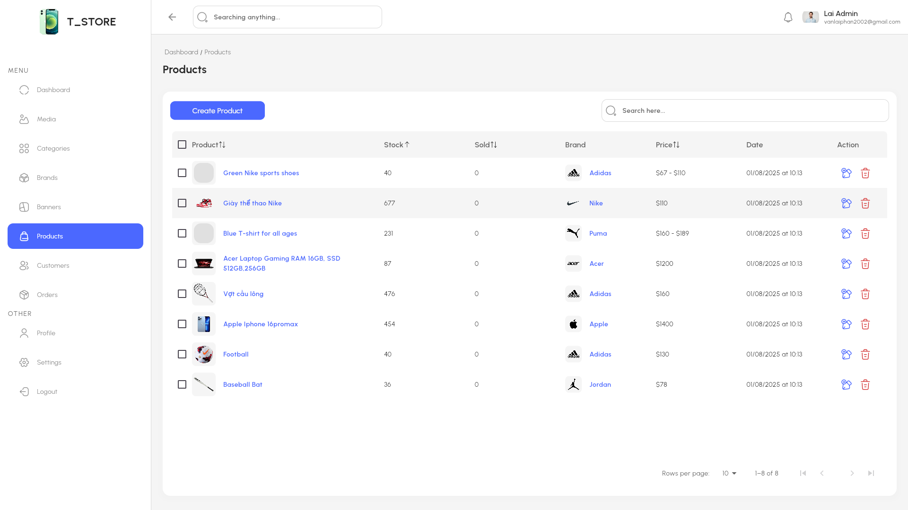

Figure 2.76 “Product” interface

In the create product screen, admin fills in the product information, selects the image, selects the brand, selects the category, publishes or hides to display in the store or not, then clicks "Save changes" to save.

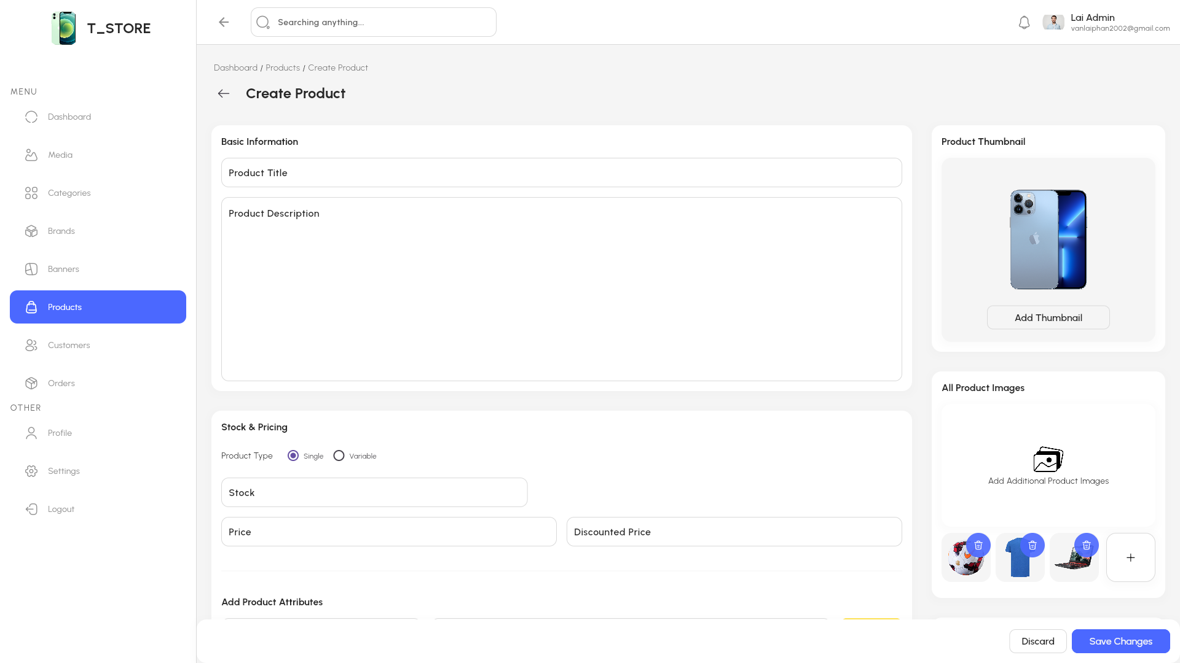

Figure 2.77 “Create product 1” interface

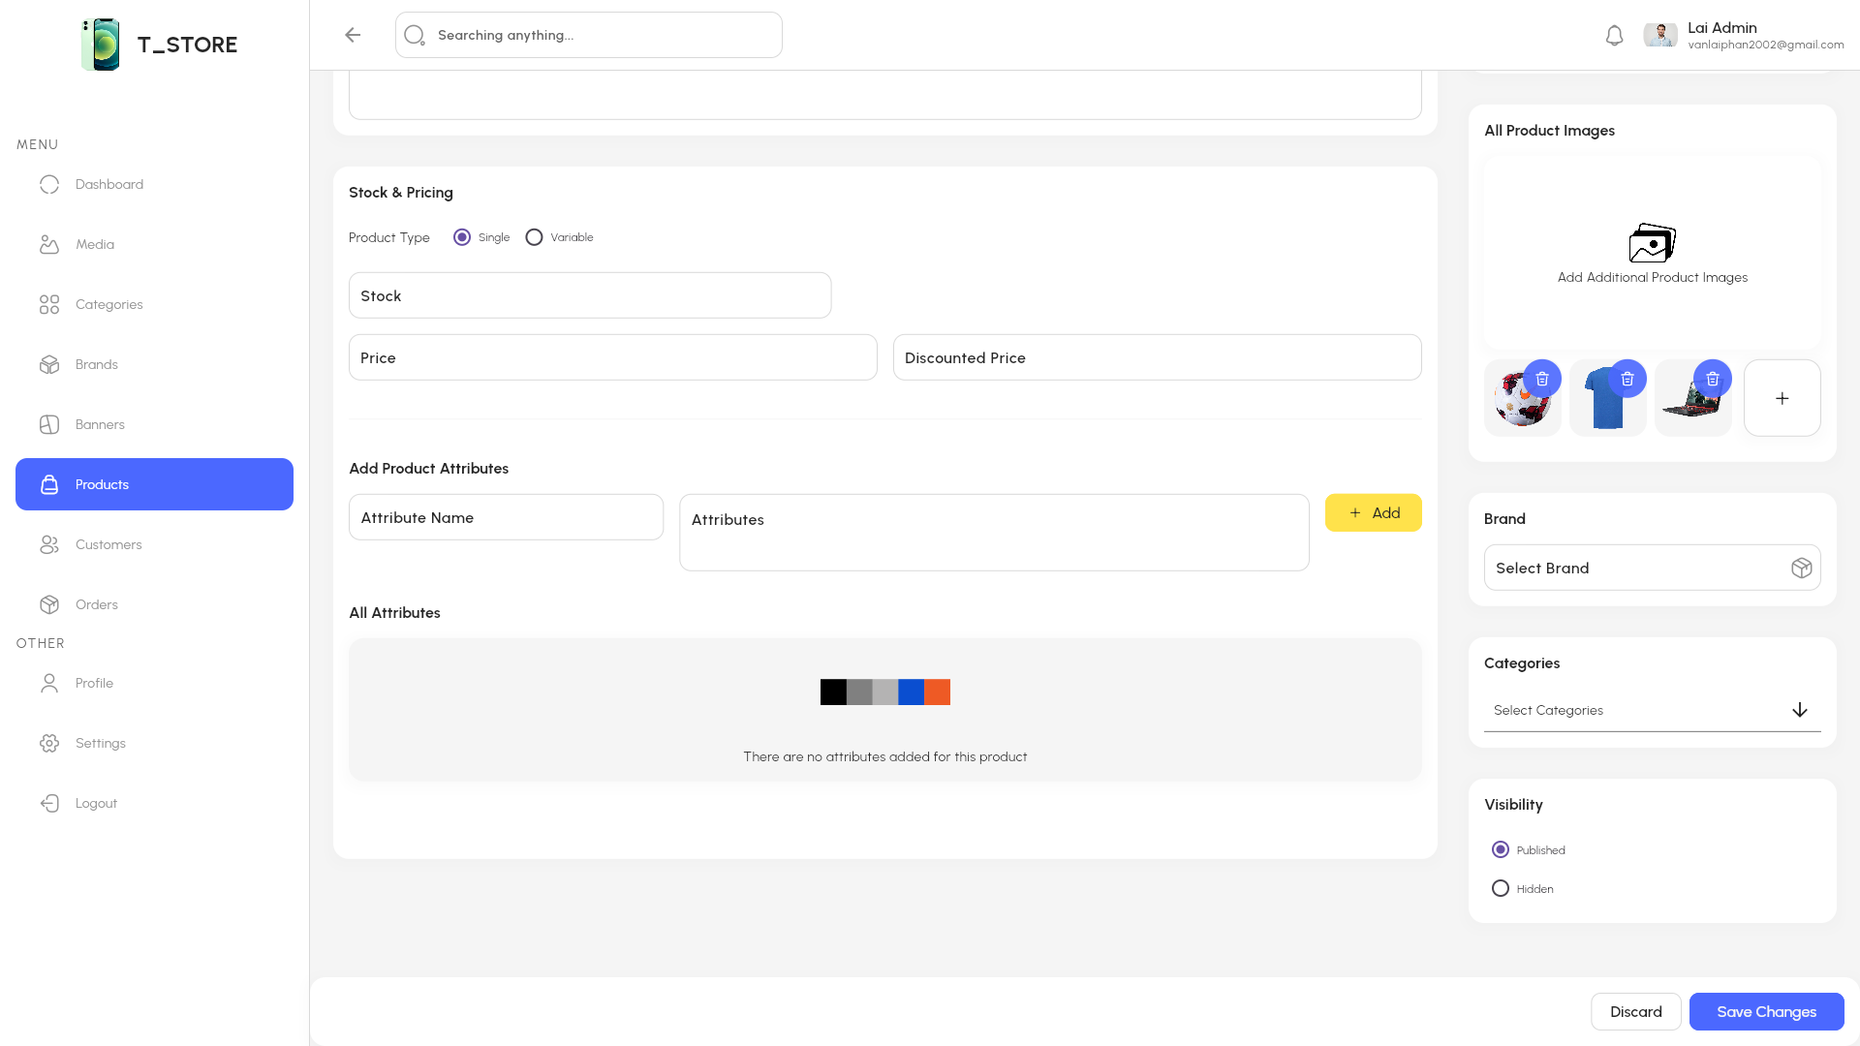

Figure 2.78 “Create product 2” interface

In the update product screen, admin can change the product information, image, brand, category, publish or hides to display in the store or not, then clicks "Save changes" to save.

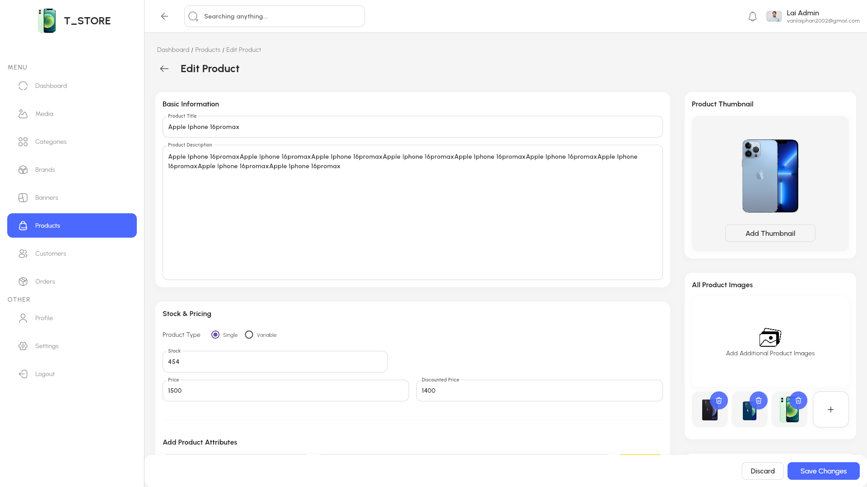

Figure 2.79“Update product 1” interface

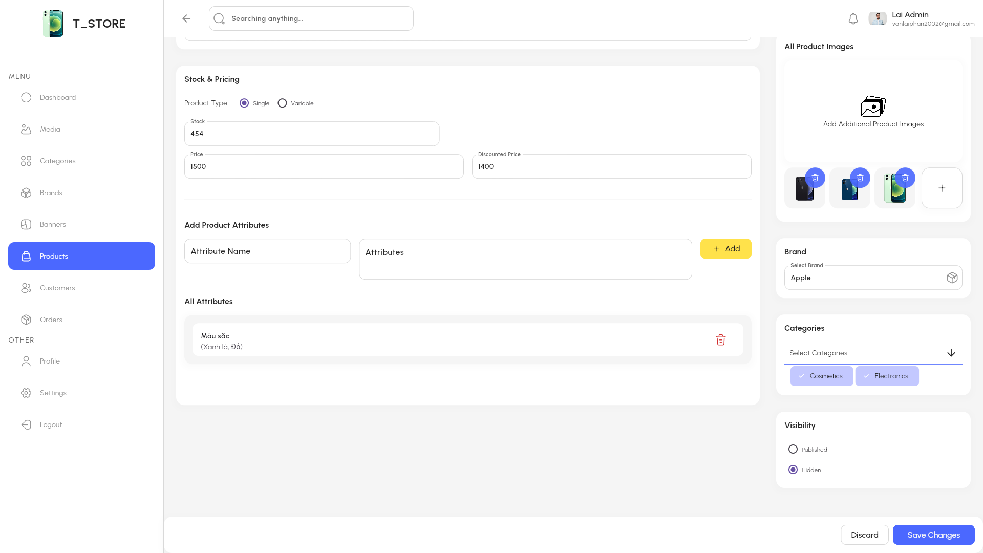

Figure 2.80 “Update product 2” interface

Table 2.49 “Products” interface

|  |  |  |  |  |  |  |
| --- | --- | --- | --- | --- | --- | --- |
| **Interface** | | Products | | | | |
| **Describe** | | Show list product and admin can create, update, delete product | | | | |
| **Access** | | Admin clicks Product button in sidebar | | | | |
| **Content** | | | | | | |
| **Item** | | **Type** | **Data** | | **Describe** | |
| Create new product | | Linked Button | N/A | | Create new product for app | |
| Table product | | Table | N/A | | Show all product | |
| Search | | Textbox-String | N/A | | Search name product | |
| Featured button | | Button | N/A | | When pressed, the product will be displayed in the app | |
| Update Action Button | | Linked Button | N/A | | Update product | |
| Delete Action Button | | Button | N/A | | Delete product | |
| **Act** | | | | | | |
| **Name** | **Describe** | | | **Success** | | **Failure** |
| Click Create new product Button | Admin click Create new product | | | Redirect to Create product screen | |  |
| Fill in the search box | Enter the word you want to search for in the search box | | | Suggest products by characters typed | |  |
| Click Featured button | Admin click Featured products button | | | Featured product appear in the product list in the app | |  |
| Click Update action button | Admin click Update product button | | | Redirect to Update product screen | |  |
| Click Delete action button | Admin click Delete product button | | | Remove product from the table | |  |

#### Customer

In customer screen, admin can view customer list, view details or delete customer.

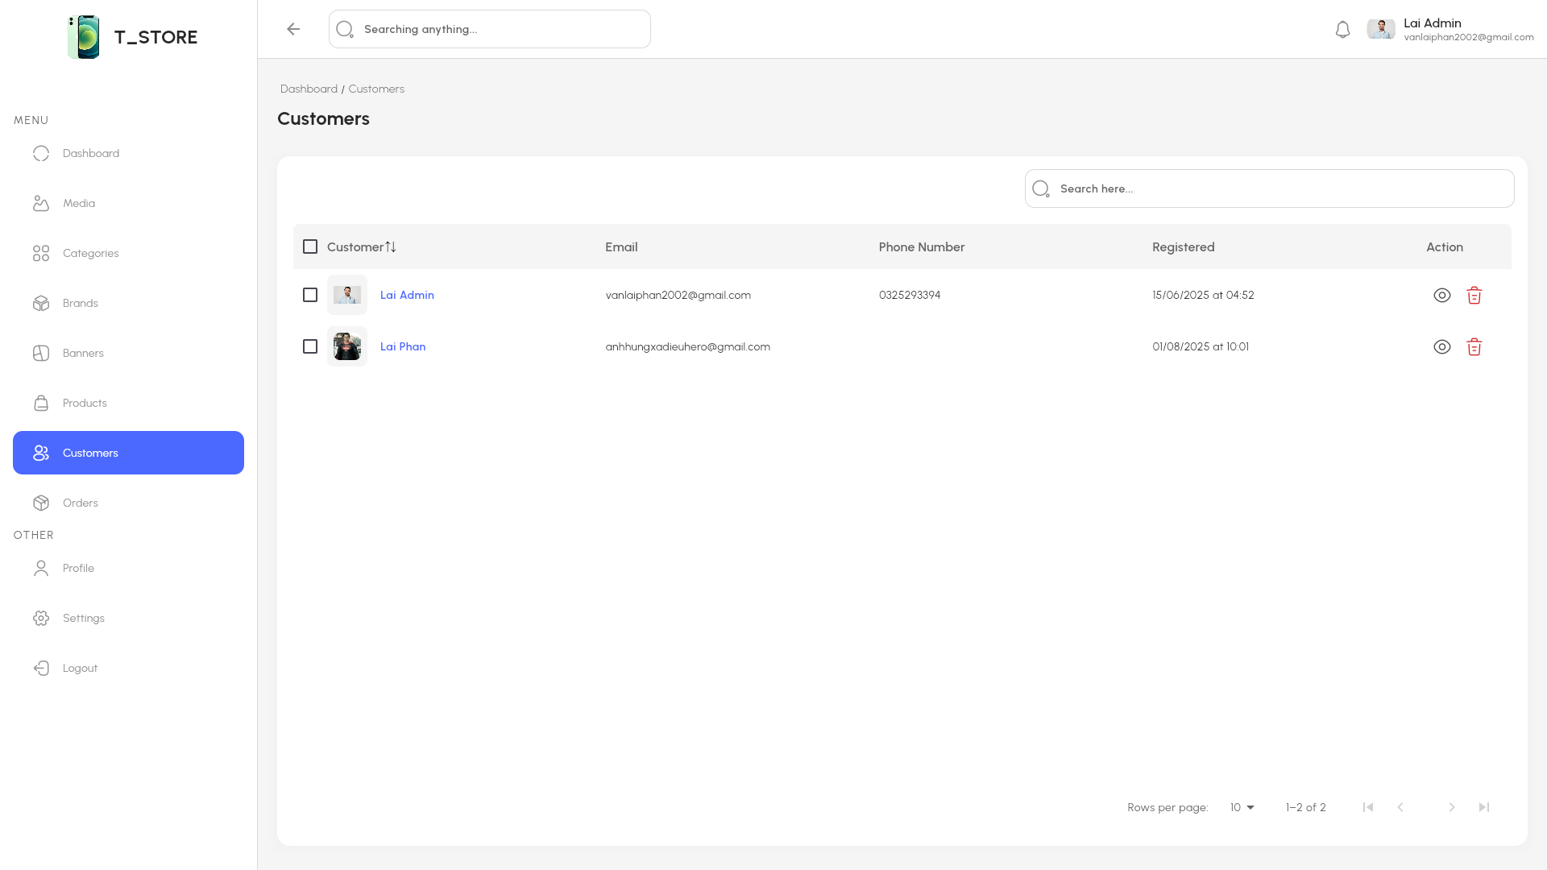

Figure 2.81 “Customer” interface

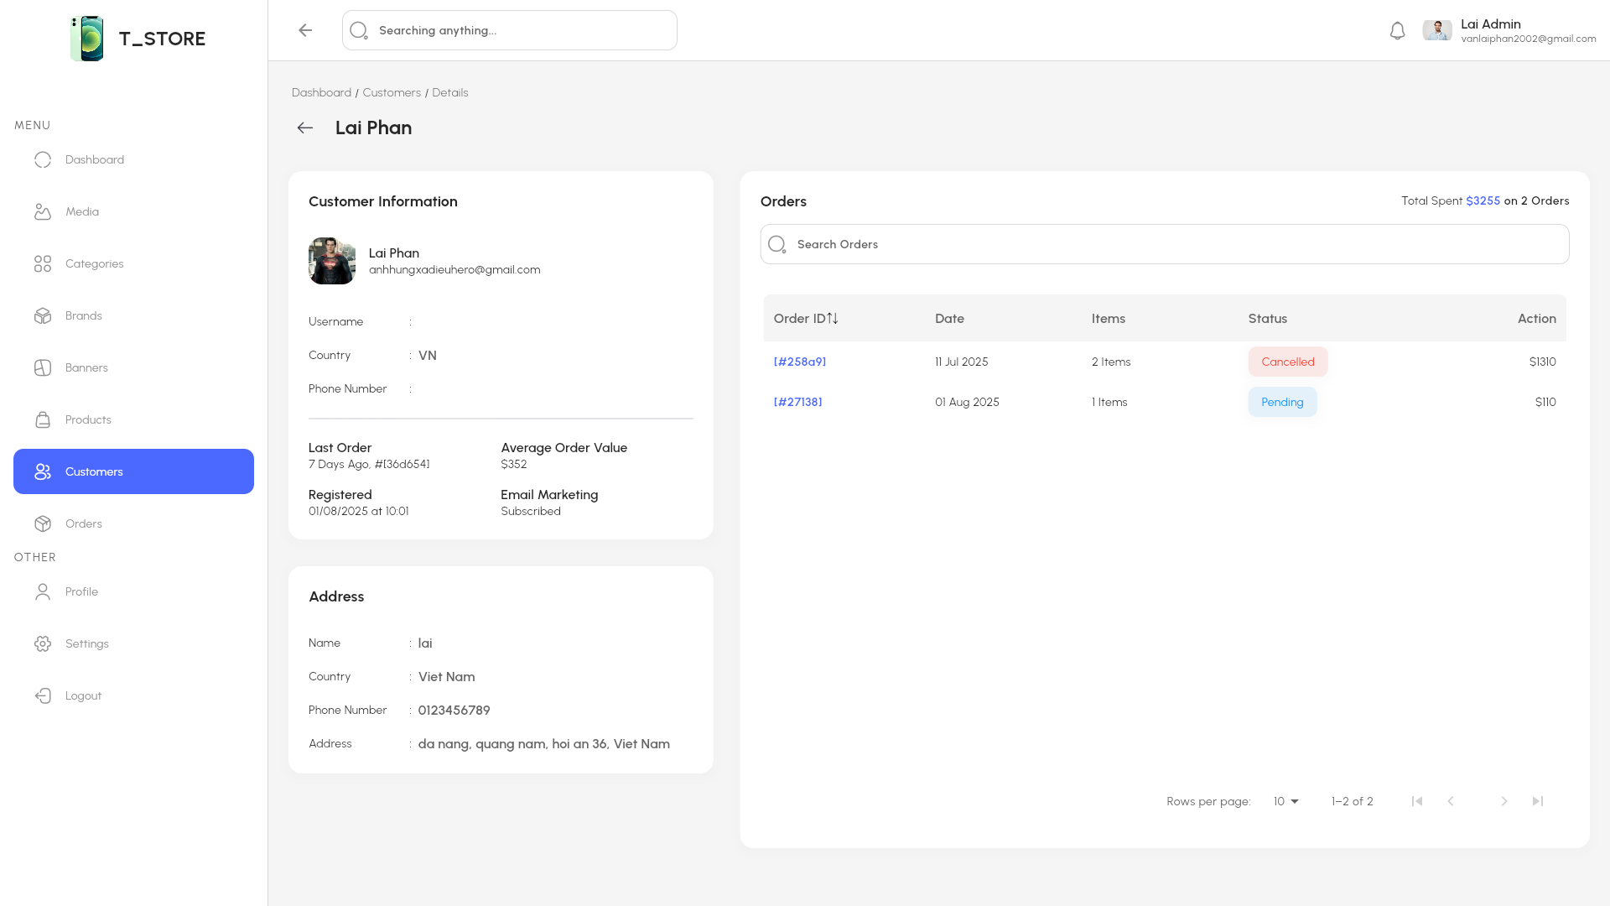

Figure 2.82 “Customer detail” interface

Table 2.50 “Customers” interface

|  |  |  |  |  |  |  |
| --- | --- | --- | --- | --- | --- | --- |
| **Interface** | | Customers | | | | |
| **Describe** | | Show list customer and admin can view customer detail | | | | |
| **Access** | | Admin clicks Customers button in sidebar | | | | |
| **Content** | | | | | | |
| **Item** | | **Type** | **Data** | | **Describe** | |
| Table customer | | Table | N/A | | Show all customer | |
| Search | | Textbox-String | N/A | | Search name customer | |
| View Action Button | | Linked Button | N/A | | View customer detail | |
| Delete Action Button | | Button | N/A | | Delete customer | |
| **Act** | | | | | | |
| **Name** | **Describe** | | | **Success** | | **Failure** |
| Fill in the search box | Enter the word you want to search for in the search box | | | Suggest customer by characters typed | |  |
| Click View action button | Admin click View customer button | | | Redirect to Customer detail screen | |  |
| Click Delete action button | Admin click Delete customer button | | | Remove customer from the table | |  |

#### Order

In the order screen, admin can view the list of orders, view details, update status and delete orders.

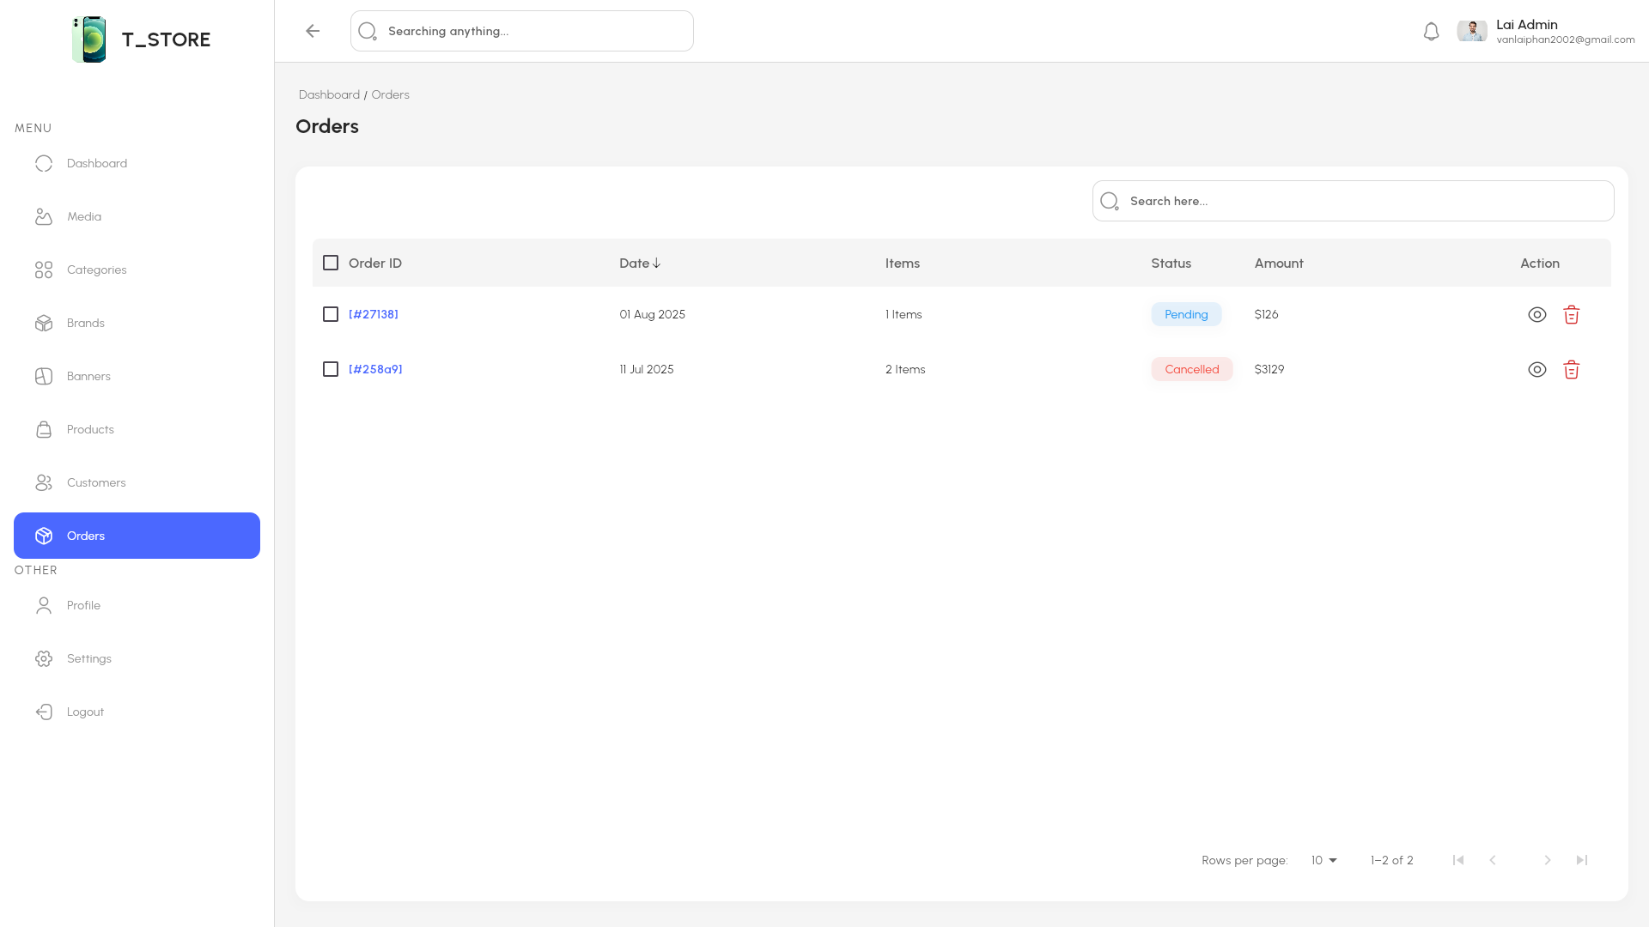

Figure 2.83 “Order” interface

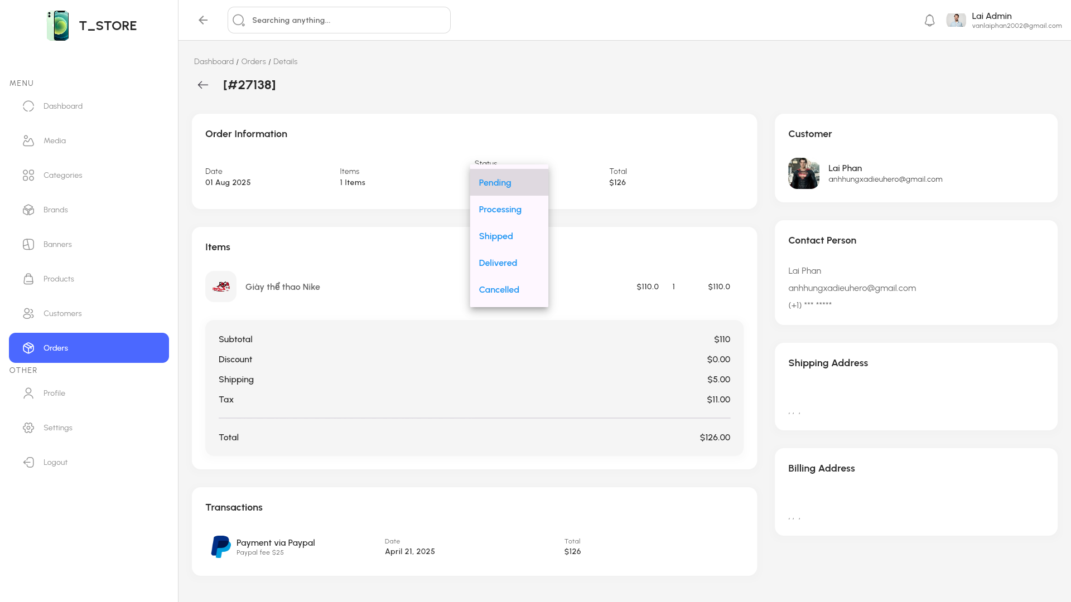

Figure 2.84 “Orders” interface

Table 2.51 “Orders” interface

|  |  |  |  |  |  |  |
| --- | --- | --- | --- | --- | --- | --- |
| **Interface** | | Orders | | | | |
| **Describe** | | Show list order and admin can update,view order detail | | | | |
| **Access** | | Admin clicks Orders button in sidebar | | | | |
| **Content** | | | | | | |
| **Item** | | **Type** | **Data** | | **Describe** | |
| Table order | | Table | N/A | | Show all order | |
| Search | | Textbox-String | N/A | | Search order | |
| Update Action Button | | Linked Button | N/A | | Update status order | |
| Delete Action Button | | Button | N/A | | Delete order | |
| **Act** | | | | | | |
| **Name** | **Describe** | | | **Success** | | **Failure** |
| Fill in the search box | Enter the word you want to search for in the search box | | | Suggest order by characters typed | |  |
| Click Update action button | Admin click Update order button | | | Redirect to Update order screen | |  |
| Click Delete action button | Admin click Delete order button | | | Remove order from the table | |  |

#### Profile

In In the profile screen, admin can view profile detail ,select image admin and change information

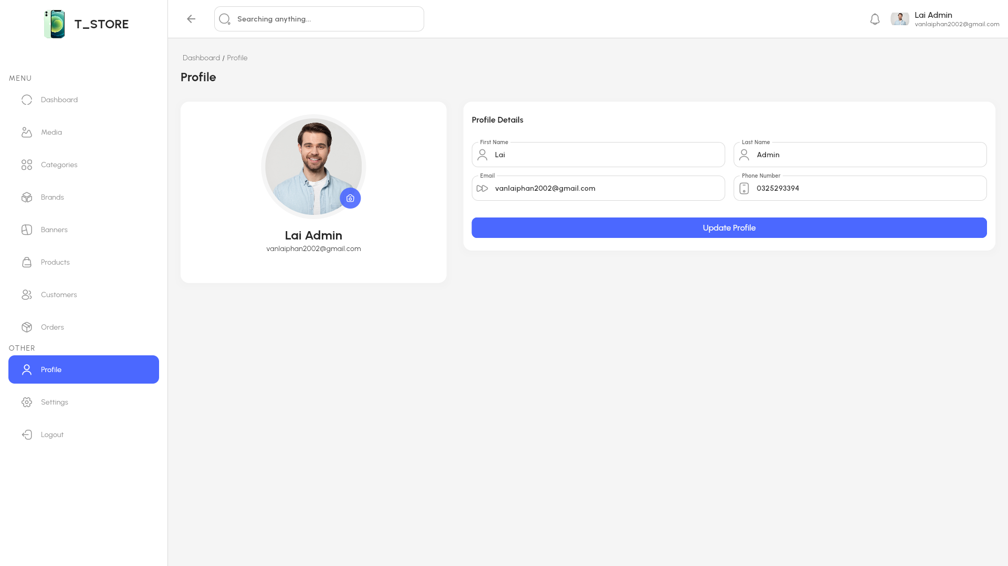

Figure 2.85 “Profile” interface

Table 2.52 “Profile” interface

|  |  |  |  |  |  |  |
| --- | --- | --- | --- | --- | --- | --- |
| **Interface** | | Profile | | | | |
| **Describe** | | Show profile detail | | | | |
| **Access** | | Admin clicks Profile button in sidebar | | | | |
| **Content** | | | | | | |
| **Item** | | **Type** | **Data** | | **Describe** | |
| Update image Button | | Linked Button | N/A | | Update profile image | |
| First name | | Textbox-String | N/A | | Update first name | |
| Last name | | Textbox-String | N/A | | Update last name | |
| Email | | Textbox-String | N/A | | Admin’s email | |
| Phone number | | Textbox-String | N/A | | Update phone number | |
| Update profile | | Button | N/A | | Update all changes | |
| **Act** | | | | | | |
| **Name** | **Describe** | | | **Success** | | **Failure** |
| Click Update image button | Admin click Update image button | | | Redirect to Media screen to select or upload image | |  |
| Click First name | Admin click First name to update last name | | | Success update first name | |  |
| Click Last name | Admin click Last name to update last name | | | Success update last name | |  |
| Click Phone number | Admin click phone number to update phone number | | | Success update phone number | |  |
| Click Update profile | Admin click Update profile | | | All changes have been updated successfully. | |  |

#### Setting

In the setting screen, admin can choose store avatar, rename, create tax rates, shipping cost, free shipping threshold

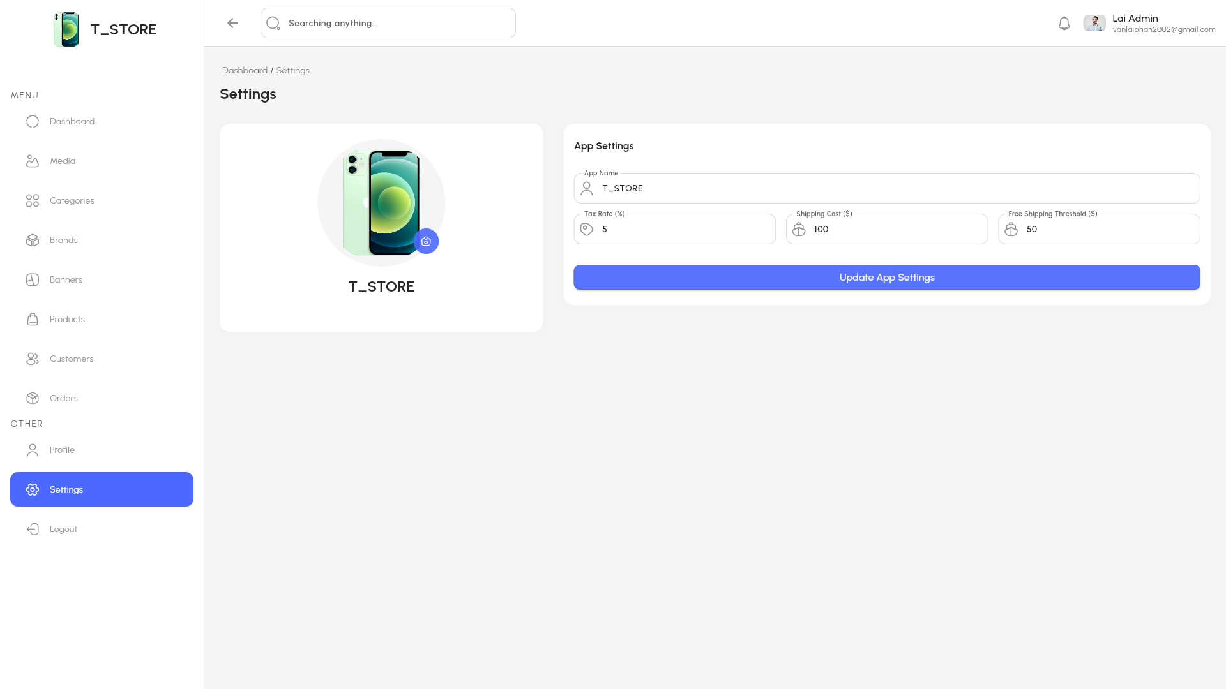

Figure 2.86 “Setting” interface

Table 2.53 “Setting” interface

|  |  |  |  |  |  |  |
| --- | --- | --- | --- | --- | --- | --- |
| **Item** | | **Type** | **Data** | | **Describe** | |
| Update image Button | | Linked Button | N/A | | Update image store | |
| App name | | Textbox-String | N/A | | Update app name | |
| Tax rate | | Textbox-String | N/A | | Update tax rate | |
| Shipping cost | | Textbox-String | N/A | | Update shipping cost | |
| Free shipping threshold | | Textbox-String | N/A | | Update free shipping threshold | |
| Update app settings | | Button | N/A | | Update all changes | |
| **Act** | | | | | | |
| **Name** | **Describe** | | | **Success** | | **Failure** |
| Click App name | Admin click App name button | | | Success update app name | |  |
| Click Tax rate | Admin click Tax rate to update tax rate | | | Success update tax rate | |  |
| Click Shipping cost | Admin click Shipping cost to update shipping cost | | | Success update shipping cost | |  |
| Click Free shipping threshold | Admin click Free shipping threshold to update phone number | | | Success update free shipping threshold | |  |
| Click Update app settings | Admin click Update app settings | | | All changes have been updated successfully. | |  |

# AI-POWERED PRODUCT IMAGE GENERATION AND SMART FEATURES

## Product Image Generation System Using AI

In the context of modern e-commerce, visually appealing product images play a crucial role in influencing consumer behavior. However, not all small and medium-sized businesses have the resources to hire professional photographers or designers. To address this challenge, this project integrates an AI-based product image generation system using Stable Diffusion and ComfyUI into the e-commerce application.

### ComfyUI

ComfyUI is a powerful, flexible, and highly modular node-based graphical user interface designed for working with Stable Diffusion models. Unlike traditional interfaces, ComfyUI allows users to build custom image generation pipelines by connecting functional nodes — such as prompt inputs, model loaders, samplers, image processors, and upscalers — in a clear and visually structured manner. This node-based workflow offers unparalleled control and transparency, making it easy to experiment with and fine-tune every aspect of the image generation process.

One of ComfyUI’s most notable advantages is its performance efficiency. It leverages GPU acceleration effectively and supports advanced features such as batch processing, latent image manipulation, image-to-image generation, and more. ComfyUI also enables users to load custom models, workflows, and extensions, making it a favorite among artists, researchers, and AI enthusiasts who require both creative freedom and technical depth.

Whether you're a beginner looking to explore AI-generated art or a developer aiming to prototype complex workflows with precision, ComfyUI provides a robust and visually intuitive environment to unlock the full potential of Stable Diffusion.

### Image Generation Workflow Design

This ComfyUI workflow is designed to perform advanced image processing combining text-to-image generation, image manipulation, and multi-stage sampling, utilizing the Flux Kontext model.

#### Model Loading and Initialization

The workflow begins by loading three core components:

* UNet model (flux1-dev-kontext) for image generation,
* CLIP encoders (clip_l.safetensors, t5xxl_fp8) for text embedding,
* VAE model (ae.safetensors) for latent encoding/decoding.  
   These are foundational to the prompt-driven image synthesis process.

#### Image Input & Preprocessing

Two images are loaded from the local system. One image is processed using background removal (RMBG), while the other is preserved. The images are then combined using ImageStitch nodes to build a customized presentation layout.

#### Prompt Handling & Translation

User-written Vietnamese prompts are entered via Text Multiline nodes, then automatically translated to English using GoogleTranslateTextNode. These translated prompts are encoded with CLIP and used for further conditioning.

#### Primary and Secondary Sampling Pipelines

* The main prompt is encoded and passed through ReferenceLatent and FluxGuidance, then sampled with KSampler to generate a new latent image.
* A secondary prompt follows the same process in a parallel branch.
* The latent outputs are stored (SaveLatent) and decoded into final images (VAEDecode).

#### Output & Visualization

The final images are rendered and saved with SaveImage. Intermediate results are visually stitched together, allowing for a clear presentation format using custom layout configurations.

#### Advanced Features

* An optional LoraLoaderModelOnly node is applied to fine-tune the model (e.g., for clothing removal or stylistic transformation).
* A Note node defines the workflow principle: “Remove clothes, then add clothes”, indicating a two-phase transformation logic—useful for virtual try-on, cosplay customization, or AI fashion previews.

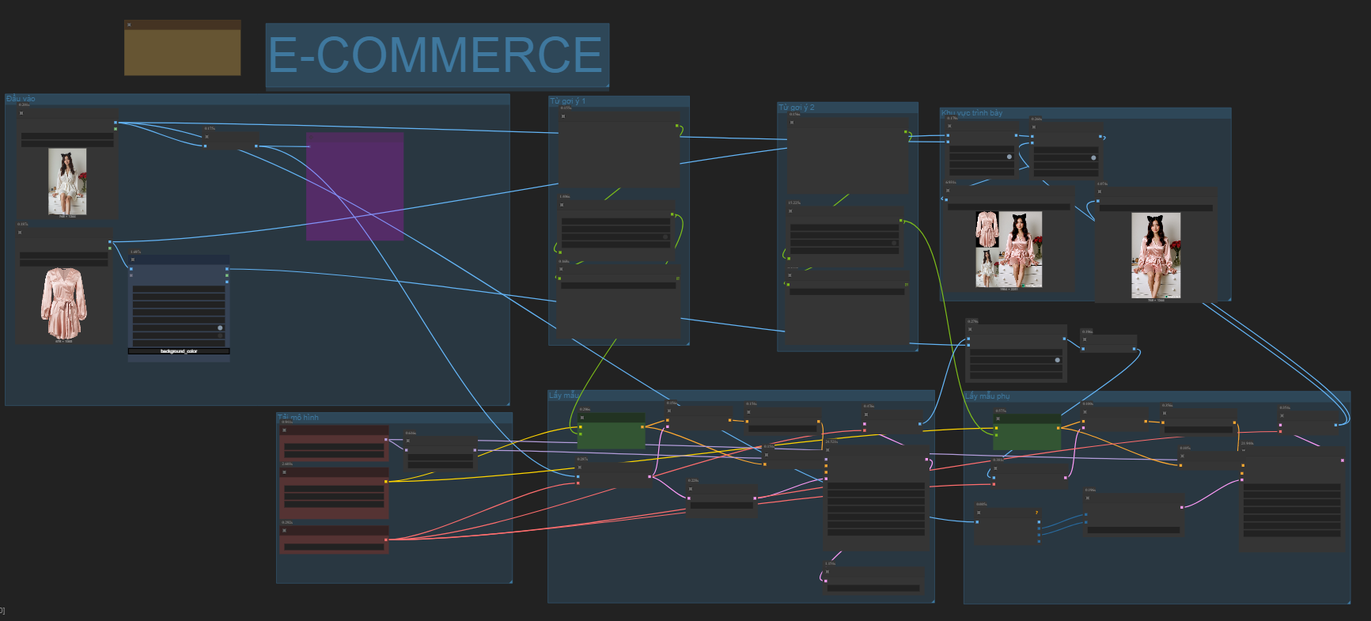

Figure 3.1 Workflow design overall

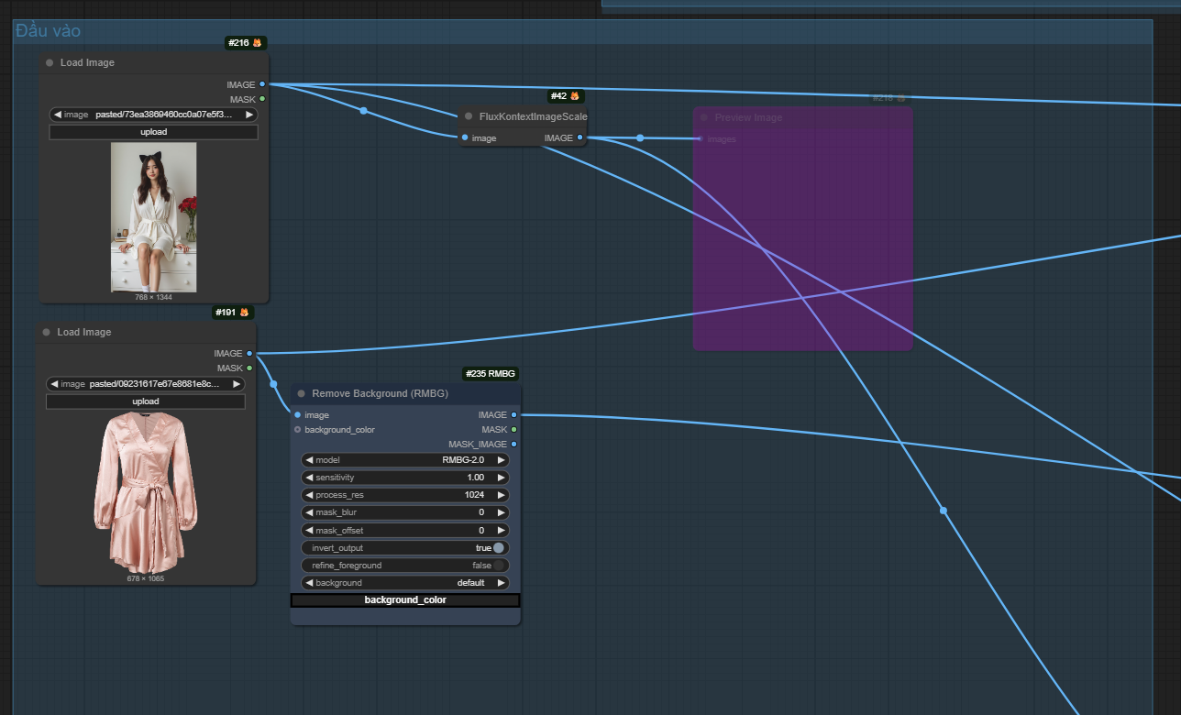

Figure 3.2 Workflow design 1

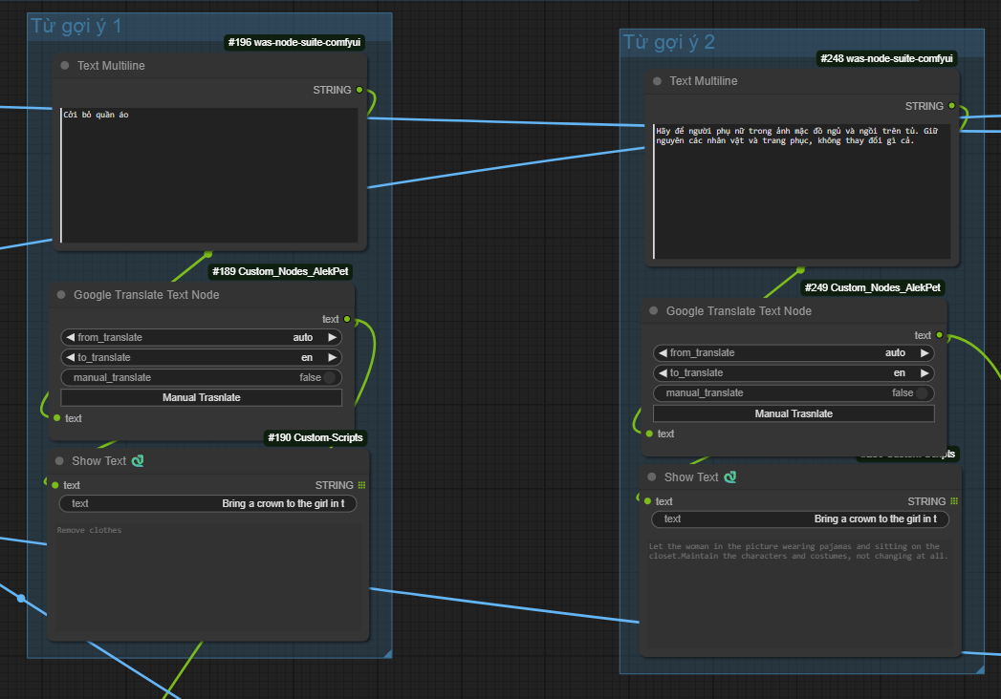

Figure 3.3 Workflow design 2

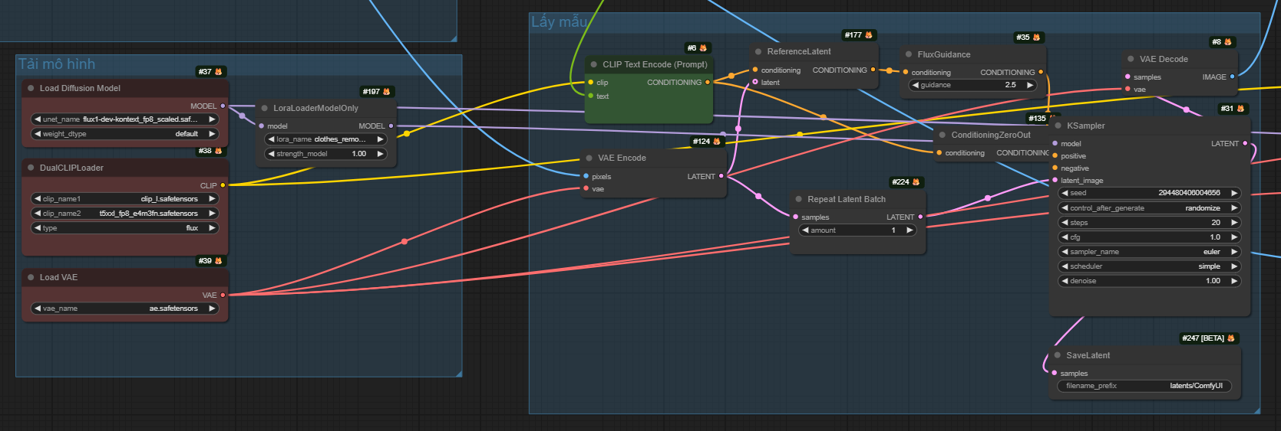

Figure 3.4 Workflow design 3

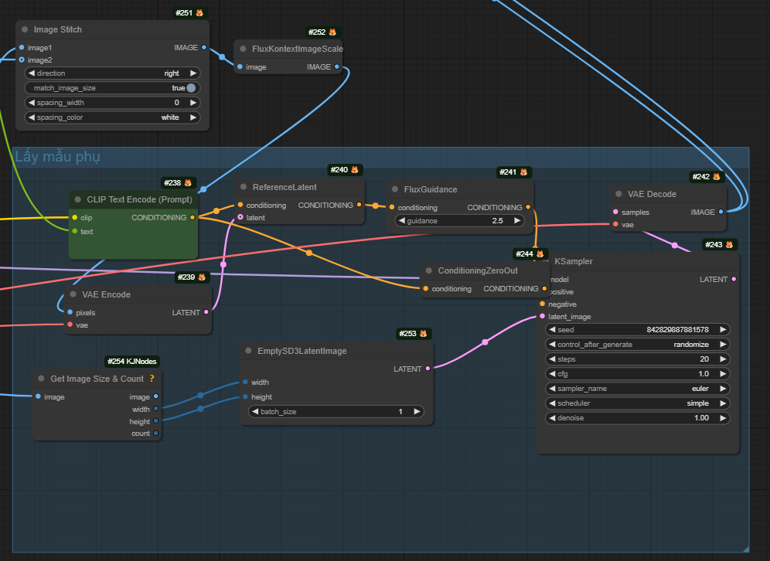

Figure 3.5 Workflow design 4

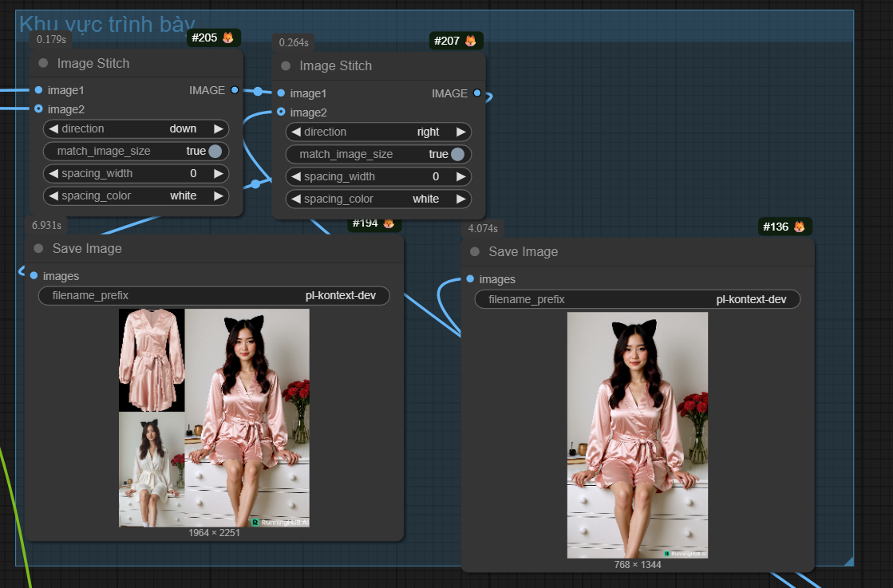

Figure 3.6 Workflow design 5

## AI Screen Design

User selects main and secondary photos, then writes description. Finally click "Start workflow" for AI to follow the description

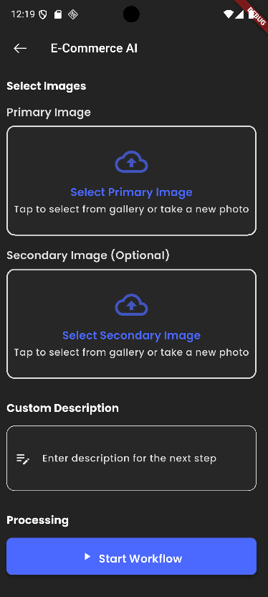

Figure 3.7 AI Image Processing

# CONCLUSIONS AND SUGGESTIONS

## Conclusions

After the process of research and development, the thesis entitled “Building a Cross-Platform E-commerce Application Using Flutter and Firebase” has achieved the following results:

* + Successfully developed an e-commerce application that runs smoothly on both Android and iOS platforms.
  + Integrated core functionalities such as user registration/login, product management, shopping cart, and basic order processing.
  + The system is implemented using Flutter combined with Firebase, ensuring real-time synchronization, stability, and scalability.
  + The application has been thoroughly tested through unit testing, integration testing, and user testing.
  + The integration of Artificial Intelligence (AI) enhances user experience by improving product recommendations and data management.

From a technical and academic perspective, this project has helped the team to:

* + Strengthen and improve programming skills with Flutter, Firebase, UI/UX design, and software project management.
  + Effectively apply system analysis and design models in practice.
  + Become familiar with incorporating modern technologies such as AI into real-world applications.

## Suggestions

* + In the future, we recommend continuing the development of advanced features such as:

+ A rating and feedback system for products.

+ Product recommendations based on user behavior (AI-based).

+ Integrated payment systems and detailed order tracking.

* + Additionally, it is important to further optimize performance and enhance system security to enable the application to be deployed on a larger scale.

REFERENCES

1. A. Dittmar. “More precise descriptions of temporal relations within task models”. In Interactive Systems: Design, Specification, and Verification, 7th International Workshop DSV-IS, Proceedings, pages 151–168, Limerick,Ireland, 5-6 June 2000.
2. E. G. Sirer and B. N. Bershad, "Using Production Grammars in Software Testing", in Proceedings of the Second Conference on Domain Specific Languages, Austin, Texas, October 3-5,1999.
3. Fewster M., Graham D., (1999), *Software Test Automation – Effective Use of Test Execution Tools, Reading,* MA: Addison – Wesley.
4. Fujiwara S, Bochman G, Khendek F, Amalou M, Ghedasmi A. “Test selection based on finite state models”. IEEE Transactions on Software Engineering 1991; 17(6):591–603.